DEPARTMENT OF LABOR AND INDUSTRY

OFFICE OF VOCATIONAL REHABILITATION

PROGRAM POLICIES, PROCEDURES, & GUIDELINES

NUMBER: 10-100.04

SUBJECT: OVR Case Filing System

DATE: June 15, 2010

ADDRESSEES: OVR Staff

EFFECTIVE: Upon Receipt

RESULTING
ACTION: Archive 03-200.02 BPO Case Filing System

INQUIRES: Policy, Procedure and Evaluation Unit
717-787-3662

OVERVIEW

As of November 19, 2007, the Office of Vocational Rehabilitation began using the Commonwealth Workforce Development System (CWDS). CWDS is an online computer case management system designed to replace the OVR Mainframe and portions of the Lotus Notes Application and Counselor Toolset. As a result of the development and implementation of CWDS, OVR uses the combination of an electronic case file and a Supporting Document Case file. All bureaus of OVR use CWDS for case management and reporting purposes.

GENERAL

As a result of the creation of CWDS, OVR has been utilizing both an electronic and Supporting Document Case file. All information that is required for reporting purposes is required to be input into CWDS. The CWDS record is considered the official Case Record. The hard copy record is to serve as a supplement only. If a document has not been made available in electronic form within CWDS, then the paper document should be utilized and filed according to the guidance below. It is the expectation that if CWDS is able to store the information electronically, then that information will be entered into the appropriate fields.

Social Security Numbers:
Social Security Numbers (SSN) should be removed from all case file folders as work is completed or cases are closed and replaced with the new system generated Case Identification number. All new Supporting Document case files that are created should utilize the Case Identification number that is generated by CWDS. Social Security Numbers should not be used for case identification or on any forms that do not specifically request SSN.

*There is no need to remove SSN’s from current documents at this time.

Viewing Case Details:

Within CWDS, OVR staff has the ability to view cases that have been created by our Workforce Partnership Agencies (WPA). OVR staff can use this information to help coordinate services and gather information regarding our customers.

HOW TO:

From the Staff Home Page:
- Select Search Participants.
  - Enter the minimum search criteria for the customer you are seeking.
    - Click Search.
      - From the Search Results, click on the Participant ID Hyperlink associated with the customer you are seeking.

This will bring you to the Participant’s Home Page.
- Select Participant Case List from the Quick Links.

This will bring you to the View Participant Case List screen.

Information Displayed:
- Case ID
- Office
- WPA
- Case Status
- Program
- Case Shared With
- Application Start Date
- Case Start Date
- Case End Date

- Select the Case ID Hyperlink that corresponds with the associated case you are seeking.

This will bring you to the View Participant Case Details screen.

The following is a list of information that is displayed. Depending on the sharing level of the case additional information may also be available.

Information Displayed:

- Case ID
- Current Case Status
- Status Change Date
- Days in Current Status
- Program
- Case Office
- WPA
- Case Start Date
- Case End Date
- Eligible for Supp. Employment (SEI)
- Eligible for GFES
- Case Manager/Supervisor

NOTE: The Bureau of Workforce Development Partnership (BWDP) and the Bureau of Employment and Training Programs (BETP) use different statuses from OVR. When a case is created in CWDS, regardless of who creates it, CWDS will automatically generate a Self Service Case (Status Open), a Labor Exchange Case (Status Eligible), and a Self Service Labor Exchange Case (Status Eligible). All Commonwealth residents are eligible/entitled to these programs. Until a customer actually starts participating in services through BWDP, the statuses will remain as indicated above. If they are actively participating, the status will change based on the program or services they are engaged in.

Case Sharing:
Within CWDS, staff has the ability to share a case or portions of a case with two other WPAs. For additional information regarding sharing a case, refer to Numbered Memorandum OVR Case Sharing 10-100.03. This document outlines how to share a case, along with what can and what cannot be shared. If a case is not shared, the other WPAs are not able to see that a case is open with the Office of Vocational Rehabilitation. However, OVR staff is able to view cases from BWDP or BETP at all times. Base and Detailed information are always shared by all partners within CWDS.

Digital Signatures

The digital signature component of CWDS allows staff to create an electronic case file by allowing staff and customers to sign OVR internal forms* digitally using their Keystone ID and Password. The digital signature using the customer’s Keystone ID and Password legally replaces the customer’s written wet signature for OVR internal forms only.

*OVR Internal Form – A form used only by OVR and OVR staff.

When utilizing the digital signature, staff must inform their customer that:
- The digital signature legally replaces their written wet signature for OVR purposes.
- By signing a form digitally using their Keystone ID and Password, the customer is legally signing a document as if they had completed a written wet signature.

If a customer does not understand, agree, is unsure of the digital signature concept, or does not have a Keystone ID and Password, a written wet signature should be obtained to avoid any confusion or problems.

OVR releases of information do not require data entry into CWDS and are not available for digital signature. Only OVR internal forms allow for digital signatures. Forms that go outside of OVR to public or private entities require a wet signature to validate that the customer has signed the document. As a result, for any type of document that will be used with third parties outside of OVR will result in a wet signature being obtained, i.e. Release of Information, OVR 169, etc.

For internal OVR use only forms, i.e. IPE, Receipt and Agreement, Training Information, etc., a digital signature legally replaces a wet signature. The Keystone ID and Password are unique to each individual customer (similar to a signature). A wet signature is required for all documents that are sent to third parties because the third party does not have access to CWDS and the Keystone ID and Password validation, i.e. OVR 132 Release of Information, OVR 169, etc.

To be able to utilize this function, a customer must be 18 years of age and must have a valid Keystone ID and Password. Staff must have the Case Manager or a higher role.

NOTE: Case Manager in Training/Intern is not able to utilize this function.

Staff will have the option to create a form using a digital signature or obtaining the traditional wet signature. Staff must only use one type of signature per form. Staff may utilize both digital and wet signatures throughout the case, i.e. one form may have a digital signature, while another form uses the traditional wet signature. Staff is responsible for ensuring that any document requiring a wet signature has either a wet signature or a digital signature using the customer’s Keystone ID and Password.

Staff must be present with a customer when entering a digital signature. However, staff is not to ask for their customer’s password, nor should they allow a customer to give them their password. The customer’s password is individual and unique to them and should not be shared with anyone. Staff does have access to a customer’s Keystone ID. It will display on the screen if the customer has an active Keystone ID and Password. If the customer does not have an active Keystone ID and Password, the digital signature feature will be disabled and staff will only have the option to enter wet signatures.

If a customer forgets their Keystone ID or Password, staff can help them retrieve their Keystone ID or password by taking them to the public homepage and following the steps for Keystone ID or password retrieval.

Staff must enter the following forms electronically by either completing data entry or by obtaining a digital signature:

To use the Digital Signature option staff must:
- Select the checkbox Signed by Case Manager.
- Press the Enter Participant Signature option.
- The customer’s Keystone ID will display in the Keystone ID field.
- The customer would then need to enter their unique Password.
  - Only the customer should enter their password. Staff should not ask the customer for or allow their customer to give them their password.
- The date the form was created will pre-populate as the Dated Signed.
- Press Save or Cancel as appropriate.
  - After pressing Save, the system will validate that the appropriate Password has been entered.
    - If the appropriate password has been entered, the form will save.
    - If the appropriate password was not entered, the customer will have the ability to try a few more times.
      - If the customer cannot remember their password, staff can assist them with resetting their password by going to the CWDS Public Homepage www.cwds.state.pa.us/cwdsonline and press the link labeled Forgot Your Password?
      - Or, if the customer cannot remember their password, staff should use paper form and obtain a wet signature from the customer

Screenshot depicting the Digital Signature option:

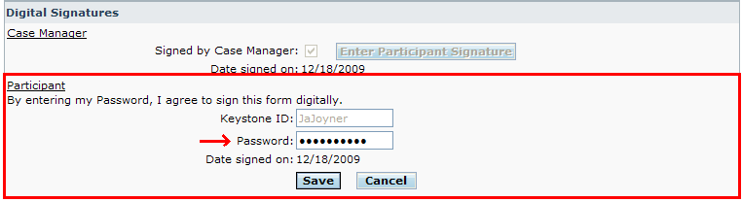

Forms Requiring Data Entry into CWDS:
Forms with a (*) are forms that require a wet or digital signature.
FORM TYPE:  - Employment Planning Application (Includes Customer Statement of Rights and Responsibilities)  - IL/SS Application (Includes Customer Statement of Rights and Responsibilities)  - OM/RT Assessment Form  - Medical Information Form  - VR Financial Needs Test  - IL/SS Financial Needs Test  - Time Extension  - Certificate of Eligibility  - IL/SS Eligibility Information  - Employment Barriers Form  - Order of Selection  - Individual Plan for Employment  - State VR Plan  - Instructional Services Plan  - IL/SS Plan  - Financial Aid Information Forms  - Training Waiver Report  - Job Coaching Referral  - Job Coaching Needs Determination  - Job Coaching Placement Report  - Job Coaching Hours Negotiated  - Service Authorization  - Invoice  - Services Provided  - Closure Form  - HGAC Admission/Discharge Report  - HGAC Referral Form  - HGAC Customer Progress Term Report  - HGAC Customer Progress COR Report  - On The Job Training Contract  - OVR Training Information  - Vocational Evaluation Referral  - Agreement for Services and Return  - Agreement to Repay  - Financial Participation Agreement (OVR T-15)  - Receipt and Agreement  - Receipt of Reusable Equipment  - Voter Registration  - Training Information/Requirements  - BBVS Access Technology Tracking Form (BBVS VR Only) | SIGNATURE REQUIRED:  - *Staff/Customer (Digital Available)  - *Staff/Customer (Digital Available)  - Staff  - NA  - *Staff/Customer (Digital Available)  - *Staff/Customer (Digital Available)  - *Staff/Customer (Digital Available)  - Staff  - Staff  - NA  - Staff  - *Staff/Customer (Digital Available)  - *Staff/Customer (Digital Available)  - *Staff/Customer (Digital Available)  - *Staff/Customer (Digital Available)  - Staff/Customer/Provider  - Staff/District Administrator  - Staff  - Staff  - Staff/Customer/Provider  - Staff/Customer/Provider  - Staff  - Staff/Provider  - NA  - Staff  - Staff  - Staff  - Staff  - Staff  - Staff/Customer/Employer  - NA  - Staff  - Staff/Customer/Provider (When Applicable) (Digital Available)  - *Staff/Customer (Digital Available)  - *Staff/Customer (Digital Available)  - *Staff/Customer (Digital Available)  - *Staff/Customer (Digital Available)  - *Staff/Customer (Digital Available)  - *Staff/Customer (Digital Available)  - NA

If an OVR form is data enterable within CWDS and a wet signature is required, staff does not need to obtain a digital signature. Staff should complete the data entry entering the information exactly as it appears on the paper copy. Staff also has the option to upload the paper copy of the form if they feel that it will be useful to access online. **See Appendix 1 at end of document for discussion of upload function.

Any form with a wet signature must be stored in the Supporting Document Case file.

SUPPORTING DOCUMENT CASEFILE:
If a form has been incorporated electronically into CWDS, staff is expected to complete the document within CWDS.

Forms requiring data entry into CWDS but not requiring a wet signature do not need to be stored in the Supporting Documents Case file. Once the data entry has occurred, the paper version can be destroyed as per local office procedure.

Forms requiring a wet or Digital Signature:

FORM TYPE:  - Employment Planning Application  - VR Financial Needs Test  - IL/SS Financial Needs Test  - Time Extension  - Individual Plan for Employment  - State VR Plan  - Instructional Services Plan  - Financial Aid Information Forms  - Agreement for Services and Return  - Agreement to Repay  - Financial Participation Agreement  - Receipt and Agreement  - Receipt of Reusable Equipment  - Voter Registration  - Training Information/Requirements | SIGNATURE REQUIRED:  - Staff/Customer (Digital Available)  - Staff/Customer (Digital Available)  - Staff/Customer (Digital Available)  - Staff/Customer (Digital Available)  - Staff/Customer (Digital Available)  - Staff/Customer (Digital Available)  - Staff/Customer (Digital Available)  - Staff/Customer (Digital Available)  - Staff/Customer (Digital Available)  - Staff/Customer (Digital Available)  - Staff/Customer (Digital Available)  - Staff/Customer (Digital Available)  - Staff/Customer (Digital Available)  - Staff/Customer (Digital Available)  - Staff/Customer (Digital Available)

If a wet signature is required and a digital signature was not captured, the paper form with the wet signature must be stored in the Supporting Document Case file and can be uploaded based upon staff need.

Certain OVR forms do not legally require a written wet signature; however, OVR policy requires a signature to be obtained. These signatures are based on business requirements and often involve a third party, i.e. Provider or Employer. As a result, the ability to capture a digital signature is not currently available.

The following forms are available to be completed electronically within CWDS but do not allow for digital signatures. As a result, staff must obtain a wet signature on these forms and enter the information into CWDS for reporting purposes:

FORM TYPE:  - On The Job Training Contract  - Job Coaching Needs Determination  - Job Coaching Hours Negotiated  - Job Coaching Placement Report | SIGNATURE REQUIRED:  - Staff/Customer/Employer  - Staff/Customer/Provider  - Staff/Customer/Provider  - Staff/Customer/Provider

Supporting Document Case File Storage:

All cases in statuses prior to Status 06 should use manila folders. Paper documents should be kept in chronological order, most recent information on the top, in manila folders. If a case has not been created yet, staff will need to use the Participant Identification Number (PID) instead of the Case Identification Number (CID). Once a case has been created, staff must use the Case Identification Number on the Supporting Document Case file. Under no circumstance should the participant’s Social Security Number (SSN) be used as a unique identifier on the Supporting Document Case file.

All paper documents are punched on the left side and filed in the appropriate section of the Blue file folder at the time of the customer’s eligibility for VR services (Status 06 or 10). Use Blue folders for all eligible cases in Statuses 06, 10, 11, or higher.

Always file key documents that are not electronic in the supporting documents case file within the appropriate section. Only Section 5, Miscellaneous, does not contain a key document. These key documents head sections to facilitate the location of essential information. They are typed in bold font on the OVR-100, and should be the first document in the file. File all other information in the Supporting Document Case file in the appropriate section in chronological order, most recent information on top.

Use only 8 1/2" x 11" white paper in the Supporting Document Case file. Odd sized forms must be attached to 8 1/2" x 11" paper to ensure that documents are secured within the folder and not lost.

Supporting Document Case file Sections (Blue Folder):
Section 1 is the first section on the left when opening the case file. This section primarily contains the Agreement to Repay OVR 104B and Eligibility Waiver OVR 103 when not signed digitally. This section will also contain any Releases of Information. Releases of information such as OVR 163 & OVR 407 should be stored in chronological order, newest to oldest, beneath any other OVR form designated for this section. *Note that the Eligibility Waiver OVR 103 is filed in Section 2, per the BVRS Case File Format OVR 100.

Section 2 is adjacent and to the right of Section 1. Section 2 includes medical and diagnostic information and forms used in connection with this information when not uploaded. Medical documentation should be filed in chronological order, newest to oldest, within this section. Only records that contain information useful to the individual’s rehabilitation should be stored. If a document is 50 pages, but only 5 pages contain information useful to the case, only the 5 pages that are useful should be stored in the Supporting Document Case file or uploaded. The other pages that are not useful to the case can be destroyed as per local office procedure.

Section 3 is on the left of the case file behind Section 2. This section contains any information related to training that the customer has received that has not been uploaded, i.e. OVR 169’s, reports, transcripts, grade summaries, course schedules, releases for grades, etc.
- The OVR 169 must be entered into CWDS to complete the calculations and generate service authorizations. However, since the customer must sign the OVR 169 on paper, the paper copy must be stored within the Supporting Document Case file and can be uploaded into CWDS using the Upload function.

Section 4 is adjacent and to the right of Section 3. The original OVR-194 IPE form is usually the top form in this section. The original OVR-194 IPE form remains on top followed by any IPE Amendment(s) for documents not signed digitally or uploaded. Other information pertaining to or regarding the customer or their disability should be filed chronologically beneath the OVR-194. E-mails should be treated as printed records and are bound by all the same confidentiality guidance and ethical standards as paper documents. Post employment information will be stored here. Signed closure letters need to be in this section as well.
NOTE: Printing CPN’s from CWDS for storage in the Supporting Documents case is not necessary. CPN’s will be stored electronically in CWDS. All CPN’s are required to be entered into CWDS.

Section 5 contains miscellaneous information and is on the left of the case file behind Section 3. Placement and Social Security Administration (SSA) related documents should be stored in this section. Placement and Social Security information can be placed here, i.e. OJT, resume, and SSA award letter.

Section 6 contains fiscal information and the OVR-105 FNT form when not signed digitally. The OVR-105 should be on top. Additional fiscal information should be stored below the OVR 105. Service Authorizations and Invoices will be entered into CWDS. If paper Invoices were received, they must be stored in chronological order in the Supporting Documents Case file and can be uploaded when appropriate.

NOTE: All bids sent to and/or received back from vendors must be kept in the supporting document file.

NOTE: The Supporting Document IL or SS Case file is contained within the IL/SS Handbook.

ELECTRONIC CASE DOCUMENTATION

Forms requiring data entry into CWDS, but not requiring a “Wet” signature, do not need to be stored in the Supporting Documents Casefile. Once the data entry has occurred, the paper version can be destroyed as per local office procedure. If a “Wet” signature is required, the paper form must be stored in the Supporting Documents Casefile.

The base, detailed, and the Employment Planning Application (EPA) or Independent Living/Specialized Services Application (IL/SS Application) will be completed in CWDS on every case as per program requirements.

The Certificate of Eligibility, Medical Information, IL/SS Eligibility Information, the Order of Selection and Employment Barriers, will be completed in CWDS on every case. (Employment Barriers is optional when completing the narrative eligibility write up.) Signatures for these forms are completed online through system checkboxes as per program requirements. Forms should be completed based on individual bureau/program requirements. The online versions of these forms must be completed. Paper versions do not need to be stored once data entry has been completed.

The Placement Report will be completed and stored within CWDS for every case status movement to 22 or for status 26 case closures.

All Case Progress Notes (CPN) will be entered and stored into CWDS. If a CPN is handwritten, it will need to be data entered into CWDS for storage.

- Annual Review – Once per year, an Annual Review CPN must be completed within CWDS per case. The Annual Review should contain a review of services provided, progress made, additional services requested/required, etc. The first Annual Review occurs 12 months from the original plan’s effective date. Successive Annual Reviews occur 12 months from the date of the previous Annual Review.

HOW TO:

From View Participant Case Details
- Select Review Type.
  - Annual Review.
    - Add Review Type.

Mandatory Fields:
- Case ID – Pre-populated
- Note Date
- Note Title
- Note Type
- Note Description

Click SAVE AND FINISH.

All Form Letters that are available within CWDS will be completed and generated by CWDS. All Form Letters will be stored in CWDS.

The OVR Closure Information form and Services Provided form will be completed and stored within CWDS for every case based on individual bureau/program requirements.

All Closure letters will be completed and generated by CWDS. All Closure Letters will be stored in CWDS.

Plan Summary:
Within CWDS, staff will be required to enter a Plan Summary. The Plan Summary contains several fields over multiple pages. Mandatory fields are noted below:

HOW TO:

From View Participant Case Details screen
- Select Form.
  - Individual Plan for Employment or State VR Plan.
    - Add Form.
      - Create Plan.

Mandatory Fields:

Individual Plan for Employment (IPE) and State VR Plan:

Create Plan
Case Information
- Case ID – Pre-populated
- WPA – Pre-populated
- Begin Date – Pre-populated
- End Date – Blank
- Status (Status Code) – Pre-populated
- Program – Pre-populated
- Office – Pre-populated
- Primary Case Manager – Pre-populated

Plan Information
- Plan Type - Individualized Plan for Employment or state VR Plan – Pre-populated
- Plan Effective Date/Amendment Date – Editable - Mandatory

SAVE AND CONTINUE

Create Goal
Goal Details
- Goal Type Employment – Pre-populated
- Occupational Goal (Utilize Search O Net Code) - Mandatory
- Specific Job Goal – Text – Mandatory
- Estimated Date for Achieving Goal – Editable – Mandatory
- Criteria for making progress toward Goal – Text – Mandatory
- Anticipated Post Employment Services – Text – Mandatory
- Extended Service and Provider for Supported Employment and basis of support – Text – Mandatory
- Participant Responsibility – Text – Mandatory

SAVE AND CONTINUE

Create Planned Service
- Specific Service – Editable – Mandatory
- Specific Provider – Editable – Mandatory
- Estimated Start Date – Editable – Mandatory
- Comparable Benefits – Text – Mandatory
- How Service Obtained – Text – Mandatory

SAVE AND CONTINUE

Goal Details
- Summary of Goal Details – See Descriptions Above
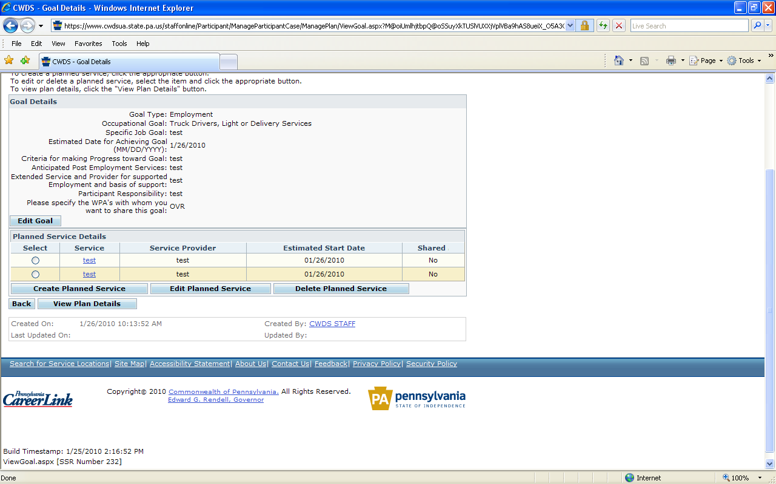

VIEW PLAN DETAILS

Create OVR Plan Details
- Summary of Case/Plan/Goal/Service Details
- Change Case Status Code

Enter Signatures
- Wet Signature
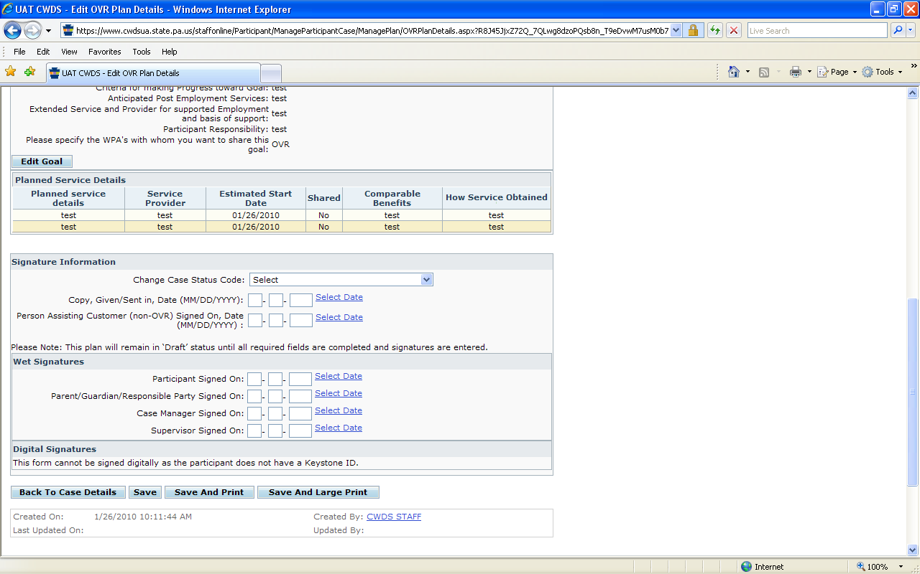

- Digital Signature
The digital signature component of CWDS allows staff to create an electronic case file by allowing staff and customers to sign OVR internal forms* digitally using their Keystone ID and Password. The digital signature using the customer’s Keystone ID and Password legally replaces the customer’s written wet signature for OVR internal forms only.

*OVR Internal Form – A form used only by OVR and OVR staff.

When utilizing the digital signature, staff must inform their customer that:
1. The digital signature legally replaces their written wet signature for OVR purposes.
2. By signing a form digitally using their Keystone ID and Password, the customer is legally signing a
document as if they completed a written wet signature.

If a customer does not understand, agree, is unsure of the digital signature concept, or does not have a Keystone ID and Password, a written wet signature should be obtained to avoid any confusion or problems.

For internal OVR use only, forms, i.e. IPE, Receipt and Agreement, Training Information, etc. a digital signature legally replaces a wet signature. The Keystone ID and Password are unique to each individual customer (similar to a signature). A wet signature is required for all documents that are sent to third parties because the third party does not have access to CWDS and the Keystone ID and Password validation, i.e. OVR 132 Release of Information, OVR 169, etc.

To be able to utilize this function, a customer must be 18 years of age and must have a valid Keystone ID and Password. Staff must have the Case Manager or a higher role.

NOTE: Case Manager in Training/Intern is not able to utilize this function.

Staff will have the option to create a form using a digital signature or obtaining the traditional wet signature. Staff must only use one type of signature per form. Staff may utilize both digital and wet signatures throughout the case, i.e. one form may have a digital signature while another form uses the traditional wet signature. Staff is responsible for ensuring that any document requiring a wet signature has either a wet signature or a digital signature using the customer’s Keystone ID and Password.

Staff must be present with a customer when entering a digital signature. However, staff is not to ask for their customer’s password, nor should they allow a customer to give them their password. The customer’s password is individual and unique to them and should not be shared with anyone. Staff does have access to a customer’s Keystone ID and it will display on the screen, if the customer has an active Keystone ID and Password. If the customer does not have an active Keystone ID and Password, the digital signature feature will be disabled and staff will only have the option to enter wet signatures.

If a customer forgets their Keystone ID or Password, staff can help them retrieve their Keystone ID or password by taking them to the public homepage and following the steps for Keystone ID or password retrieval.

Staff must enter the following forms electronically by either completing data entry or by obtaining a digital signature:

To use the Digital Signature option, staff must:
- Select the checkbox Signed by Case Manager.
- Press the Enter Participant Signature option.
- The customer’s Keystone ID will display in the Keystone ID field.
- The customer would then need to enter their unique Password.
  - Only the customer should enter their password. Staff should not ask the customer for or allow their customer to give them their password.
- The date the form was created will pre-populate as the Dated Signed.
- Press Save or Cancel as appropriate.
  - After pressing Save, the system will validate that the appropriate Password has been entered.
    - If the appropriate password has been entered, the form will save.
    - If the appropriate password was not entered, the customer will have the ability to try a few more times.
      - If the customer can not remember their password, staff can assist them with resetting their password by going to the CWDS Public Homepage www.cwds.state.pa.us/cwdsonline and press the link labeled Forgot Your Password?
      - Or, if the customer cannot remember their password, staff should use paper form and obtain a wet signature from the customer.

Screenshot depicting the Digital Signature option:

SAVE/SAVE AND PRINT

Independent Living/Specialized Services Plan (IL/SSP):

Create Plan
Case Information
- Case ID – Pre-populated
- WPA – Pre-populated
- Begin Date – Pre-populated
- End Date – Blank
- Status (Status Code) – Pre-populated
- Program – Pre-populated
- Office – Pre-populated
- Primary Case Manager – Pre-populated

Plan Information
- Plan Type - IL/SS – Pre-populated
- Plan Effective Date/Amendment Date – Editable - Mandatory

SAVE AND CONTINUE

Create Goal
Goal Details
  - Goal Description – Mandatory
  - Participant Responsibility - Text

SAVE AND CONTINUE

Create Planned Service
  - Specific Service – Editable – Mandatory
  - Specific Provider – Editable
  - Estimated Start Date – Editable
  - Comparable Benefits – Text

SAVE AND CONTINUE

Goal Details
- Summary of Goal Details – See Descriptions Above

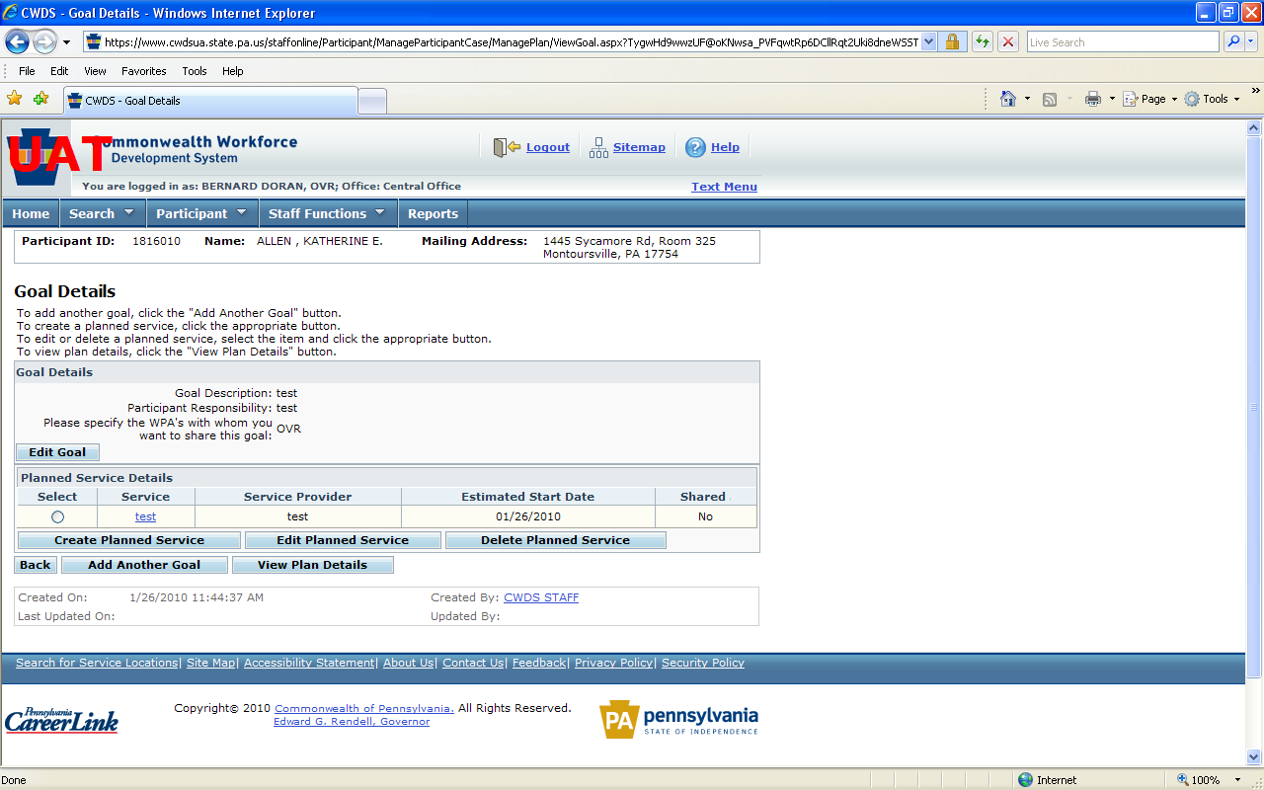

VIEW PLAN DETAILS

Create OVR Plan Details
- Summary of Case/Plan/Goal/Service Details
Enter Signatures
- Wet Signature
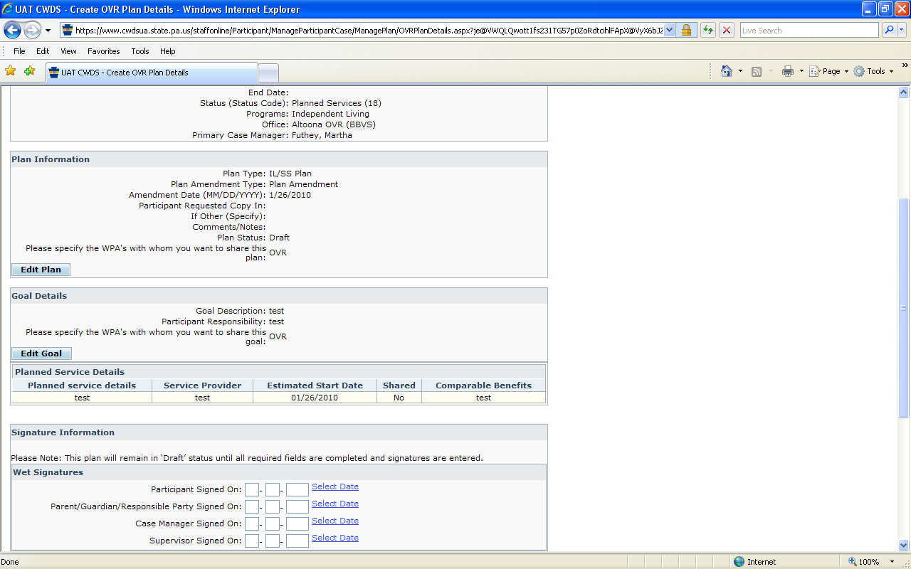

- Digital Signature
The digital signature component of CWDS allows staff to create an electronic case file by allowing staff and customers to sign OVR internal forms* digitally using their Keystone ID and Password. The digital signature using the customer’s Keystone ID and Password legally replaces the customer’s written wet signature for OVR internal forms only.

*OVR Internal Form – A form used only by OVR and OVR staff.

When utilizing the digital signature staff must inform their customer that:
- The digital signature legally replaces their written wet signature for OVR purposes.
- By signing a form digitally using their Keystone ID and Password, the customer is legally signing a document as if they completed a written wet signature.

If a customer does not understand, agree, is unsure of the digital signature concept, or does not have a Keystone ID and Password, a written wet signature should be obtained to avoid any confusion or problems.

For internal OVR use only, forms, i.e. IPE, Receipt and Agreement, Training Information, etc., a digital signature legally replaces a wet signature. The Keystone ID and Password are unique to each individual customer (similar to a signature). A wet signature is required for all documents that are sent to third parties because the third party does not have access to CWDS and the Keystone ID and Password validation, i.e. OVR 132 Release of Information, OVR 169, etc.

To be able to utilize this function, a customer must be 18 years of age and must have a valid Keystone ID and Password. Staff must have the Case Manager or a higher role.

NOTE: Case Manager in Training/Intern is not able to utilize this function.

Staff will have the option to create a form using a digital signature or obtaining the traditional wet signature. Staff must only use one type of signature per form. Staff may utilize both digital and wet signatures throughout the case, i.e. one form may have a digital signature while another form uses the traditional wet signature. Staff is responsible for ensuring that any document requiring a wet signature has either a wet signature or a digital signature using the customer’s Keystone ID and Password.

Staff must be present with a customer when entering a digital signature. However, staff is not to ask for their customer’s password, nor should they allow a customer to give them their password. The customer’s password is individual and unique to them and should not be shared with anyone. Staff does have access to a customer’s Keystone ID, and it will display on the screen if the customer has an active Keystone ID and Password. If the customer does not have an active Keystone ID and Password, the digital signature feature will be disabled and staff will only have the option to enter wet signatures.

If a customer forgets their Keystone ID or Password, staff can help them retrieve their Keystone ID or password by taking them to the public homepage and following the steps for Keystone ID or password retrieval.

Staff must enter the following forms electronically by either completing data entry or by obtaining a digital signature:

To use the Digital Signature option staff must:
- Select the checkbox Signed by Case Manager.
- Press the Enter Participant Signature option.
- The customer’s Keystone ID will display in the Keystone ID field.
- The customer would then need to enter their unique Password.
  - Only the customer should enter their password, Staff should not ask the customer for or allow their customer to give them their password.
- The date the form was created will pre-populate as the Dated Signed.
- Press Save or Cancel as appropriate.
  - After pressing Save, the system will validate that the appropriate Password has been entered.
    - If the appropriate password has been entered, the form will save.
    - If the appropriate password was not entered, the customer will have the ability to try a few more times.
      - If the customer cannot remember their password, staff can assist them with resetting their password by going to the CWDS Public Homepage www.cwds.state.pa.us/cwdsonline and press the link labeled Forgot Your Password?
      - Or, if the customer cannot remember their password, staff should use paper form and obtain a wet signature from the customer.

Screenshot depicting the Digital Signature option:

SAVE/SAVE AND PRINT

Instructional Services Plan (ISP):

Create Plan
Case Information
  - Case ID – Pre-populated
  - WPA – Pre-populated
  - Begin Date – Pre-populated
  - End Date – Blank
  - Status (Status Code) – Pre-populated
  - Program – Pre-populated
  - Office – Pre-populated
  - Primary Case Manager – Pre-populated

Plan Information
- Plan Type - Instructional Service Plan – Pre-populated
- Plan Effective Date/Amendment Date – Editable

SAVE AND CONTINUE

Create Goal
Goal Details
  - Objective/Recommendation – Mandatory
  - Schedule of Instruction – Text
  - Equipment Recommendation – Text
  - Participant Responsibility - Text

SAVE AND CONTINUE

Goal Details
- Summary of Goal Details – See Descriptions Above

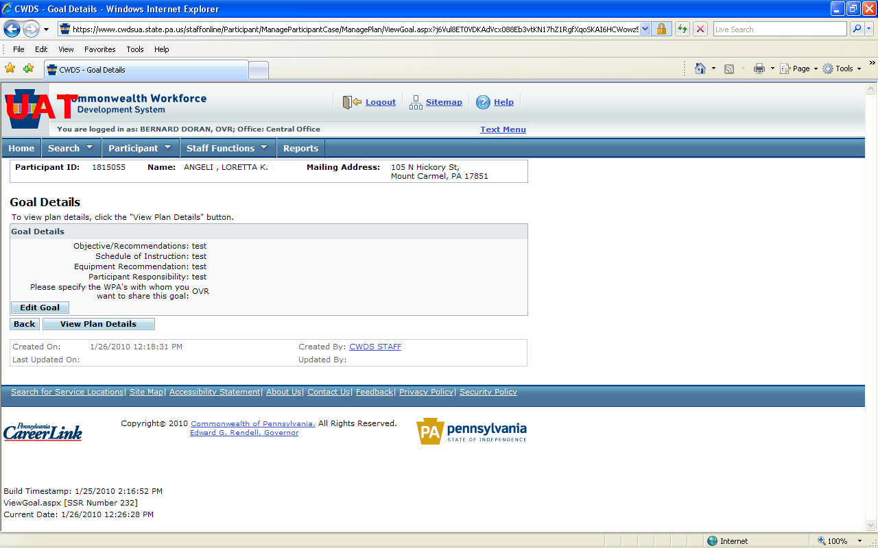

VIEW PLAN DETAILS

Create OVR Plan Details
- Summary of Case/Plan/Goal Details

Enter Signatures
- Wet Signature

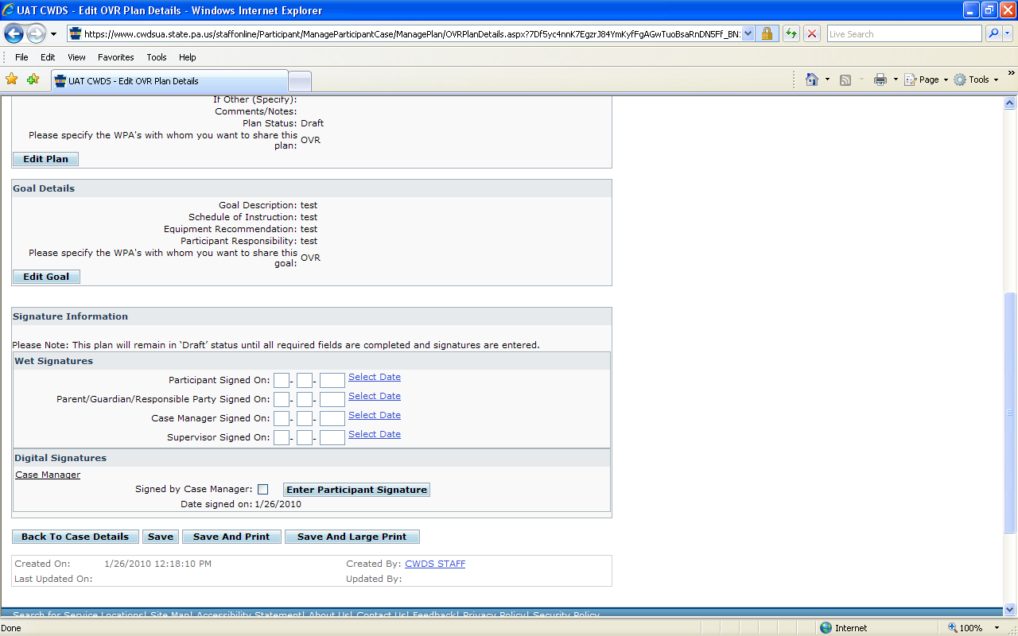

- Digital Signature
The digital signature component of CWDS allows staff to create an electronic case file by allowing staff and customers to sign OVR internal forms* digitally using their Keystone ID and Password. The digital signature using the customer’s Keystone ID and Password legally replaces the customer’s written wet signature for OVR internal forms only.

*OVR Internal Form – A form used only by OVR and OVR staff.

When utilizing the digital signature, staff must inform their customer that:
- The digital signature legally replaces their written wet signature for OVR purposes.
- By signing a form digitally using their Keystone ID and Password, the customer is legally signing a document as if they completed a written wet signature.

If a customer does not understand, agree, is unsure of the digital signature concept, or does not have a Keystone ID and Password, a written wet signature should be obtained to avoid any confusion or problems.

For internal OVR use only, forms, i.e. IPE, Receipt and Agreement, Training Information, etc., a digital signature legally replaces a wet signature. The Keystone ID and Password are unique to each individual customer (similar to a signature). A wet signature is required for all documents that are sent to third parties because the third party does not have access to CWDS and the Keystone ID and Password validation, i.e. OVR 132 Release of Information, OVR 169, etc.

To be able to utilize this function, a customer must be 18 years of age and must have a valid Keystone ID and Password. Staff must have the Case Manager or a higher role.

NOTE: Case Manager in Training/Intern is not able to utilize this function.

Staff will have the option to create a form using a digital signature or obtaining the traditional wet signature. Staff must only use one type of signature per form. Staff may utilize both digital and wet signatures throughout the case, i.e. one form may have a digital signature while another form uses the traditional wet signature. Staff is responsible for ensuring that any document requiring a wet signature has either a wet signature or a digital signature using the customer’s Keystone ID and Password.

Staff must be present with a customer when entering a digital signature. However, staff is not to ask for their customer’s password, nor should they allow a customer to give them their password. The customer’s password is individual and unique to them and should not be shared with anyone. Staff does have access to a customer’s Keystone ID and it will display on the screen if the customer has an active Keystone ID and Password. If the customer does not have an active Keystone ID and Password, the digital signature feature will be disabled and staff will only have the option to enter wet signatures.

If a customer forgets their Keystone ID or Password, staff can help them retrieve their Keystone ID or password by taking them to the public homepage and following the steps for Keystone ID or password retrieval.

Staff must enter the following forms electronically by either completing data entry or by obtaining a digital signature:

To use the Digital Signature option, staff must:
- Select the checkbox Signed by Case Manager.
- Press the Enter Participant Signature option.
- The customer’s Keystone ID will display in the Keystone ID field.
- The customer would then need to enter their unique Password.
  - Only the customer should enter their password. Staff should not ask the customer for or allow their customer to give them their password.
- The date the form was created will pre-populate as the Dated Signed.
- Press Save or Cancel as appropriate.
  - After pressing Save, the system will validate that the appropriate Password has been entered.
    - If the appropriate password has been entered, the form will save.
    - If the appropriate password was not entered the customer will have the ability to try a few more times.

- If the customer cannot remember their password, staff can assist them with resetting their password by going to the CWDS Public Homepage www.cwds.state.pa.us/cwdsonline and press the link labeled Forgot Your Password?
      - Or, if the customer cannot remember their password, staff should use paper form and obtain a wet signature from the customer.

Screenshot depicting the Digital Signature option:

SAVE/SAVE AND PRINT

Status Changes:

Within CWDS, staff will have the ability to make case status changes. Staff should follow all guidelines and documentation requirements regarding changing case statuses according to their program requirements. Program requirements are found in the IL/SS Handbook or the RSA 911 Reporting Manual.

HOW TO:

From the View Participant Case List screen:
- Select the appropriate case by clicking the radio button.
  - Click Edit.

This brings you to the Edit Participant Case Details screen:

From the Edit Participant Case Details:
- Select the appropriate Case Status using the Change Case Status dropdown.
  - Complete the New Status Change Date field.
    - Click Save and Finish.

Fiscal Documents:

For additional information regarding fiscal procedures refer to Numbered Memorandum 07-DRAFT Fiscal Procedures memo dated 10/02/2007.

All Service Authorizations will be completed and stored within CWDS.

All Purchase Orders will be generated by and stored within CWDS.

All Invoices will be entered and stored within CWDS. If paper Invoices were received, they will be stored in the supporting document file or uploaded and stored in CWDS. All electronic Invoices received will be stored in CWDS.

NOTE: Copies of all electronic forms, letters, or fiscal documents created in CWDS will be stored in CWDS. If copies are needed, they can be obtained through the CWDS application for up to 5 years after case closure.

GENERATING CORRESPONDENCE

CWDS has the ability to generate over 40 standard correspondences. Staff should always use the standard correspondences through CWDS when generating a letter to a participant when the correspondence is available through CWDS. When staff uses CWDS to generate and print a correspondence, a copy will be stored within CWDS. If a correspondence is not available within CWDS, staff should keep a copy in the Supporting Document Case file or upload a copy and store in CWDS or use the Correspondence Template or the OVR Correspondence Template.

Within CWDS, customers will have the ability to choose a preference regarding how they would like to receive correspondence (Post or Email). For customers who select Post, all correspondence should be mailed. For customers who select E-mail, they will receive an e-mail indicating that they have a correspondence waiting for them within CWDS. Customers must then login to the system and view the correspondence through their Participant Home Page. For customers who select E-mail, certain correspondences will have to be mailed regardless of preference. The following rules should be followed when the customer’s preference is E-mail:
- Participant ID Letter – Staff should select to Send Participant ID Letter when creating a new participant. This letter will then generate from the Labor and Industry mail server in Harrisburg.
  - Alternate Format Participant ID Letter – Alternate Format letters should be completed in the local office and can be created from the Generate Correspondence tab following the steps outlined below.
- Purchase Orders and Invoices – Staff should mail regardless of preference.
- Eligibility Letter – Staff should mail regardless of preference.
- Closure Letters – All closure letters should be mailed regardless of preference.
- All other Correspondences can be completed using the customers preference.

Generating Large Print Correspondence:

Staff has the ability to generate correspondence in Large Print format using CWDS. The following outlines the steps to be able to utilize that functionality:

HOW TO:
It is essential that the participant’s Base Record reflect Large Print for the Communication Needs in the Other Information section. To check this, go to the participant’s base record. If large print is not selected, press the “Edit” button, select large print, and press Save and Continue.

With the Participant in focus:

- From the navigation bar, Participant->Correspondence->Create Correspondence
- From the Create Correspondence screen, choose the desired template and get options. Fill in needed fields.
- Press Generate Correspondence.
- From the Correspondence Recipient Summary screen, confirm that Special Communication Needs reflects large print.

NOTE: If you do not see this screen, go to the participant base record and check that Large Print is checked for the Communication Needs in the Other Information section.

- Press Generate Correspondence
- Staff should verify information on the Preview Correspondence Currently Generating: Export. Press Save as Final.
- From the Save Correspondence As Word screen, under Save Correspondence, press Save.
- File Download pop-up; Press Save.
- Save As pop-up. Choose where you want to save the file. Press Save.
- Download Complete pop-up. Press Close.
- Retrieve and open the file.
- Use Ctrl + A or from the tool bar, use the Edit drop-down, choose Select All.
- While highlighted:
  - Choose font type and size.
  - Right click. Choose Paragraph.
  - In Line spacing box, choose At least.
  - In the At: box, choose one pt above font choice, i.e. If you chose 18 pt, enter 19 pt here.
  - Press the Tabs box, select Clear All then press OK.

NOTE: Staff may need to do some minor spacing corrections prior to printing. Some documents may need to be “pushed” down from the top to be able to use OVR letterhead.

WORKFLOW GUIDELINES

In an effort to minimize double data entry work, it is the expectation that all staff will enter information directly into CWDS when available and able.

When direct data entry is not possible, staff should gather all appropriate and required information and provide it to support staff to enter the data into CWDS.

Local office management should monitor CWDS usage and work volumes with supervisory, professional field, and clerical professional staff to ensure policy and procedural guidelines are being followed and that staff have appropriate levels of work and assistance.

Attachment
OVR -100
**Appendix 1

Upload Feature:

General Information:
The intention of the upload feature is to allow staff to upload documents that they feel are essential to case development to be able to access while online and to eventually phase-out the need for a Supporting Document Casefile. OVR staff is not required to upload documents from previously created cases. However, if a staff member feels that a specific document from a previously created case would be useful to have online it can be uploaded. Moving forward, as cases are created, staff should upload any document that they feel is essential to case development and would like to access while online as the document is received. At this time, uploading all case related documents is not required. OVR will be monitoring the success and use of the upload feature to determine if changes to the process need to be made. Until OIT has a better understanding of OVR’s need for storage space staff may choose which documents are uploaded. However, it is staff’s responsibility to ensure that any document where a wet signature is obtained is stored in the Supporting Document Casefile. Staff may choose to also upload the wet signature document, but if a wet signature is obtained the original must be maintained in the Supporting Document Casefile.

CWDS has the ability to allow staff to take an electronic document and upload it into individual cases within the system. Staff who has the ability to upload documents will see a Manage Uploaded Documents button on the View Case Details page within a customer’s case. All staff with a primary role (Case Manager, Case Manager in Training, Supervisor, LOFA, Clerical, and Manager) will have the ability to upload a document to an individual case.

Screenshot depicting a section of View Case Details highlighting the Manage Uploaded Documents button
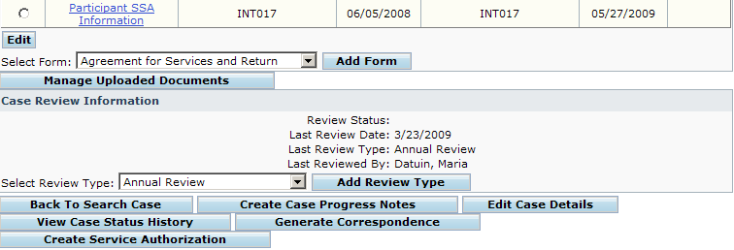

Staff should only upload documents that they feel are essential to case development or will need to reference when in the field. Miscellaneous documents that are associated with a customer’s case, but are not essential to case development should not be uploaded at this time. Staff is responsible for ensuring that documents that are uploaded are viewable, usable, and essential to the case. Once uploaded staff should press the hyperlink to the document to ensure that the upload occurred successfully and that the document is associated with the appropriate case/customer, contains the correct number of pages, and is readable. Documents that are related to the case but are deemed not essential to case development can be stored in the Supporting Document Casefile.

Documents that are not legible when scanned, i.e. X-Rays, MRI images, etc. should not be uploaded. Staff often receives records that are multiple pages in length; staff should only upload the portions of the document that provide useful information to the casefile. If a document is originally 50 pages, but only 5 pages contain information worthwhile to the individual’s rehabilitation, only those 5 pages should be uploaded. The other pages, if they provide no useful information, can be destroyed per local office procedure or be stored in the Supporting Documents Casefile. If staff chose to destroy the non useful portions of the document, staff should note the original number of pages received on the portion kept.

NOTE: Staff should be careful when destroying portions of a document and ensure that all relevant information that might be needed for case development (Eligibility determination, IPE development, or service approval/denial) has been retained/uploaded. This would include any signature pages, charts, or coding that would be essential for case review i.e. School Psychologist Signature on IEP, DSM Coding, etc.

For the immediate future staff should keep the portion of the document that has been uploaded in the Supporting Document Casefile. After the upload feature has been monitored for several months, original guidance will be reviewed and modified as appropriate.

For OVR forms that are not data enterable within CWDS staff can chose to enter those documents into the system using the upload feature if they would be useful for case development. Otherwise those documents must be stored in the Supporting Document Casefile.

Paper Forms List:

If staff has uploaded an OVR Form they do not need to enter information related to that document in the Paper Forms List.

Document Size:
CWDS will only allow 1MB of information to be uploaded per document. There is no limit on the number of documents that can be uploaded per case. If a document is larger then 1MB and staff need to upload it into CWDS they will have to split the document into sections that are 1MB or less and upload the sections of the document individually. The 1MB limitation was implemented as a system performance precaution to allow staff to access the uploaded documents when in the field using Wi-Fi or Air Card connections. OIT will monitor the use of this feature and determine if document size can be increased over time.

Depending on the type of file/document being uploaded the size of the document will vary greatly. Documents that contain images or were scanned at a very high resolution will be larger and may need to be split into sections. Depending on the document/file type, scanner used, or document content the size of the document will vary greatly. Staff will need to be mindful of the variance and plan accordingly when uploading documents.

Currently OVR has 500GB of space allocated for the upload of documents. OIT will be monitoring the usage of the upload feature to determine when additional space will be needed and added.

Estimated document size based on initial testing:
- Word Document – 1MB = Estimated 50 pages (Text Only)
- PDF – 1MB = Estimated 15 pages (Scanned Image, Text Only, Standard Resolution)

Standard Scanner Settings:
When scanning text documents OVR staff should confirm that the scanner they are using is set to a standard setting usually 200dpi (dots per inch). 200dpi is the common default setting used for scanning documents that are text based. To check a scanners default go to Scanner Settings or Scanner Administration and look for Image Quality/Output or similar options and review the setting and change if necessary.

Uploaded Document Storage:
All documents that are uploaded will be stored on the View Uploaded Documents page within CWDS. Staff is able to sort the document by: Document Type, File Type, Uploaded Date, Original Document Date, and Uploaded By when searching for a document.

Screenshot depicting the View Uploaded Document list
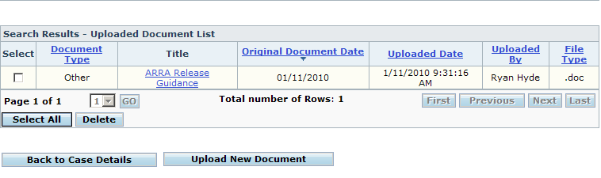

Once a file has been uploaded into a casefile within CWDS it will remain with the case until the case is purged from the system. For documents that were originally electronic staff should delete the document once they have confirmed that it has been successfully uploaded into CWDS.

If another case is opened on the same individual, staff has the ability to Copy an uploaded document from one case to another.
- NOTE: Staff should not reference in a CPN “see previous case”, because if the case is purged the record will also be destroyed orphaning the information staff is referencing within the CPN. Staff should Copy the record into the new case in these situations.
  - To Copy an uploaded document from one case to another, select the document using the Check Box next to the document, select the appropriate case to copy the document to, press the Copy button.
  - NOTE: This feature is only available when multiple cases are present.
To upload a document staff will press the Manage Uploaded Documents button on View Case Details and they will be taken to a new screen that will allow staff to upload new documents and review previously uploaded documents. Staff will have the option to select a type of form to be uploaded from a list of current OVR forms and a list of generic document types. Staff will also be able to add a specific title and a date or date range to the uploaded document.

Staff will be responsible for following a standard naming convention when uploading documents into CWDS to help with consistency and ease of locating documents.

Naming Convention:
OVR Forms:
- If the document to be uploaded is an OVR form staff must select the form type from the OVR Form drop down.

Screenshot of the Upload Document screen within CWDS depicting the dropdown of OVR specific forms.
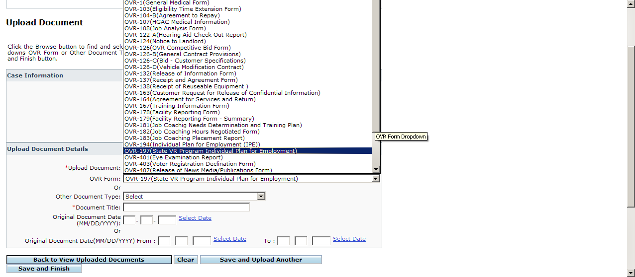
  - Staff would then enter a title for the form to be uploaded
    - The title must follow these rules for OVR Forms:
      - Customer Last Name, First Name for forms that only reference the customer
OR
      - Provider Name for forms that involve a provider
  - Staff would then enter a date or date range for the document based on when the document was signed.
  - The type of document, Title, Original Document Date, Date Uploaded, Staff uploading the document, and File Type will appear in the list of Uploaded documents.
- If the document to be uploaded is a generic medical document staff must select document type from the Other Document Type dropdown that best represents the document to be uploaded.

Screenshot depicting the Upload Document Details Screen and the Other Document Type dropdown
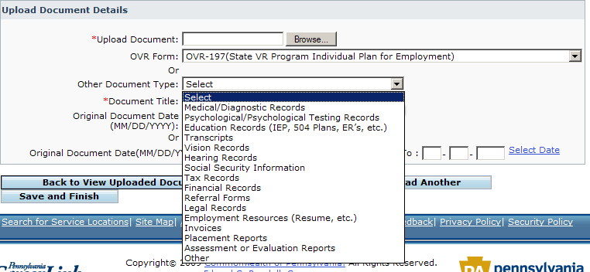
  - Staff would then enter a title
    - The title for the document should clearly establish the document from other documents stored in the file.
      - For document types:
        - Medical/Diagnostic Records
        - Psychological/Psychological Testing Records
        - Vision Records
        - Hearing Records
        - Assessments or Evaluation Reports
      - Staff should use the last name of the primary doctor/therapist/professional so that when searching the records they can be easily differentiated from other records from the same provider.
      - If a document is to large to be scanned as one document, staff should follow the above naming convention and add (Section 1), (Section 2), (Section 3), etc. to the title as applicable to the appropriate document section.
  - Staff would then enter a date or date range from the original document.
  - The type of document, Title, Original Document Date, Date Uploaded, Staff uploading the document, and File Type will appear in the list of Uploaded documents.
- If the document to be uploaded is another type of generic record staff must select document type from the Other Document Type dropdown that best represents the document to be uploaded.
  - Staff would then enter a title
    - The title for the document should clearly establish the document from other documents stored in the file.
      - For document types:
        - Education Records (IEP, 504 Plans, ER’s, etc.)
        - Transcripts
        - Tax Records
        - Financial Records
        - Social Security Information
        - Correspondence
        - Invoice
      - Staff should use the name of the school or agency and the document type, i.e. 504 Plan, IEP, etc. so that when searching the records they can be easily differentiated from other records from the same provider.
      - If a document is too large to be scanned as one document, staff should follow the above naming convention and add (Section 1), (Section 2), (Section 3), etc. to the title as applicable to the appropriate document section.
  - Staff would then enter a date or date range from the original document.
  - The type of document, Title, Original Document Date, Date Uploaded, Staff uploading the document, and File Type will appear in the list of Uploaded documents.
- If the document to be uploaded is a generic record staff must select document type from the Other Document Type dropdown that best represents the document to be uploaded.
  - Staff would then enter a title
    - The title for the document should clearly establish the document from other documents stored in the file.
      - For document types:
        - Employment Resources
        - Placement Record
        - Other
      - Staff should use the customers, last name, first name, for Employment Resources or Placement Records and define the document when using type Other, so that when searching the records they can be easily differentiated from other records from the same provider.
      - If a document is too large to be scanned as one document, staff should follow the above naming convention and add (Section 1), (Section 2), (Section 3), etc. to the title as applicable to the appropriate document section.
  - Staff would then enter a date or date range from the original document.
  - The type of document, Title, Original Document Date, Date Uploaded, Staff uploading the document, and File Type will appear in the list of Uploaded documents.
- Confidentiality
  - Staff who has access to the customers case (View Case Details) will be able to view any documents uploaded into the case.
  - Staff is responsible for ensuring that any document that is uploaded into CWDS is uploaded to the appropriate case/customer.
  - Staff is responsible for ensuring that any document that is uploaded to the wrong case accidentally is removed by a supervisor, manager, or the CWDS help desk immediately.
  - Staff is responsible for immediately deleting any electronic document from their email or hard drive once successfully uploaded to CWDS.
    - It is essential for staff to remove any electronic document that is successfully uploaded into CWDS from their personal Commonwealth machine due to storage, confidentiality and security concerns.
    - Once staff has confirmed that a document has been uploaded successfully they should immediately delete the document from their machine.

For documents that are not essential or not necessary for staff to have online staff should store those records in the Supporting Document Casefile. Staff should follow the guidelines outlined for where in the Supporting Document Casefile the various record types should be stored.

SUPPORTING DOCUMENT CASEFILE:
If a form has been incorporated electronically into CWDS staff is expected to complete the document within CWDS.

Forms requiring data entry into CWDS, but not requiring a wet signature do not need to be stored in the Supporting Documents Casefile. Once the data entry has occurred, the paper version can be destroyed as per local office procedure.

Forms requiring a wet or Digital Signature:

FORM TYPE:  - Employment Planning Application  - VR Financial Needs Test  - ILSS Financial Needs Test  - Time Extension  - Individual Plan for Employment  - State VR Plan  - Instructional Services Plan  - Financial Aid Information Forms  - Agreement for Services and Return  - Agreement to Repay  - Financial Participation Agreement  - Receipt and Agreement  - Receipt of Reusable Equipment  - Voter Registration  - Training Information/Requirements | SIGNATURE REQUIRED:  - Staff/Customer (Digital Available)  - Staff/Customer (Digital Available)  - Staff/Customer (Digital Available)  - Staff/Customer (Digital Available)  - Staff/Customer (Digital Available)  - Staff/Customer (Digital Available)  - Staff/Customer (Digital Available)  - Staff/Customer (Digital Available)  - Staff/Customer (Digital Available)  - Staff/Customer (Digital Available)  - Staff/Customer (Digital Available)  - Staff/Customer (Digital Available)  - Staff/Customer (Digital Available)  - Staff/Customer (Digital Available)  - Staff/Customer (Digital Available)

If a wet signature is required and a digital signature was not captured, the paper form with the wet signature must be stored in the Supporting Document Casefile and can be uploaded based on staff need.

Certain OVR forms legally do not require a written wet signature; however, OVR policy requires a signature to be obtained. These signatures are based on business requirements and often involve a third party i.e. Provider or Employer; as a result, the ability to capture a digital signature is not currently available.

The following forms are available to be completed electronically within CWDS, but do not allow for digital signatures. As a result staff must obtain a wet signature on these forms and enter the information into CWDS for reporting purposes:

FORM TYPE:  - On The Job Training Contract  - Job Coaching Needs Determination  - Job Coaching Hours Negotiated  - Job Coaching Placement Report | SIGNATURE REQUIRED:  - Staff/Customer/Employer  - Staff/Customer/Provider  - Staff/Customer/Provider  - Staff/Customer/Provider

Supporting Document Casefile Storage:
All cases in statuses prior to Status 06 should use manila folders. Paper documents should be kept in chronological order, most recent information on the top, in manila folders. If a case has not been created yet, staff will need to use the Participant Identification Number (PID) instead of the Case Identification Number (CID). Once a case has been created, staff must use the Case Identification Number on the Supporting Document Casefile. Under no circumstance should the participants Social Security Number (SSN) be used as a unique identifier on the Supporting Document Casefile.

All paper documents are punched on the left side and filed in the appropriate section of the Blue file folder at the time of the customer’s eligibility for VR services (Status 06 or 10). Use Blue folders for all eligible cases in Statuses 06, 10, 11, or higher.

Always file key documents that are not electronic in the supporting documents casefile within the appropriate section. Only Section 5, Miscellaneous, does not contain a key document. These key documents head sections to facilitate the location of essential information. File all other information in the Supporting Document Casefile in the appropriate section in chronological order, most recent information on top.

Use only 8 1/2" x 11" white paper in the Supporting Document Casefile. Odd sized forms must be attached to 8 1/2" x 11" paper to ensure that documents are secured within the folder and not lost.

Supporting Document Casefile Sections (Blue Folder):

Section 1 is the first section on the left when opening the case file. This section primarily contains the Agreement to Repay and Eligibility Waiver when not signed digitally. This section will also contain any Releases of Information. Releases of information should be stored in chronological order, newest to oldest beneath any other OVR form designated for this section.

Section 2 is adjacent and to the right of Section 1. Section 2 includes medical and diagnostic information and forms used in connection with this information when not uploaded. Medical documentation should be filed in chronological order, newest to oldest within this section. Only records that contain information useful to the individual’s rehabilitation should be stored. If a document is 50 pages, but only 5 pages contain information useful to the case, only the 5 pages that are useful should be stored in the Supporting Document Casefile or uploaded. The other pages that are not useful to the case can be destroyed as per local office procedure.

Section 3 is on the left of the case file behind Section 2. This section contains any information related to training that the customer has received that has not been uploaded (i.e. OVR 169’s, reports, transcripts, grade summaries, course schedules, releases for grades, etc.).
- The OVR 169 must be entered into CWDS to complete the calculations and generate service authorizations. However, since the customer must sign the OVR 169 on paper the paper copy must be stored within the Supporting Document Casefile and can be uploaded into CWDS using the Upload function.

Section 4 is adjacent and to the right of Section 3. The original OVR-194 IPE form is usually the top form in this section. The original OVR-194 IPE form remains on top followed by any IPE Amendment(s) for documents not signed digitally or uploaded. Other information pertaining to or regarding the customer or their disability should be filed chronologically beneath the OVR-194. Emails should be treated as printed records and are bound by all the same confidentiality guidance and ethical standards as paper documents. See Numbered Memorandum 210.13 Email Records for additional information.

NOTE: Printing CPN’s from CWDS for storage in the Supporting Documents case is not necessary. CPN’s will be stored electronically in CWDS. All CPN’s are required to be entered into CWDS.

Section 5 contains miscellaneous information and is on the left of the case file behind Section 3. Placement and Social Security Administration (SSA) related documents can be stored in this section.

Section 6 contains fiscal information and the OVR-105 FNT form when not signed digitally. The OVR-105 should be on top. Additional fiscal information should be stored below the OVR 105. Service Authorizations and Invoices will be entered into CWDS. If paper Invoices were received, they must be stored in chronological order in the Supporting Documents Casefile and can be uploaded when appropriate.

NOTE: All bids sent to and/or received back from vendors must be kept in the supporting document file.

NOTE: The Supporting Document IL or SS Casefile will be contained within the IL/SS Handbook that is being updated. Staff should continue to file IL/SS cases as prior guidance dictates.

