Developing a Model Comprehensive Statewide Needs Assessment With Corresponding Training Materials For State VR Agency Staff and SRC Members:
The VR Needs Assessment Guide
Volume II - Appendices

Submitted to:
Rehabilitation Services Administration
Janette Shell, COR

Submitted by:
InfoUse
2560 9th Street, Suite 320
Berkeley, CA 94710

November 30, 2009

This report was produced under U.S. Department of Education Contract No. ED04CO0106 with InfoUse. Janette Shell served as the contracting officer’s technical representative. The views expressed herein do not necessarily represent the positions or policies of the Department of Education. No official endorsement by the U.S. Department of Education of any product, commodity, service or enterprise mentioned in this publication is intended or should be inferred.

Appendices Contents
Appendix A: Disability Population Statistics A-1
American Community Survey (ACS) A-1
Examples of available ACS state and sub-state data A-3
Current Population Survey (CPS) A-14
Behavioral Risk Factor Surveillance Survey (BRFSS) Brief Description A-15
How to Use the BRFSS A-16
Examples of BRFSS Disability Questions A-17
Appendix B: Disability Population Estimates B-1
Estimating Subpopulations of Disabilities B-6
Appendix C: Projections of State Population and Labor and Economic Forecasts C-1
Population Projections C-1
Examples of Population Projection Data Available for All States C-1
Examples of Recent Population Projections Available for Some States C-3
Employment and labor force forecasts C-4
Examples of Available Data C-5
Other Sources of Data on Labor and Economic Projections C-6
Appendix D: VR Agency Data D-1
VR program data examples and required state reports D-1
VR Counselors and staff stakeholder surveys and interviews D-7
Appendix E: State-level Data from National Programs E-1
Individuals with Disabilities Education Act (IDEA) E-1
IDEA Data Examples E-2
Section 504 Data E-6
Section 504 Data Example E-7
Social Security Data E-7
Social Security Data Examples E-9
Workforce Investment Act (WIA) Data E-12
Appendix F: State and Sub-state Reports and Other Materials F-1
State and Sub-state Reports and Other Materials F-1
Appendix G: Input from Stakeholders G-1
Surveys G-1
Focus Groups G-3
Key Informant Interviews G-5
Community hearings G-6
Appendix H: Minorities and Unserved or Underserved Groups H-1
Examples of Potentially Unserved or Underserved Groups H-2
Appendix I – Literature Review I-1
Conclusions I-4
Appendix J – Reviews of State Needs Assessments J-1

Appendix A: Disability Population Statistics
In order to assess the rehabilitation needs of people with disabilities at the state level it is essential to gain an overall picture of the distribution and characteristics of the population of people with disabilities in the state. The American Community Survey (ACS) provides existing state and substate data on disability and other demographic characteristics of the state population. For the Comprehensive Statewide Needs Assessment (CSNA) the ACS provides estimates of the disability population, employment, and language spoken. Starting in 2009 the Current Population Survey (CPS) will provide another source of data that will use the ACS questions of disability together with labor force questions. The Behavioral Risk Factor Surveillance System (BRFSS) is an optional method that includes an existing sampling frame for gathering more in-depth state-level data from a representative sample of people with disabilities in the state.

American Community Survey
The ACS is an annual survey of social, economic, housing and demographic characteristics, including disability. The ACS is the largest household survey in the United States, with an annual sample size of about 3 million addresses. The ACS was developed to replace the long form of the Decennial Census, which provided detailed information on geographical areas every 10 years. The ACS, however, can provide single-year estimates each year for geographic population areas of 65,000 or more people and will accumulate 3- and 5-year samples to produce estimates for smaller geographic areas, including census tracts and block groups (U.S. Census Bureau, 2008c). The ACS will provide 3-year-period estimates for areas with populations of 20,000 or more starting in 2008 and 5-year estimates in 2010 (U.S. Census Bureau, 2008c). In 2006 data collection began in group quarters, which include institutions such as correctional facilities and nursing homes as well as group living situations such as college dormitories and group homes (U.S. Census Bureau, 2008c). The ACS supports state and community planning by providing the information for local geographic units. Full implementation of the ACS began in 2005 in every county nationwide. Data products for the 2007 survey were released in late 2008.
The ACS provides:
- an overall picture of disability;
- demographic characteristics of the state;
- substate regions, such as metropolitan areas, larger counties, and other geographic areas;
- languages other than English that are spoken in the state; and
- most significant disability, depending on how a state defines most significant (e.g., self-care disabilities, people with two or more ACS disabilities, and people who receive SSI and/or SSDI).
There are three major sources to obtain information about the disability population from the ACS.
American FactFinder. The American FactFinder Web site <http://factfinder.census.gov> includes data from the ACS as well as other Census surveys. The Web site includes technical information on the data, the survey questionnaire, updates on technical questions, the public use data sets, and pre-designed tables and maps that can be obtained for state and substate levels (substate population units of 65,000 and above for 2007 ACS).
The American FactFinder Web site includes a number of ways to access information from the ACS. The following national, state and substate tables and maps are most pertinent to the CSNA:
- Data Profile (quick snapshot of the state in terms of population, types of households, marital status, fertility, school enrollment, educational attainment, veteran status, disability status, place of birth, and language spoken)
- Subject Tables – Disability
- Disability Characteristics (Table S1801). This table includes population by age group by sensory, physical, mental, self-care, go-outside-house and employment disabilities. A sample S1801 table is included below.
- Selected Economic Characteristics for the Civilian Non-institutionalized Population By Disability Status (Table S1802). This table includes information on people with and without disabilities, 16 years and over, including: employed, not in labor force, class of worker (private, government, self-employed, etc.), occupation, industry, method of commuting to work, educational attainment (25 years and older), earnings in past 12 months, and poverty status in past 12 months. A sample S1802 table is included below.
- Characteristics of People by Language Spoken at Home (Table S1603). A sample S1603 table is included below.
- Language Spoken at Home (S1601). A sample S1601 table is included below.
- Ranking Tables – Disability
- Percent of People 21 to 64 Years Old With a Disability (R1802). This table lists in rank order, from highest to lowest, the percent of people in each state age 21-64 with a disability as well as the percent for the entire U.S.
- Detailed Tables (all of the disability tables are listed below)
- The American FactFinder Web site also allows users to download Public Use Microdata Sample (PUMS) files, which are a sample of the actual responses to the American Community Survey and include most population and housing characteristics. These files provide users with the flexibility to prepare customized tabulations and can be used for detailed research and analysis. Files have been edited to protect the confidentiality of all individuals and of all individual households. For an overview of the file, please see: <http://www.census.gov/acs/www/Products/PUMS/index.htm> (U.S. Census Bureau, 2008a).
All tables can be downloaded and saved in a various formats including comma separated and Excel.

Examples of available ACS state and substate data
American FactFinder:
Table on disability characteristics S1801.
The American FactFinder subject table, S1801, includes summary information about the characteristics of the disability population. Table S1801 is available for state and substate areas. This table includes:
- percentage of the total population that has no disability, one disability, and two or more disabilities;
- percentage of the working-age (16-64 years) population that has any disability, sensory, physical, mental, go-outside-home, self care and employment disabilities; and
- the number and percentage that are employed among working-age people (16-64 years) with any disability and each of the six disabilities mentioned above.

Table S1801 also includes information on poverty status and other demographics.
Exhibit A-1 shows a screen shot of Table S1801 for Oregon as an example. The exhibit shows the total population 5 years and over (as well as male and female), and percents for those with and without any disability, with one type of disability, and with two or more types of disabilities. The table also contains population totals and male and female totals for the population 5-15 years, 16-64 years, and 65 and over, along with percentages for with any disability, with a sensory disability, with a physical disability, with a mental disability, with a self-care disability, with a go-outside the home disability (for the latter two age groupings), and with an employment disability (for the 16-64 year age group).

Exhibit A-1 Table S1801, Disability Characteristics, for Oregon, 2007American Community Survey
Oregon
S1801: Disability Characteristics
Data Set: 2007 American Community Survey 1-Year Estimates
Geographic Area: Oregon
NOTE. For information on confidentiality protection, sampling error, nonsampling error, and definitions, see Survey Methodology.
Subject | Total | Margin of Error | Male | Margin of Error | Female | Margin of Error
Population 5 years and over | 3,468,683 | +/-1,641 | 1,708,927 | +/-3,471 | 1,759,756 | +/-3,265
Without any disability | 83.6% | +/-0.3 | 84.0% | +/-0.4 | 83.2% | +/-0.4
With one type of disability | 7.3% | +/-0.2 | 7.6% | +/-0.3 | 7.1% | +/-0.3
With two or more types of disabilities | 9.1% | +/-0.3 | 8.4% | +/-0.4 | 9.7% | +/-0.3
Population 5 to 15 years | 524,043 | +/-3,963 | 269,856 | +/-2,673 | 254,187 | +/-3,038
With any disability | 7.0% | +/-0.7 | 8.7% | +/-0.9 | 5.2% | +/-0.8
With a sensory disability | 1.0% | +/-0.2 | 1.0% | +/-0.3 | 1.1% | +/-0.3
With a physical disability | 1.1% | +/-0.2 | 1.1% | +/-0.3 | 1.1% | +/-0.4
With a mental disability | 5.9% | +/-0.6 | 7.5% | +/-0.9 | 4.3% | +/-0.8
With a self-care disability | 1.0% | +/-0.2 | 1.1% | +/-0.3 | 0.8% | +/-0.3
Population 16 to 64 years | 2,470,203 | +/-4,099 | 1,229,431 | +/-3,336 | 1,240,772 | +/-3,514
With any disability | 13.5% | +/-0.4 | 13.5% | +/-0.5 | 13.6% | +/-0.5
With a sensory disability | 3.3% | +/-0.2 | 3.9% | +/-0.3 | 2.7% | +/-0.3
With a physical disability | 7.9% | +/-0.3 | 7.5% | +/-0.4 | 8.2% | +/-0.4
With a mental disability | 5.5% | +/-0.3 | 5.4% | +/-0.3 | 5.5% | +/-0.4
With a self-care disability | 2.2% | +/-0.2 | 2.0% | +/-0.2 | 2.4% | +/-0.2
With a go-outside-home disability | 3.3% | +/-0.2 | 2.7% | +/-0.2 | 3.9% | +/-0.3
With an employment disability | 7.8% | +/-0.3 | 7.4% | +/-0.4 | 8.1% | +/-0.4
Population 65 years and over | 474,437 | +/-2,315 | 209,640 | +/-2,025 | 264,797 | +/-1,829
With any disability | 42.2% | +/-1.0 | 40.5% | +/-1.5 | 43.4% | +/-1.2
With a sensory disability | 17.7% | +/-0.7 | 20.1% | +/-1.0 | 15.9% | +/-1.0
With a physical disability | 31.9% | +/-0.9 | 28.6% | +/-1.4 | 34.6% | +/-1.2
With a mental disability | 13.9% | +/-0.7 | 12.2% | +/-1.1 | 15.3% | +/-1.0
With a self-care disability | 10.6% | +/-0.8 | 8.6% | +/-1.0 | 12.2% | +/-0.9
With a go-outside-home disability | 17.0% | +/-0.8 | 12.4% | +/-1.2 | 20.6% | +/-1.0
EMPLOYMENT STATUS
Population 16 to 64 years | 2,470,203 | +/-4,099 | 1,229,431 | +/-3,336 | 1,240,772 | +/-3,514
With any disability | 333,755 | +/-9,162 | 165,469 | +/-6,513 | 168,286 | +/-6,412
Employed | 40.3% | +/-1.6 | 43.3% | +/-2.1 | 37.4% | +/-2.1
With a sensory disability | 80,318 | +/-5,178 | 47,356 | +/-3,518 | 32,962 | +/-3,605
Employed | 50.8% | +/-3.0 | 52.9% | +/-3.8 | 47.8% | +/-4.0
With a physical disability | 193,961 | +/-7,501 | 92,157 | +/-5,075 | 101,804 | +/-4,648
Employed | 35.5% | +/-1.9 | 38.2% | +/-2.7 | 33.1% | +/-2.4
With a mental disability | 134,654 | +/-6,313 | 66,625 | +/-4,073 | 68,029 | +/-4,366

Table on disability employment and other economic characteristics S1802.
The second relevant subject table in the American FactFinder is Table S1802, which summarizes selected economic characteristics of the population by disability status. This table is available by state and for substate population areas of 65,000 or more. This table includes:
- For the population 16 years and over, how many and what percentage are employed and how many and what percentage are not in the labor force (neither working, not looking for work) with a disability and no disability?
- What is the educational attainment of the population 25 years and over with a disability and no disability?
- What are the earnings of people 16 years and over with a disability and no disability?
Table S1802 also provides information on classes, occupations and industries of workers with and without disabilities, the means of commuting to work for workers with and without disabilities, and the poverty status for people 16 years and over, with and without disabilities.
An example from Table S1802 for the state of Kansas is shown below in Exhibit A-2. The exhibit shows portions of the table that contain information about the total civilian noninstitutionalized population age 16 and over and columns for the population with and without a disability along with percentages for those employed and those not in the labor force and the resulting total number of those employed age 16 and over. A second portion of the exhibit shows the population age 25 and over, and columns for the population with and without a disability, along with percentages of educational attainment as less than high school graduate, high school graduate (includes equivalency), some college or associate’s degree, and bachelor’s degree or higher. Also shown are the earnings in the past 12 months (in 2007 inflation adjusted dollars) for the population age 16 and over with earnings with percentages for those earning $1-$9,999 or less, $10,000-$14,999, $15,000-$24,999, $25,000-$34,999, $35,000-$49,999, $50,000-$74,999, and $75,000 or more.

Exhibit A-2 Table S1802, Selected Economic Characteristics, Kansas, 2007 American Community Survey
Kansas
S1802: Selected Economic Characteristics for the Civilian Noninstitutionalized Population By Disability Status
Data Set: 2007 American Community Survey 1-Year Estimates
Survey: American Community Survey
NOTE. For information on confidentiality protection, sampling error, nonsampling error, and definitions, see Survey Methodology.
Subject | Total Civilian Noninstitutionalized Population | Margin of Error | With a Disability | Margin of Error | No Disability | Margin of Error
Population Age 16 and Over | 2,104,682 | +/-3,650 | 339,688 | +/-6,456 | 1,764,994 | +/-7,586
EMPLOYMENT STATUS
Employed | 66.5% | +/-0.5 | 29.7% | +/-1.0 | 73.6% | +/-0.5
Not in Labor Force | 29.9% | +/-0.4 | 66.1% | +/-1.2 | 23.0% | +/-0.4
Employed Population Age 16 and Over | 1,399,842 | +/-10,434 | 100,952 | +/-4,134 | 1,298,890 | +/-10,051
CLASS OF WORKER
Private for-profit wage and salary workers | 68.5% | +/-0.6 | 61.1% | +/-2.3 | 69.0% | +/-0.6
Employee of private company workers | 65.2% | +/-0.6 | 59.3% | +/-2.3 | 65.6% | +/-0.6
Self-employed in own incorporated business workers | 3.3% | +/-0.2 | 1.8% | +/-0.5 | 3.4% | +/-0.2
Private not-for-profit wage and salary workers | 7.6% | +/-0.3 | 10.5% | +/-1.4 | 7.4% | +/-0.3
Local government workers | 8.1% | +/-0.3 | 7.7% | +/-1.3 | 8.1% | +/-0.3
State government workers | 5.8% | +/-0.3 | 7.7% | +/-1.1 | 5.6% | +/-0.3
Federal government workers | 2.6% | +/-0.2 | 3.3% | +/-0.7 | 2.6% | +/-0.2
Self-employed in own not incorporated business workers | 7.1% | +/-0.3 | 9.2% | +/-1.2 | 7.0% | +/-0.3
Unpaid family workers | 0.3% | +/-0.1 | 0.5% | +/-0.3 | 0.3% | +/-0.1
OCCUPATION
Management, professional, and related occupations | 35.4% | +/-0.7 | 26.9% | +/-1.9 | 36.0% | +/-0.7
Service occupations | 15.9% | +/-0.5 | 21.5% | +/-2.0 | 15.5% | +/-0.5
Sales and office occupations | 24.7% | +/-0.6 | 23.6% | +/-2.1 | 24.7% | +/-0.6
Farming, fishing, and forestry occupations | 0.8% | +/-0.1 | 1.0% | +/-0.5 | 0.8% | +/-0.1
Construction, extraction, maintenance, and repair occupations | 9.1% | +/-0.4 | 8.5% | +/-1.2 | 9.2% | +/-0.4
Production, transportation, and material moving occupations | 14.1% | +/-0.5 | 18.5% | +/-1.4 | 13.8% | +/-0.5
INDUSTRY
Agriculture, forestry, fishing and hunting, and mining | 3.5% | +/-0.2 | 4.7% | +/-0.8 | 3.4% | +/-0.2
Construction | 6.4% | +/-0.3 | 5.9% | +/-1.0 | 6.4% | +/-0.4
Manufacturing | 13.9% | +/-0.4 | 13.6% | +/-1.6 | 14.0% | +/-0.5
Wholesale trade | 3.1% | +/-0.2 | 2.4% | +/-0.7 | 3.2% | +/-0.2
Retail trade | 10.9% | +/-0.5 | 12.0% | +/-1.5 | 10.8% | +/-0.5
Transportation and warehousing; utilities | 5.3% | +/-0.3 | 6.4% | +/-1.1 | 5.2% | +/-0.3
Information | 2.9% | +/-0.2 | 2.7% | +/-0.8 | 3.0% | +/-0.2
Finance and insurance; real estate, rental and leasing | 6.1% | +/-0.3 | 2.8% | +/-0.7 | 6.4% | +/-0.3
ACS PUMS data. While the ACS tables provide a valuable resource for state and substate disability measures, these estimates do not specifically identify the subpopulation that would be eligible for VR services. The ACS estimate that might best provide a measure of the population in need of VR services would be the population with a disability in the state that is not currently employed and is looking for work (in the labor force, not employed.) However, this subgroup is not identified specifically in the available ACS tables. The ACS Public Use Microdata Samples (PUMS) is available in the FactFinder and may be used to conduct custom analyses from ACS data.
Tables on racial and ethnic minorities. There are a number of possible sources for data on racial and ethnic minorities by disability from the ACS, including American FactFinder, the Cornell Disability Statistics Web site and the Center for Personal Assistance Services (PAS) Web site. American FactFinder provides data from which a table may be constructed that shows the number of people with disabilities, ages 16 to 64 years, who are not employed, by racial and ethnic group.
The following sample table (Exhibit A-3) was constructed using data from 10 different American FactFinder tables - C18020, C18020A, C18020B, C18020C, C18020D, C18020E, C18020F, C18020G, C18020H, C18020I. These tables provide data on noninstitutionalized people with a disability and not employed in Oregon, ages 16 – 64 years, by race and ethnicity, estimates from the 2006 American Community Survey:

Exhibit A-3 Sample Table, Number and Percentage of People with a Disability who are not Employed, Oregon 2006 ACS
ACS OREGON 2006 | With a disability and not employed (Thousands) | Percentage of total with a disability and not employed
Total (16 - 64 years) | 198 | 100.0%
Race (16 - 64 years)
White | 172 | 87.1%
African American | 5 | 2.5%
Asian/Pacific Islander | 4 | 1.8%
American Indian/Alaska Native | 4 | 2.0%
Some other race(s) | 4 | 1.9%
Two or more races | 9 | 4.6%
Ethnicity (16 - 64 years)
Hispanic | 11 | 5.7%

This table provides a means to compare the ethnic and racial composition of people with disabilities in the state overall and those who are not employed to identify need for employment services.
Tables on languages spoken. American FactFinder includes a number of tables that have information on languages spoken. For example, Table S1601 is a table on languages spoken at home and Table S1603 presents information on characteristics of people by languages spoken at home. American FactFinder also includes other geographical comparison tables (GCT) and ranking tables on languages spoken at home that provide additional information and comparisons. Table B16001, “Language spoken at home by ability to speak English for the population 5 years and older” presents information about the number of people in the state who speak languages other than English at home, which languages they speak and how many speak English “less than very well.” Exhibit A-4 shows a portion of a sample table for New York:

Exhibit A-4 Table B16001, Languages Spoken at Home by Ability to Speak English, New York, 2007 ACS
B16001. LANGUAGE SPOKEN AT HOME BY ABILITY TO SPEAK ENGLISH FOR THE POPULATION 5 YEARS AND OVER - Universe: POPULATION 5 YEARS AND OVER
Data Set: 2007 American Community Survey 1-Year Estimates
Survey: American Community Survey
NOTE. Although the American Community Survey (ACS) produces population, demographic and housing unit estimates, it is the Census Bureau's Population Estimates Program that produces and disseminates the official estimates of the population for the nation, states, counties, cities and towns and estimates of housing units for states and counties.
For information on confidentiality protection, sampling error, nonsampling error, and definitions, see Survey Methodology.
 | New York
 | Estimate | Margin of Error
Total: | 18,097,578 | +/-2,470
Speak only English | 12,868,476 | +/-34,152
Spanish or Spanish Creole: | 2,556,829 | +/-15,994
Speak English "very well" | 1,345,191 | +/-17,937
Speak English less than "very well" | 1,211,638 | +/-19,001
French (incl. Patois, Cajun): | 134,405 | +/-8,654
Speak English "very well" | 96,083 | +/-6,833
Speak English less than "very well" | 38,322 | +/-4,384
French Creole: | 140,275 | +/-11,554
Speak English "very well" | 90,930 | +/-8,060
Speak English less than "very well" | 49,345 | +/-5,658
Italian: | 234,697 | +/-10,305
Speak English "very well" | 158,378 | +/-7,864
Speak English less than "very well" | 76,319 | +/-4,852
Portuguese or Portuguese Creole: | 43,130 | +/-5,838
Speak English "very well" | 24,339 | +/-4,304
Speak English less than "very well" | 18,791 | +/-3,593
German: | 64,761 | +/-4,422
Speak English "very well" | 53,245 | +/-4,041
Speak English less than "very well" | 11,516 | +/-1,808
Yiddish: | 124,722 | +/-11,122
Speak English "very well" | 83,863 | +/-9,346
Speak English less than "very well" | 40,859 | +/-5,327
Other West Germanic languages: | 14,027 | +/-2,576
Speak English "very well" | 10,572 | +/-1,967
Speak English less than "very well" | 3,455 | +/-1,335
Scandinavian languages: | 8,875 | +/-1,794
Speak English "very well" | 7,407 | +/-1,473
Speak English less than "very well" | 1,468 | +/-717
Greek: | 72,818 | +/-8,690
Speak English "very well" | 48,754 | +/-6,792
Speak English less than "very well" | 24,064 | +/-3,443
Russian: | 226,535 | +/-13,435
Speak English "very well" | 97,354 | +/-9,252
Speak English less than "very well" | 129,181 | +/-7,598
Once downloaded, this table may be sorted by the linguistic groups that speak English less than very well to determine which groups may have the most need for materials and services in their native language. The language tables also are available by substate regions, which can assist in planning for local needs.
List of Additional Disability Tables Available at American FactFinder. The 2007 Data Products Details (U.S. Census Bureau, 2008b) lists 45 tables concerning disability that are available in American FactFinder and shown in the list below. These tables are available by state and substate regions. There are also other tables that are expanded or condensed versions of these tables. For example Table C18001 is a condensed version of Table B18001 (the first table listed below). C18001 contains the same basic information as B18001 but with less disaggregation by age group.

Exhibit A-5 Tables on Disability in American FactFinder
B18001 | Sex by Age by Number of Disabilities for the Civilian Noninstitutionalized Population 5 Years and Over
B18002 | Sex by Age by Disability Status for the Civilian Noninstitutionalized Population 5 Years and Over
B18003 | Sex by Age by Sensory Disability for the Civilian Noninstitutionalized Population 5 Years and Over
B18004 | Sex by Age by Physical Disability for the Civilian Noninstitutionalized Population 5 Years and Over
B18005 | Sex by Age by Mental Disability for the Civilian Noninstitutionalized Population 5 Years and Over
B18006 | Sex by Age by Self-Care Disability for the Civilian Noninstitutionalized Population 5 Years and Over
B18007 | Sex by Age by Go-Outside-Home Disability for the Civilian Noninstitutionalized Population 16 Years and Over
B18008 | Sex by Age by Employment Disability for the Civilian Noninstitutionalized Population 16 to 64 Years
B18010 | Disability Status by School Enrollment and Educational Attainment for the Civilian Noninstitutionalized Population 18 to 34 Years
B18011 | Sensory Disability by School Enrollment and Educational Attainment for the Civilian Noninstitutionalized Population 18 to 34 Years
B18012 | Physical Disability by School Enrollment and Educational Attainment for the Civilian Noninstitutionalized Population 18 to 34 Years
B18013 | Mental Disability by School Enrollment and Educational Attainment for Civilian Noninstitutionalized Population 18 to 34 Years
B18014 | The Self-Care Disability by School Enrollment and Educational Attainment for the Civilian Noninstitutionalized Population 18 to 34 Years
B18015 | Go-Outside-Home Disability by School Enrollment and Educational Attainment for the Civilian Noninstitutionalized Population 18 to 34 Years
B18016 | Employment Disability by School Enrollment and Educational Attainment for the Civilian Noninstitutionalized Population 18 to 34 Years
B18020 | Disability Status by Sex by Age by Employment Status for the Civilian Noninstitutionalized Population 16 to 64 Years
B18020A | Disability Status by Sex by Age by Employment Status for the Civilian Noninstitutionalized Population 16 to 64 Years (White Alone)
B18020B | Disability Status by Sex by Age by Employment Status for the Civilian Noninstitutionalized Population 16 to 64 Years (Black or African American Alone)
B18020C | Disability Status by Sex by Age by Employment Status for the Civilian Noninstitutionalized Population 16 to 64 Years (American Indian and Alaska Native)
B18020D | Disability Status by Sex by Age by Employment Status for the Civilian Noninstitutionalized Population 16 to 64 Years (Asian Alone)
B18020E | Disability Status by Sex by Age by Employment Status for the Civilian Noninstitutionalized Population 16 to 64 Years (Native Hawaiian and Other Pacific Islander Alone)
B18020F | Disability Status by Sex by Age by Employment Status for the Civilian Noninstitutionalized Population 16 to 64 Years (Some Other Race Alone)
B18020G | Disability Status by Sex by Age by Employment Status for the Civilian Noninstitutionalized Population 16 to 64 Years (Two Or More Races)
B18020H | Disability Status by Sex by Age by Employment Status for the Civilian Noninstitutionalized Population 16 to 64 Years (White Alone, Not Hispanic or Latino)
B18020I | Disability Status by Sex by Age by Employment Status for the Civilian Noninstitutionalized Population 16 to 64 Years (Hispanic or Latino)
B18021 | Sensory Disability by Sex by Age by Employment Status for the Civilian Noninstitutionalized Population 16 to 64 Years
B18022 | Physical Disability by Sex by Age by Employment Status for the Civilian Noninstitutionalized Population 16 to 64 Years
B18023 | Mental Disability by Sex by Age by Employment Status for the Civilian Noninstitutionalized Population 16 to 64 Years
B18024 | Self-Care Disability by Sex by Age by Employment Status for the Civilian Noninstitutionalized Population 16 to 64 Years
B18025 | Go-Outside-Home Disability by Sex by Age by Employment Status for the Civilian Noninstitutionalized Population 16 to 64 Years
B18026 | Sex by Age by Employment Disability by Employment Status for the Civilian Noninstitutionalized Population 16 to 64
B18030 | Disability Status by Sex by Age by Poverty Status for the Civilian Noninstitutionalized Population 5 Years and Over
B18031 | Sensory Disability by Sex by Age by Poverty Status for the Civilian Noninstitutionalized Population 5 Years and Over
B18032 | Physical Disability by Sex by Age by Poverty Status for the Civilian Noninstitutionalized Population 5 Years and Over
B18033 | Mental Disability by Sex by Age by Poverty Status for the Civilian Noninstitutionalized Population 5 Years and Over
B18034 | Self-Care Disability by Sex by Age by Poverty Status for the Civilian Noninstitutionalized Population 5 Years and Over
B18035 | Go-Outside-Home Disability by Sex by Age by Poverty Status for the Civilian Noninstitutionalized Population 16 Years and Over
B18036 | Employment Disability by Sex by Age by Poverty Status for the Civilian Noninstitutionalized Population 16 To 64 Years
B18040 | Median Earnings in the Past 12 Months (in 2006 Inflation-Adjusted Dollars) by Disability Status by Sex for the Civilian Noninstitutionalized Population 16 Years and Over With Earnings
B18041 | Median Earnings in the Past 12 Months (in 2006 Inflation-Adjusted Dollars) by Sensory Disability by Sex for the Civilian Noninstitutionalized Population 16 Years and Over With Earnings
B18042 | Median Earnings in the Past 12 Months (in 2006 Inflation-Adjusted Dollars) by Physical Disability by Sex for the Civilian Noninstitutionalized Population 16 Years and Over With Earnings
B18043 | Median Earnings in the Past 12 Months (in 2006 Inflation-Adjusted Dollars) by Mental Disability by Sex for the Civilian Noninstitutionalized Population 16 Years and Over With Earnings
B18044 | Median Earnings in the Past 12 Months (in 2006 Inflation-Adjusted Dollars) by Self-Care Disability by Sex for the Civilian Noninstitutionalized Population 16 Years and Over With Earnings
B18045 | Median Earnings in the Past 12 Months (in 2006 Inflation-Adjusted Dollars) by Go-Outside-Home Disability by Sex for the Civilian Noninstitutionalized Population 16 Years and Over With Earnings
B18046 | Median Earnings in the Past 12 Months (in 2006 Inflation-Adjusted Dollars) by Employment Disability by Sex for the Civilian Noninstitutionalized Population 16 to 64 Years With Earnings

Cornell’s Research and Rehabilitation Training Center (RRTC) on Disability Demographics publishes disability Status Reports by state based on ACS data and maintains a Disability Statistics Web site: <http://www.ilr.cornell.edu/edi/DisabilityStatistics/> with interactive ACS tables as well as online versions of the Status Reports (Erickson & Lee, 2008).
Interactive tables on employment and other demographic characteristics of people with disabilities. The Cornell Disability Statistics Web site provides interactive tables based on ACS PUMS data, which complement the information that is available from the American FactFinder. In particular, the Cornell tables provide information on employment rates of people with and without disability, by gender, type of disability, age group, race, ethnicity, and education level. The tables show either number of people or percentage. The Cornell tables are available by accessing the Web site and choosing the variables of interest to create the interactive tables.
For example, the Cornell interactive tables provide information about employment rates among people who have achieved different levels of educational attainment within the working age population, aged 21-64 years. Exhibit A-8 shows an example interactive table with information on the percentage of people with disabilities who have an educational attainment of less than high school and are employed. (Information is displayed for a number of states.)

Exhibit A-8 Cornell Disability Statistics Center Interactive Table, Employment Rate, People with a Disability Aged 21-64 Years, with Less than High School Education
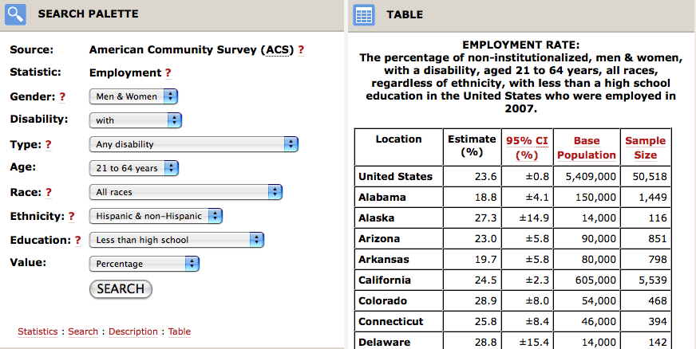

Disability Status Reports. The Cornell RRTC on Disability Demographics also publishes annual status reports by state that are based on ACS data. The reports are published in hard copy and also may be downloaded from the Web site <http://www.ilr.cornell.edu/edi/DisabilityStatistics/index.cfm>. The Disability Status Reports provide another means of obtaining ACS data.
Disability Planning Data for Planners Web site. Another product of the Cornell RRTC is this Web site, created by InfoUse, that is intended to provide local planning data for municipal and regional planners. It provides state and county level ACS number and percentage estimates from the 2005-2007 pooled PUMS data set, including labor force participation variables for those age 16-64 (employed, in the labor force – not employed, and in the labor force). <http://disabilityplanningdata.com/>
University of California at San Francisco’s Research and Rehabilitation Training Center on Personal Assistance Services (Center for PAS) provides tables by state that are based on the ACS and focus on the need for personal care. The tables are available at: <http://www.pascenter.org/state_based_stats/disability_statistics.php>
These tables are especially helpful for obtaining more detailed information about the population with “self-care” disability in the state such as characteristics of age, race, ethnicity, family income, benefit recipiency, employment (for ages 18-64) and living arrangement (alone, with others) for people without disability, with disability, and with a “self-care” disability. In the ACS, people with a self-care disability are those who had difficulty dressing, bathing or getting around inside the home because of a physical, mental, or emotional condition lasting six months or more. Depending on a state’s definition of most significant disability, information on those with self-care disabilities may assist in answering questions about the needs of people with most significant disability. The state disability tables at the Center for PAS include: disability type, gender, age, race, ethnicity, family income, benefit recipiency, employment (ages 18-64 years) and living arrangement. All of these variables are shown for the population, number with a disability, percent with a disability, number with a self-care difficulty, and percent with a self-care disability.
Exhibit A-9 shows a portion of a table for Nebraska, based on ACS 2005 data.

Exhibit A-9 Center for PAS Nebraska Disability Data Table from 2005 ACS
Nebraska Disability Data Table From the 2005 American Community Survey
Estimates for 2005
An estimated 229,000 people in Nebraska have a disability, or 14.4 percent of the population age 5 and over. An estimated 34,000 people, or 2.1 percent of the population 5 and over, have difficulty performing self-care activities, also known as Activities of Daily Living, such as dressing, bathing, or getting around inside the home.
Subject | Population (Thousands) | With a disability (Thousands) | With a disability (Percent) | With a self-care difficulty (Thousands) | With a self-care difficulty (Percent)
Total in Nebraska (ages 5 and over) | 1,586 | 229 | 14.4% | 34 | 2.1%
Disability Type
Sensory |  | 69 |  | 11 | 15.5%
Mobility |  | 128 |  | 29 | 22.8%
Cognitive |  | 74 |  | 17 | 22.8%
Self-care |  | 34 |  | 34
Leaving the home |  | 52 |  | 24 | 46.6%
Work disability |  | 118 |  | 27 | 22.8%
Gender
Male | 775 | 109 | 14.1% | 15 | 1.9%
Female | 811 | 120 | 14.7% | 19 | 2.3%
Age
Children (5-17) | 313 | 20 | 6.5% | 2 | 0.7%
5-15 | 260 | 17 | 6.5% | 2 | 0.8%
16-17 | 53 | 3 | 6.5% | 0 | 0.2%
Work Ages (18-64) | 1,054 | 118 | 11.2% | 16 | 1.5%
As of October of 2008, a new Rehabilitation Research and Training Center (RTC) on disability statistics and demographics funded by the National Institute on Disability and Rehabilitation Research was awarded to Hunter College.

Current Population Survey (CPS)
In 2008 the Current Population Survey (CPS) included disability questions from the American Community Survey and provided state level estimates. The CPS is a monthly labor force survey of about 50,000 U.S. households conducted by the Census Bureau for the Bureau of Labor Statistics (BLS) for more than 50 years. The CPS collects information about the civilian noninstitutionalized population 15 years and older. The sample provides estimates for the nation as a whole and serves as part of model-based estimates for individual states and other geographic areas (U.S. Census Bureau, 2008d). These data will be available for needs assessments conducted in 2009 and later.
The Census Bureau Web site <http://www.census.gov/cps/> describes the general content of the CPS:
“Estimates obtained from the CPS include employment, unemployment, earnings, hours of work, and other indicators. They are available by a variety of demographic characteristics including age, sex, race, marital status, and educational attainment. They are also available by occupation, industry, and class of worker. Supplemental questions to produce estimates on a variety of topics including school enrollment, income, previous work experience, health, employee benefits, and work schedules are also often added to the regular CPS questionnaire.” (U.S. Census Bureau, 2008d)

Behavioral Risk Factor Surveillance Survey (BRFSS) Brief Description
The Behavioral Risk Factor Surveillance System (BRFSS) is an optional method to obtain state-level data on the needs of people with disabilities and the population that is potentially eligible for VR.
The BRFSS is the world’s largest, ongoing telephone health survey system, currently interviewing more than 350,000 adults each year. Since 1984 all of the 50 state health departments, as well as those in the District of Columbia, Puerto Rico, Guam, and the U.S. Virgin Islands, have been supported by the Centers for Disease Control (CDC) to collect data on health conditions and risk behaviors. States use BRFSS data to “identify emerging health problems, establish and track health objectives, and develop and evaluate public health policies and programs” (Centers for Disease Control, 2006a).
For the CSNA, the BRFSS provides an existing annual telephone survey method and a sampling frame for a representative sample of the state population. Existing core questions on disability provide information about the prevalence of disability in the state and could serve as screener questions to create a follow-back sample of people with disabilities who could answer more specific questions related to vocational rehabilitation needs.
As an optional method, the BFRSS can provide:
- a representative sample of people with disabilities in the state;
- questions about groups of individuals with disabilities who might be identified as a focus in a particular state’s comprehensive needs assessment (e.g., the aging workforce);
- questions about racial and ethnic minority groups and health disparities;
- additional questions about employment and disability; and
- questions about whether people with disabilities received services in other parts of the statewide work force investment system.

How to Use the BRFSS
The BRFSS includes two core disability questions that provide estimates of the disability populations in the state and could serve as a screener for follow-back questions if state-only questions are added. Prevalence rates for the core disability questions are available by state at: <http://apps.nccd.cdc.gov/brfss/index.asp> (Centers for Disease Control, 2006b).
Optional modules have been approved by the CDC and state BRFSS coordinators and may be adopted by any state BRFSS as long as they are used verbatim. Depending on which optional modules have been used in a given state, existing data from optional modules may be helpful in defining the needs of subpopulations such as people with mental illness, visual impairment, diabetes, and arthritis or of other groups already surveyed in an optional module. If an “optional module” on employment needs or vocational rehabilitation were approved by the CDC and the state BRFSS coordinators it could be used in any state BRFSS.
Even without an optional module on employment and vocational rehabilitation, state-only modules or questions could be added to help understand vocational rehabilitation needs in the state. State-only questions may be added for a cost to a state’s BRFSS by contacting the BRFSS coordinator for the state. The CDC does not control which questions a state adds, as long as the core questions (and any optional module questions) are asked exactly as worded. Each state has a slightly different process for adding questions. The state BRFSS coordinator has information on the process for adding questions in each state, and the BRFSS coordinators ultimately decide which questions are added. (For a list of BRFSS coordinators, see: <http://www2.cdc.gov/nccdphp/brfss2/coordinator.asp>
All states require a proposal before adding questions to the BRFSS. The length of the proposal depends on whether the proposed questions have been used on the BRFSS before. (For example, the optional modules may be easily added. Each year at the BRFSS meeting, the coordinators vote on which modules should become sanctioned “optional modules.” It may be possible for a module of questions related to disability and employment to become sanctioned as an “optional module.” In addition, any nontested or nonapproved modules can be added as “state-added” questions or modules at the discretion of the state’s BRFSS coordinator.)
States vary in terms of cost per questions, amount of “lead time” for adding a question, (which may be as early as a year before the data will be collected), how the questions are tested, and how the data are analyzed and reported. Most states try to keep the BRFSS interview to 20 minutes or less and, as a result only a limited number of questions may be added each year. In addition to the Core questions (including the two disability questions) there are mandated chronic disease questions every other year, so that states typically add more questions related to chronic disease in those years rather than questions on other topics. It is easier to add questions to the BRFSS if there are multiple stakeholders (such as state agencies, nonprofits, and research institutions) in the state who support those particular questions.

Examples of BRFSS Disability Questions
Core disability questions. The two core disability questions in the BRFSS are as follows:
(The following questions are about health problems or impairments you may have.)
1. Are you limited in any way in any activities because of physical, mental, or emotional problems? (Yes/No/Don’t know or not sure/Refused) (Variable Name: QLACTLM2)
2. Do you now have any health problem that requires you to use special equipment, such as a cane, a wheelchair, a special bed, or a special telephone? (Yes/No/Don’t know or not sure/Refused) (Variable Name: USEEQUIP)
State-only disability questions. Questions that states have added to the BRFSS have focused on access, activity limitations, assistive equipment, nature of disability, and personal assistance. Some states have added questions about employment of people with disabilities that may help set a precedent for employment-related questions in the BRFSS and could help to shape questions about the VR population. For example, in 1999 and 2001 Oregon added a 14-question module about the employment concerns of people with disability, which contained the following questions (Centers for Disease Control, 2008; American Association on Health and Disability, 2005):
- Are you concerned that employers have negative attitudes toward people with disabilities?
- Are you concerned that there were no jobs available that you could perform?
- Are you concerned that you don't have convenient or accessible transportation?
- Are you concerned that you would lose Supplemental Security Income, known as SSI, Supplemental Security Disability Income, known as SSDI, or other sources of income if you went to work?
- Are you concerned that you would lose your Medicare or Medicaid coverage if you went to work?
- Are you concerned that you would lose your subsidized housing if you went to work?
- Are you concerned that you would lose your subsidized personal attendant services if you went to work?
- Are you concerned that you would need additional attendant care services at home if you went to work?
- Are you concerned that you would need work accommodations, such as accessible work space?
- Are you concerned that you would not be able to find a job offering affordable health insurance as a benefit?
- Are you concerned that you would not be able to take time off for health-related reasons?
- Are you concerned that you wouldn't earn enough money to make up for the disability-related benefits that you would lose by becoming employed?
- Are you concerned that you wouldn't have control over the pace or scheduling of work activities?
- Are you concerned that your training or skills are not adequate to be employed?

Appendix B: Disability Population Estimates
National surveys that contain detailed disability information do not provide estimates at the state or substate level of the number of people with specific disabilities. In general, state and local disability subpopulations are estimated by other means.
The methods described below provide estimates of the number of people in specific disability groups because more precise data are not available at the state or substate level. In most cases, the estimates are obtained by using data from national surveys to create state estimates. These estimates are useful where no other data exist on a particular subject in a particular geographic area.
There are two estimating approaches. The simplest involves multiplying the state population by a coefficient derived from a national survey. For example, the Survey on Income and Program Participation (SIPP) estimates that 0.8 percent of the national population has a severe vision impairment. Multiplying that percentage by the state population gives a rough estimate of severe vision impairment in any state.
The Comprehensive Statewide Needs Assessment (CSNA) also incorporates a second approach – a multivariate estimation using the rates of one population and applying them to the population structure of another population. This more complex estimate takes into account differences in demographic characteristics in the state, such as age, poverty, education and other characteristics. In this approach the relationship between a specific disability (such as severe visual disability) and a set of demographic characteristics is estimated using the SIPP data, and then these estimates are used to predict the prevalence of the specific disability using ACS local demographic data. This is the same methodology used by the Census Bureau to generate local area disability statistics for 1990. The Census Bureau combined specific disability information from the disability information from the Content Reinterview Survey (CRS), which used the SIPP instrument, and local information on the 1990 Decennial Census Long-Form (U.S. Census Bureau, 2004; 2006b).
The first step in the estimation procedure is to use logistic regressions and 2004 SIPP data to estimate the probability of reporting a specific disability as a function of demographic characteristics (age, race, gender, ethnic origin, educational attainment). In other words, estimate the following equation:
Prob[specific disability] = 1/(1 + e^{-f(z)}),
where z = α + β¹×(age) + β²×(age squared) + β³×(female) +
β⁴×(Hispanic) + β⁵×(less than high school diploma) +
β⁶× (some college experience) + β⁷× (Bachelor's degree or more).
The second step is to use this equation to calculate the probability reporting the specific disability for each sample member in the 2006 ACS data. The final step is, for each location, to calculate the average probability (and multiplied by 100) to obtain the percentage of people with the disability, and then calculate the number of people with the specific disability. Preliminary tables for states are shown in Exhibit B-1. Public Use Microdata Sample (PUMAs) and counties can also be calculated.

Exhibit B-1 Multivariate Estimates for States
 | 2004 SIPP  Actual |  |  |  |  |  | 2006 ACS  Predicted
 | Total Population Ages 18-64 |  |  |  |  |  | Total Population Ages 18-64
Location | Disability | Severe | MR | Mental Illness | Blind | Visual Difficulty | Disability | Severe | MR | Mental Illness | Blind | Visual Difficulty
United States | 21.6 | 9.9 | 0.61 | 9.2 | 0.11 | 2.4 | 21.1 | 9.5 | 0.56 | 8.6 | 0.11 | 2.3
Alabama | 21.3 | 12.2 | 1.72 | 9.4 | 0.10 | 1.8 | 19.4 | 10.3 | 1.09 | 8.9 | 0.12 | 1.5
Alaska | 23.9 | 8.7 | 2.17 | 7.6 | 0.00 | 1.1 | 22.2 | 7.8 | 0.52 | 5.7 | 0.09 | 1.9
Arizona | 18.5 | 9.4 | 0.29 | 7.5 | 0.00 | 2.5 | 19.0 | 9.4 | 0.42 | 7.4 | 0.08 | 2.4
Arkansas | 24.4 | 10.6 | 0.21 | 8.7 | 0.21 | 2.1 | 23.3 | 10.8 | 0.52 | 7.6 | 0.14 | 2.0
California | 18.9 | 8.2 | 0.27 | 7.7 | 0.08 | 2.1 | 18.8 | 8.3 | 0.45 | 7.3 | 0.09 | 2.2
Colorado | 27.7 | 10.9 | 0.52 | 12.2 | 0.00 | 3.5 | 27.5 | 10.5 | 0.37 | 11.5 | 0.07 | 3.7
Connecticut | 18.0 | 7.9 | 0.94 | 6.9 | 0.09 | 1.6 | 18.2 | 8.1 | 0.67 | 6.9 | 0.12 | 2.0
Delaware | 20.7 | 6.4 | 1.43 | 13.6 | 0.00 | 2.1 | 19.2 | 5.8 | 0.47 | 12.4 | 0.14 | 2.3
District of Columbia | 20.7 | 8.7 | 0.00 | 13.0 | 0.00 | 3.3 | 16.9 | 6.5 | 0.48 | 11.5 | 0.17 | 2.8
Florida | 17.7 | 9.2 | 0.43 | 7.7 | 0.17 | 2.2 | 17.4 | 9.1 | 0.47 | 6.9 | 0.15 | 2.2
Georgia | 17.4 | 8.5 | 0.73 | 6.8 | 0.18 | 2.3 | 16.2 | 7.6 | 0.52 | 5.9 | 0.15 | 2.3
Hawaii | 16.0 | 5.1 | 1.14 | 4.0 | 0.00 | 2.9 | 17.3 | 6.0 | 0.56 | 3.7 | 0.12 | 3.0
Idaho | 32.0 | 9.4 | 0.00 | 10.9 | 0.00 | 5.5 | 31.7 | 9.3 | 0.41 | 10.1 | 0.07 | 5.4
Illinois | 21.2 | 8.3 | 0.60 | 8.2 | 0.22 | 2.3 | 21.1 | 8.0 | 0.54 | 8.0 | 0.18 | 2.2
Indiana | 21.6 | 10.2 | 0.73 | 8.2 | 0.15 | 2.6 | 20.7 | 9.7 | 0.55 | 7.6 | 0.16 | 2.5
Iowa | 18.4 | 7.8 | 0.87 | 8.5 | 0.10 | 1.5 | 18.6 | 7.9 | 0.46 | 8.2 | 0.05 | 1.6
Kansas | 19.5 | 7.8 | 0.60 | 8.1 | 0.12 | 2.0 | 19.3 | 7.7 | 0.47 | 8.0 | 0.05 | 2.1
Kentucky | 25.2 | 13.2 | 1.11 | 10.5 | 0.00 | 3.7 | 23.7 | 12.2 | 0.97 | 9.4 | 0.10 | 3.4
Louisiana | 26.7 | 13.2 | 1.34 | 10.9 | 0.49 | 2.4 | 26.3 | 12.7 | 0.55 | 10.6 | 0.15 | 1.8
Maine | 32.6 | 14.0 | 0.00 | 15.5 | 0.00 | 2.3 | 30.3 | 12.9 | 0.72 | 13.0 | 0.12 | 2.0
Maryland | 19.9 | 8.8 | 0.20 | 8.4 | 0.00 | 2.5 | 18.9 | 7.8 | 0.46 | 7.6 | 0.14 | 2.3
Massachusetts | 21.8 | 9.7 | 0.65 | 9.1 | 0.00 | 2.7 | 21.8 | 9.3 | 0.65 | 8.4 | 0.11 | 2.5

Exhibit B-1 Multivariate Estimates for States (cont.)
 | 2004 SIPP  Actual |  |  |  |  |  | 2006 ACS  Predicted
 | Total Population Ages 18-64 |  |  |  |  |  | Total Population Ages 18-64
Location | Disability | Severe | MR | Mental Illness | Blind | Visual Difficulty | Disability | Severe | MR | Mental Illness | Blind | Visual Difficulty
Michigan | 26.4 | 10.3 | 0.68 | 12.3 | 0.12 | 2.4 | 24.9 | 9.5 | 0.55 | 11.7 | 0.17 | 2.0
Minnesota | 18.2 | 7.4 | 0.46 | 8.9 | 0.00 | 1.3 | 19.4 | 7.7 | 0.45 | 8.9 | 0.04 | 1.3
Mississippi | 27.4 | 15.1 | 1.05 | 13.5 | 0.30 | 3.6 | 26.3 | 14.6 | 1.22 | 13.0 | 0.13 | 3.6
Missouri | 26.1 | 11.8 | 0.31 | 11.6 | 0.06 | 2.6 | 25.0 | 11.2 | 0.49 | 10.8 | 0.05 | 2.4
Montana | 27.1 | 14.5 | 0.60 | 15.1 | 0.00 | 1.8 | 26.1 | 14.4 | 0.40 | 15.3 | 0.07 | 1.8
Nebraska | 16.8 | 4.3 | 0.66 | 5.6 | 0.00 | 2.3 | 18.9 | 4.1 | 0.46 | 5.9 | 0.05 | 3.1
Nevada | 27.2 | 11.5 | 0.59 | 11.8 | 0.00 | 4.1 | 27.3 | 11.5 | 0.46 | 12.8 | 0.08 | 4.1
New Hampshire | 27.1 | 13.3 | 0.49 | 14.8 | 0.49 | 2.5 | 26.3 | 12.7 | 0.65 | 14.2 | 0.11 | 2.7
New Jersey | 17.7 | 8.1 | 0.58 | 7.1 | 0.17 | 1.2 | 17.8 | 8.4 | 0.70 | 7.2 | 0.06 | 1.3
New Mexico | 25.5 | 8.6 | 0.72 | 12.2 | 0.00 | 2.9 | 27.4 | 11.8 | 0.44 | 11.6 | 0.10 | 4.7
New York | 19.3 | 8.8 | 0.89 | 8.4 | 0.04 | 2.2 | 19.5 | 8.8 | 0.76 | 8.2 | 0.07 | 2.2
North Carolina | 20.6 | 10.1 | 0.80 | 8.0 | 0.07 | 2.0 | 21.8 | 10.1 | 0.50 | 7.5 | 0.15 | 1.9
North Dakota | 23.1 | 7.7 | 0.00 | 8.7 | 0.00 | 2.9 | 24.4 | 9.1 | 0.46 | 8.0 | 0.05 | 3.4
Ohio | 23.9 | 11.9 | 0.40 | 10.5 | 0.23 | 3.2 | 23.4 | 11.4 | 0.54 | 10.1 | 0.17 | 3.3
Oklahoma | 27.8 | 13.8 | 0.56 | 13.3 | 0.16 | 4.9 | 26.8 | 12.9 | 0.52 | 11.7 | 0.14 | 4.6
Oregon | 20.4 | 10.0 | 0.23 | 10.2 | 0.39 | 1.4 | 20.3 | 9.8 | 0.39 | 9.8 | 0.07 | 1.3
Pennsylvania | 23.7 | 10.4 | 1.00 | 10.2 | 0.00 | 2.9 | 22.7 | 9.5 | 0.73 | 9.4 | 0.06 | 2.7
Rhode Island | 24.6 | 11.3 | 0.70 | 10.6 | 0.70 | 2.8 | 25.1 | 11.5 | 0.73 | 10.5 | 0.12 | 3.2
South Carolina | 22.8 | 14.5 | 0.73 | 9.8 | 0.41 | 2.6 | 22.8 | 14.8 | 0.52 | 9.5 | 0.16 | 2.1
South Dakota | 18.5 | 7.4 | 0.74 | 8.1 | 0.00 | 0.7 | 18.4 | 6.9 | 0.49 | 7.1 | 0.05 | 0.9
Tennessee | 30.8 | 15.8 | 1.03 | 14.2 | 0.14 | 5.3 | 28.9 | 15.0 | 1.01 | 13.3 | 0.10 | 4.9
Texas | 21.9 | 9.1 | 0.39 | 9.4 | 0.07 | 2.1 | 22.1 | 9.1 | 0.50 | 9.3 | 0.15 | 2.0
Utah | 11.0 | 6.4 | 0.00 | 4.7 | 0.00 | 2.2 | 11.1 | 6.0 | 0.41 | 4.3 | 0.06 | 2.7

Exhibit B-1 Multivariate Estimates for States (cont.)

 | 2004 SIPP  Actual |  |  |  |  |  | 2006 ACS  Predicted
 | Total Population Ages 18-64 |  |  |  |  |  | Total Population Ages 18-64
Location | Disability | Severe | MR | Mental Illness | Blind | Visual Difficulty | Disability | Severe | MR | Mental Illness | Blind | Visual Difficulty
Vermont | 16.5 | 8.9 | 0.00 | 6.3 | 0.00 | 2.5 | 16.8 | 9.5 | 0.67 | 6.5 | 0.11 | 2.5
Virginia | 16.6 | 7.9 | 0.66 | 5.7 | 0.12 | 1.2 | 15.4 | 7.0 | 0.46 | 5.1 | 0.14 | 1.0
Washington | 26.3 | 12.3 | 0.77 | 12.0 | 0.15 | 2.7 | 26.4 | 12.3 | 0.40 | 11.8 | 0.07 | 2.6
West Virginia | 20.6 | 10.3 | 0.30 | 5.2 | 0.00 | 2.1 | 21.7 | 10.3 | 0.46 | 5.1 | 0.13 | 2.4
Wisconsin | 17.9 | 8.3 | 0.38 | 8.4 | 0.05 | 0.8 | 18.7 | 8.6 | 0.53 | 8.5 | 0.16 | 1.0
Wyoming | 24.2 | 15.4 | 1.10 | 8.8 | 0.00 | 5.5 | 22.8 | 12.8 | 0.41 | 8.4 | 0.07 | 5.8

The Exhibit shows predicted rates of any disability: severe disability, mental retardation, mental illness, blindness, and visual difficulty for each state.
Any of these estimates have less accuracy than those from a survey that is done with a large sample from the state or substate area. Often, however, conducting a survey on these subpopulations can be infeasible or prohibitively expensive. Therefore, these “synthetic” estimates are the most cost-effective method to supply a reasonably accurate estimate. In making decisions based on these relatively imprecise estimates, it is important to obtain different estimates to see the possible range of the size of the subpopulation. The estimates can help to draw a preliminary demographic sketch of the subpopulations, and other qualitative and quantitative methods in the CSNA and can help to provide detail for a fuller description of the needs of the groups.

Estimating Subpopulations of Disabilities
People with blindness and visual impairment. Applying national estimates to state populations. Different national surveys ask different questions to determine the prevalence of specific disabilities, resulting in different estimates.
- A recent analysis of the National Health Interview Survey (NHIS), a survey that is conducted by the National Center for Health Statistics, found that among noninstitutionalized US adults 18 years and older the estimated prevalence for visual impairment was 9.3 percent, including 0.3 percent with blindness (Ryskulova, Turczyn, Makuc, Cotch, Klein, & Janiszewski, 2008).
- According to the SIPP, 3.5 percent of the population age 15 and older has a visual disability (difficulty seeing words or letters in ordinary print even when wearing glasses or contact lenses), including 0.8 percent of the population with a severe visual disability (unable to see words and letters) (Steinmetz, 2006).
- By using the multivariate estimating approach, rates that take state demographic differences into consideration can be predicted by state. The SIPP actual national estimate for 2004 for those age 18-64 is 0.11 percent for blindness and 2.4 percent for visual impairment (Note that the SIPP estimate for this group should be lower than for the more inclusive age group above). The multivariate analysis using disability measures and demographic relationships in the SIPP for this age group and applying them to ACS populations results in predicted state estimates that vary from 0.04 percent (MN) to 0.18 percent (IL) for blindness and 0.9 percent (SD) to 5.8 percent (WY) visual impairment. Exhibit B-1 shows state disability rates predicted using this approach.
Applying these estimates to state population will provide a range of estimates of the number of people with blindness or severe visual impairment and those with visual impairment.
Deaf or severe hearing disability. Applying national estimates to state populations. According to the SIPP estimates, 3.5 percent of the population 15 years and older have a hearing disability, including 0.4 percent severe and 3.1 percent nonsevere (Steinmetz, 2006). Applying the SIPP national estimates will provide a rough estimate of the number of people with hearing disabilities in the state.
American Community Survey (ACS) for visual and hearing disabilities. Through 2007 the ACS provides estimates of the number of people with sensory disabilities, which include both hearing and vision disabilities together as one estimate. Beginning with the 2008 ACS, the survey will ask a separate question about vision disability: “Is this person blind or does he/she have serious difficulty seeing even when wearing glasses?” and about hearing disability: ”Is this person deaf or does he/she have serious difficulty hearing?” When the 2008 ACS estimates are available in 2009, there will be state and substate estimates of vision disability and hearing disability from the ACS.
Mental retardation and other developmental disabilities. Estimates from the American Journal on Mental Retardation. Experts in mental retardation (MR) and developmental disabilities (DD) have calculated an overall estimate of the population 18 years and older with MR as two per 1,000 in the noninstitutionalized population, as published in an article in the American Journal on Mental Retardation (Larson, Lakin, Anderson, Kwak & Anderson, 2001). This estimate is based on analysis of data for the entire nation, using the National Health Interview Survey – Disability (NHIS-D), conducted in 1994-95. The same study estimated the population of people 18 years and older with MR and/or other developmental disabilities (MR/DD) as seven per 1,000 in the noninstitutionalized population. State VR agencies may apply these rates to their state ACS population estimates to obtain estimates of the subpopulations 18 years and over with MR and with MR/DD who are not living in institutions.
Estimate used by Developmental Disabilities Councils. To estimate the rate of developmental disabilities, which includes mental retardation, many Developmental Disabilities Councils use the prevalence estimate of 1.8 percent of the noninstitutionalized population developed by Gollay and Associates, based upon their analysis of the National Survey of Income and Education (Gollay, 1981). This estimate, which includes children, is higher than the one reported above, in part because the reported rates of developmental disabilities among children are higher than those of adults.
Multivariate estimates from the ACS and SIPP. Exhibit B-1 shows the 2004 SIPP national estimate to be 0.61 percent of the population ages 18-64, and predicted state estimates using the 2006 ACS ranging from 0.37 percent (CO) to 1.22 percent (MS).
Applying these estimates to state populations will provide a range of estimates of the number of people with mental retardation and other developmental disabilities. In the adult population 0.2 percent of the population is estimated to have MR and 0.7 percent is estimated to have MR/DD. However, including a younger population, such as transitional youths, the estimate for MR/DD would be 1.8 percent.
Mental illness. SAMHSA block grant guidelines. One source to estimate the population with severe mental illness in the state is the Substance Abuse and Mental Health Services Administration (SAMHSA) guideline to calculate the rate of severe mental illness for its block grants. According to this estimate, 5.5 percent of the adult population (18 years and older) has a severe mental illness (SMI), a percentage that may be applied to the ACS state population estimate. Among youth, 10 to 17 years of age, 9.5 percent is estimated to have a serious emotional disturbance (SED) (Substance Abuse and Mental Health Services Administration [SAMHSA]Office of Applied Studies, 2008).
SAMSHA state profiles. Another resource for estimates of severe mental illness is a SAMSHA publication that includes profiles on each state, with tables estimating the number of adults with SMI and youths with SED, available at http://www.hrsa.gov/reimbursement/TA-materials.htm (SAMSHA, 2000).
Multivariate estimates from the ACS and SIPP. Predicted state estimates from the 2006 ACS vary from 3.7 percent (HI) to 14.2 percent (NH) with mental illness for those age 18-64. Nationally, the 2004 SIPP actual estimate is 9.2 percent.
Applying these estimates to state populations will provide a range of estimates of the number of people with severe mental illness. In this case, the range would be between 5.5 percent and 8.6 percent for the individual state’s rate for adults, and 9.5 percent for the individual state’s rate for youths with SED.
Additional state data on people with mental illness. The Web site www.statedata.info also contains state data on people with mental illness from state mental health agencies. Employment-related data include the number of mental health (MH) consumers who are employed, the number of MH consumers in the labor force, and the percentage of all state MH consumers who are served in the community who are employed.
Self-care disabilities. The ACS provides a method for estimating self-care disabilities. Self-care disabilities may be considered “most significant,” depending on the state’s definition. These estimates are available for state and substate areas. As of the 2005 ACS, 2.8 percent had a self-care difficulty. The Center for PAS Web site has these data by state. The range is 1.0 percent (HI) to 3.8 percent (MS and WV) for those ages 18-64. (Choose “Disability Statistics” at http://www.pascenter.org/state_based_stats/index.php).
Severe speech disability. Applying SIPP estimates to ACS state population. According to the SIPP estimates, 1.2 percent of the population 15 years and older has a speech disability, including 0.3 percent severe and 0.9 percent nonsevere (Steinmetz, 2006).
Wheelchair users. Applying SIPP estimates to ACS state population. According to the SIPP estimates, 1.2 percent of the population 15 years and older used a wheelchair or similar device (Steinmetz, 2006).
Traumatic brain injury. People with a traumatic brain injury (TBI) represent another group that may be considered most significant and may have needs for supported employment. There is no SIPP estimate of TBI. Some states have TBI registries or state TBI offices that may have state-level estimates.

Appendix C: Projections of State Population and Labor and Economic Forecasts
Projections are an important component of the needs assessment model: They allow VR agencies to understand expected changes in the state in upcoming years and to plan for those changes. Two different kinds of projections are recommended in the model for the Comprehensive Statewide Needs Assessment (CSNA): population projections, and employment and labor force forecasts.

Population Projections
Population projections provide information about expected population changes in the state, including overall population trends and changes within age groups that are of interest to VR. These projections are estimates of the population at future dates based on assumptions about future births, deaths, and international and domestic migration. Current Census Bureau projections by state include age and sex projections from census 2000 to 2030 in five-year increments (U.S. Census Bureau, 2007e).
Population projections also provide information about expected changes in the populations of racial and ethnic minority groups. As of June 2008, the most recent population projections from the US Census Bureau that include racial and ethnic minorities by state were published in 1996 and are based on the 1990 census. However, many states have more recent projections on racial and ethnic minorities that are based on census 2000. There is variation in the dates to which states have projected their populations and the age groups for which data are available.
Population projections provide
- a picture of upcoming changes in the overall population that will influence rehabilitation needs; and
- information about projected changes in the populations of racial and ethnic minority groups.

Examples of Population Projection Data Available for All States
Population by Age Group
Based on census 2000 data, Summary Table B1 from the Census Bureau at: <http://www.census.gov/population/www/projections/projectionsagesex.html> provides projected population changes from 2000 to 2030, by 5-year increments, by age groups of interest to VR. Exhibit C-1 is an example of data from Summary Table B1 on the census.gov Web site for Nevada.

Exhibit C-1: Table of Projected Population Data for Nevada, Showing Projected Population Changes 2000 to 2030, by 5-Year Increments, Selected Age Groups
Geo-graphic Area Selected Age Groups | Census April 1, 2000 | Projected July 1, 2005 | Projected July 1, 2010 | Projected July 1, 2015 | Projected July 1, 2020 | Projected July 1, 2025 | Projected July 1, 2030
NEVADA
Total | 1,998,257 | 2,352,086 | 2,690,531 | 3,058,190 | 3,452,283 | 3,863,298 | 4,282,102
14 to 17 years | 104,267 | 126,996 | 140,930 | 151,047 | 170,434 | 192,340 | 219,275
18 to 24 years | 179,708 | 208,923 | 241,995 | 268,976 | 285,509 | 312,870 | 345,666
25 to 44 years | 628,572 | 685,376 | 718,950 | 764,185 | 828,071 | 906,584 | 1,000,603
45 to 64 years | 459,249 | 598,068 | 734,880 | 851,422 | 950,822 | 1,015,982 | 1,063,021
65 years and over | 218,929 | 266,255 | 329,621 | 421,719 | 531,120 | 659,700 | 797,179

Data in this table indicate that the total population of Nevada is expected to more than double between 2000 and 2030. A number of age groups will also double in size, and the population of people 65 years and over will nearly triple during that same period.

Population by Race and Ethnicity
For all states, state-level race and ethnicity data that were based on census 1990 and released October 1996 are available at:
http://www.census.gov/population/projections/state/stpjrace.txt (U.S. Census Bureau, 1996), which provides projected population, changes from 1995 to 2025, by 5-year increments, by sex, race and ethnicity.
Exhibit C-2 provides an example of a table excerpted from data at that Web site, showing the expected population growth of the population by race and ethnicity for Arizona.

Exhibit C-2: Projected State Population, Arizona, by Sex, Race, and Hispanic Origin, 2000-2025
ARIZONA (in thousands) | July 1, 2000  (projected from 1990) | July 1, 2005  projected | July 1, 2015  projected | July 1, 2025  projected
White | 4,252 | 4,623 | 5,103 | 5,599
Black | 177 | 203 | 241 | 285
American Indian, Eskimo, Aleut | 262 | 277 | 304 | 332
Asian/Pacific Islander | 107 | 129 | 159 | 195
Hispanic | 1,071 | 1,269 | 1,641 | 2,065

According to this information, the Hispanic population of Arizona is expected to nearly double in the period between 2000 and 2025, and the population of Asian/Pacific Islanders to increase by more than 80 percent. The black population is also expected to increase by more than 60 percent in that time period, while the white and American Indian populations are projected to increase less dramatically.

Examples of Recent Population Projections Available for Some States
At least 14 states have created recent state population projections that include race and ethnicity and are based on census 2000. Census 2000-based state data are available for Arkansas, California, Connecticut, Delaware, Florida, Georgia, Illinois, Minnesota, Mississippi, New Hampshire, New Jersey, North Carolina, Texas and Washington, and may be available for other states (Cole, 2003; Connecticut State Data Center, 2007; Delaware Population Consortium, 2007; Florida Legislature Office of Economic & Demographic Research, 2007; Georgia Office of Planning and Budget, 2005; Hamilton, 2005; Illinois Department of Commerce and Economic Development, 2005; Minnesota State Demographic Center, 2005; Mississippi Institutions of Higher Learning Office of Policy Research and Planning, 2009; New Hampshire Office of Energy and Planning, 2006; New Jersey Department of Labor and Workforce Development, 2006; North Carolina State Demographics, 2007; State of California Department of Finance, 2007; State of Washington Office of Financial Management, 2006; Texas Populations Projections Program, 2009).
When more recent projections are available, they will provide a more accurate picture of the future population of the state than the current projections based on Census 1990. However, state-generated projections vary in terms of how far into the future the data are projected and the increments by which the data are projected. In addition, some state projections may not include all racial and ethnic groups that are enumerated in the census.
For example, California has used census 2000 data to project the population by race and Hispanic origin from 2000 to 2050 in 5-year increments. These data are available at: <http://www.dof.ca.gov/html/DEMOGRAP/Data/RaceEthnic/Population-00-50/RaceData_2000-2050.php> (State of California Department of Finance, 2007). Exhibit C-3 shows data excerpted from that Web site.

Exhibit C-3 Race and Ethnic Population Projections, California
California  All Ages  (in thousands) | 2000 Census | 2005 projected | 2010 projected | 2015 projected | 2020 projected | 2025 projected | 2030 projected
Total | 34,105 | 36,957 | 39,136 | 41,573 | 44,136 | 46,720 | 49,241
White not Hispanic | 16,134 | 16,408 | 16,439 | 16,474 | 16,509 | 16,483 | 16,378
Hispanic | 11,057 | 12,906 | 14,513 | 16,314 | 18,261 | 20,279 | 22,336
Asian/Pacific Islander | 3,872 | 4,393 | 4,834 | 5,290 | 5,724 | 6,160 | 6,581
Black | 2,218 | 2,255 | 2,287 | 2,341 | 2,390 | 2,438 | 2,475
American Indian | 186 | 215 | 241 | 271 | 300 | 326 | 351
Two or more races | 637 | 780 | 822 | 883 | 951 | 1,035 | 1,120

According to these data, the populations of Hispanic, Asian/Pacific Islander, American Indian and “two or more races” are each expected to increase by well over 50 percent by 2030, while the populations of white not Hispanic and black will not dramatically increase.

Employment and labor force forecasts
The Bureau of Labor Statistics (BLS) provides detailed 10-year projections at the national level on occupational outlook, including projected employment growth by industry, occupational category and occupations. In late 2007 the BLS released projections for the period 2006 to 2016; earlier national projections for 2004 to 2014 were released in 2006.
Employment and labor force projections provide:
- which jobs will have higher demand in upcoming years; and
- which jobs and industries are likely to employ people according to their demographic characteristics (for states with more detailed reports on employment and labor force projections).

Examples of Available Data
The BLS Web site links to <http://www.projectionscentral.com>, a Web site that uses BLS and state data to provide occupational employment projections (Almis State Projections, 2007). Projectionscentral.com currently has projections from 2006 to 2016 for each state. Exhibit C-4 provides an example of a table from the projections central Web site that shows the occupations with the highest expected numeric change in employment from 2006 to 2016 for Alabama (column labeled “Numeric employment change):

Exhibit C-4: Occupational Projections 2006 to 2016, Alabama,
Sorted by Numeric Employment Change
Area | Title | 2006 Employment | 2016 Employment | Numeric Employment Change | Percent Employment Change | Average Annual Openings
Alabama | Total- all occupations, | 2,167,980 | 2,485,400 | 317,420 | 15 | 81,440
Alabama | Retail sales persons | 62,340 | 76,190 | 13,850 | 22 | 3,300
Alabama | Registered nurses | 40,320 | 51,850 | 11,530 | 29 | 1,820
Alabama | Combined food preparation and serving workers, including fast food | 6,230 | 57,130 | 10,890 | 24 | 1,970
Alabama | Team assemblers | 34,390 | 43,620 | 9,240 | 27 | 1,640
Alabama | Office clerks, general | 41,770 | 48,650 | 6,880 | 17 | 1,460
Alabama | Janitors and cleaners, except maids and housekeeping cleaners | 33,260 | 39,960 | 6,700 | 20 | 1,310
Alabama | Waiters and waitresses | 28,900 | 35,370 | 6,470 | 22 | 2,220
Alabama | Truck drivers, heavy and tractor-trailer | 41,030 | 47,240 | 6,210 | 15 | 1,350
Alabama | Bookkeeping, accounting, and auditing clerks | 31,730 | 37,770 | 6,040 | 19 | 1,100
Alabama | Customer service representatives | 22,790 | 8,770 | 5,980 | 26 | 1,230
Alabama | Postsecondary teachers | 17,400 | 22,430 | 5,020 | 29 | 790

Exhibit C-5 shows the data for Alabama, sorted by “Average Annual Openings.”

Exhibit C-5: Occupational Projections 2006 to 2016, Alabama, Sorted by Average Annual Openings
Area | Title | 2006 Employment | 2016 Employment | Numeric Employment Change | Percent Employment Change | Average Annual Openings
Alabama | Total, all occupations | 2,167,980 | 2,485,400 | 317,420 | 15 | 81,440
Alabama | Retail salespersons | 62,340 | 76,190 | 13,850 | 22 | 3,300
Alabama | Cashiers, except gaming | 57,690 | 61,310 | 3,620 | 6 | 3,110
Alabama | Waiters and waitresses | 28,900 | 35,370 | 6,470 | 22 | 2,220
Alabama | Combined food preparation and serving workers, including fast food | 46,230 | 57,130 | 10,890 | 24 | 1,970
Alabama | Registered nurses | 40,320 | 51,850 | 1,530 | 29 | 1,820
Alabama | Laborers and freight, stock, and material movers, hand | 40,990 | 45,840 | 4,850 | 12 | 1,800
Alabama | Team assemblers | 34,390 | 43,620 | 9,240 | 27 | 1,640
Alabama | Office clerks, general | 41,770 | 48,650 | 6,880 | 17 | 1,460
Alabama | Truck drivers, heavy and tractor-trailer | 41,030 | 47,240 | 6,210 | 15 | 1,350
Alabama | Janitors and cleaners, except maids and housekeeping cleaners | 33,260 | 39,960 | 6,700 | 20 | 1,310
Alabama | Customer service representatives | 22,790 | 28,770 | 5,980 | 26 | 1,230

Together, these tables suggest that there are a number of occupations that are projected to have both higher numbers of jobs and higher average annual openings in 2016.

Other Sources of Data on Labor and Economic Projections
In addition to these data that are available for all states, individual state departments of labor and economic development have used BLS and other data to produce state-level reports on employment outlook and labor force growth. For example, the New Jersey Department of Labor and Economic Development used census, BLS, and state projections to produce a report that details many aspects of employment growth that are relevant to VR planning, including information about the industries that will produce the most jobs in the state, annual projected job openings by educational attainment, and labor force growth by race, ethnicity and gender (New Jersey Department of Labor and Workforce Development, 2006).

Appendix D: VR Agency Data
VR data and reports provide rich sources of information to answer the questions about rehabilitation needs in the state. Essential information is available from the state’s RSA-911 data system, from existing reports to RSA, and from other internal reports and studies, which complement new data collection from VR counselors and administrators. VR data also may be used to look at service patterns and needs in substate areas.
VR agency data and reports provide:
- characteristics of those who are currently receiving services (caseload statistics);
- characteristics of those who have exited the program;
- disability and other demographic characteristics of the consumer, pre- and post-descriptors of status, types of services received, and their costs, and the nature of the closure, such as reason, type, and characteristics of employment status; and
- overall service patterns and expenditures.
Each state agency has its own data system from which it can retrieve all necessary data. In order to discuss the information that can be used, examples will be presented in this appendix from the national data sources, but each state agency can refer to its own data.

VR program data examples and required state reports
Information from the following program data and existing reports from state agencies provide a snapshot of VR service patterns at the state level. Many of the reports are publicly available at: <http://rsamis.ed.gov> (Rehabilitation Services Administration, 2008a).
VR agency internal MIS reports. Internal reporting on case services and outcomes will be valuable sources of information. VR data useful for the CSNA are just a part of the overall state agency MIS and QA system. These reports may be available not only at the state level but for regions, districts or office, and show variation in services within the state as well as for the state overall.
Data from the RSA-911 system. In addition to the picture of current services provided by existing reports, administrative data from the RSA-911 data system also provide a basis for comparison with other data. Data on characteristics of VR consumers who were served may be compared with data from the ACS to obtain an overview of the population served, within the context of the state’s disability population. Data on a number of demographic characteristics are available in both the ACS and the VR-911, allowing comparison of the population that is currently served by VR with the ACS disability population that is not working. The comparisons may help to identify groups that are unserved or underserved in the VR program, relative to their representation in the state, with the caution that the ACS disability measures are much more general than VR’s definitions, and the ACS disability population is much broader than the population eligible for VR services.
Minority groups. The following sample table shell (Exhibit D-1) shows how data from the ACS on the representation of ethnic and racial minorities within the population of working age people with disabilities who are not employed may be compared with VR data.

Exhibit D-1: Noninstitutionalized people with a disability and not employed in California, ages 16 – 64 years, by race and ethnicity, estimates from the 2006 ACS
California ACS 2006 | Percentage of people with a disability and not employed | All clients served by VR agency  FY2006
Total (16 – 64 years) | 100.0% | 100.0%
Race (16 years – 64 years)
White | 61.2%
African American | 11.0%
Asian/Pacific Islander | 8.6%
American Indian/Alaska Native | 1.7%
Some other race(s) | 13.6%
Two or more races | 3.9%
Ethnicity (16 – 64 years)
Hispanic | 28.9%

In addition, the VR population may be compared to the ACS state population on other variables that are in both data sets, including gender, age group, educational attainment, receipt of supplementary security income (SSI), and others. This information can help to identify other groups that may be unserved or underserved within the VR program.
Using R-911 data on employment outcomes for minorities. RSA-911 data can be used also to look at the needs of minorities in the VR system by examining data on employment status at closure by type of closure for the different racial and ethnic groups. These data provide information about the extent to which the different minority groups are achieving comparable employment outcomes. Large differences in the rates for different groups may indicate need for tailored services for the underserved group.
Exhibit D-2 presents a table shell that shows how employment outcome closures may be compared by type of employment outcome and race/ethnicity.

Exhibit D-2: Table Shell for Comparing Employment Outcomes by Race/Ethnicity
 |  | All employment outcomes | Competitive employment | Extended employment | Self-employment | Business enterprise | Homemaker
Whites | #
Whites | %
Blacks | #
Blacks | %
American Indian | #
American Indian | %
Asian Pacific Islander | #
Asian Pacific Islander | %
Two or more races | #
Two or more races | %
Hispanic/Latino | #
Hispanic/Latino | %

Service patterns of people with most significant disability and their needs for supported employment. The RSA-911 data also provide information about people who have most significant disabilities and the extent to which they are using supported employment services. An examination of the service patterns and outcomes for people with most significant disabilities and those who received supported employment services may help understand their needs. Data on supported employment from the SF-269 Financial Status Report (not publicly available on the RSA Web site but available from state agency office) also will assist in understanding current service patterns in supported employment.
Using RSA-911 information on CRPs. The RSA-911 data includes information on whether an individual was referred by a CRP, whether services were provided by public or private CRPs, and whether individuals were closed in “extended employment,” or work in nonintegrated settings. This can be examined at the substate level (offices, districts) to identify differences in service utilization, costs, or coverage.
Annual Client Assistance Program Report (RSA-227). The RSA-227 is used to analyze and evaluate the services administered by designated Client Assistance Program (CAP) agencies. CAP grantees advocate for clients and client applicants in the VR system as well as provide assistance and advocacy regarding other employment-related services (Rehabilitation Services Administration, 2006a; 2006b; 2008b). RSA-227 summarizes services provided to consumers, consumer applicants, and CRPs. Relevant data elements include number of individuals served, reasons for closing cases, demographics of those who were served, and description of “problem areas” identified in CAP cases. Examination of the CAP reports can help to determine whether any minority groups, disability groups, or age groups have a disproportionate number of CAP cases relative to their representation in the VR agency, which could be a possible indicator of that group being unserved or underserved. A qualitative examination of “problem areas” could help to determine needs for outreach or services. See Exhibit D-4 at the end of the appendix for the data included in the RSA-227.
Waiting List Data. Examining the characteristics of individuals on the waiting list may identify some people who currently are unserved by the VR system. It also may be useful to compare the characteristics of the people on the waiting list with the state’s population, by demographic factors such as race and ethnicity, education level, age group, gender or other factors to learn whether any groups are disproportionately represented on the list relative to their representation in the state.
Annual Review Report. The Annual Review Report (ARR) uses information from a variety of sources to summarize each state’s data and annual performance, including compliance with standards and indicators (Rehabilitation Services Administration, 2007b). Many data items in this report are relevant to the CSNA. Exhibit D-3 shows the tables that are contained in the ARR, which assist in understanding service patterns for different populations (underlined below) as well as overall employment outcomes, expenditures and other pertinent information. (Information that is most relevant to the CSNA is underlined in the Exhibit.)

Exhibit D-3: List of tables in the ARR
Table 1 | Program highlights for FY
Table 2 | Caseload statistics
Table 3 | Individuals whose cases were closed after receiving services by disability for ADRS (includes visual impairments, physical disorders, communicative impairments, cognitive impairments, and mental/emotional impairments.)
Table 4 | Special populations served (includes transition youths)
Table 5 | SSI recipients and SSDI beneficiaries
Table 6 | Services provided (includes eight broad services plus “other”)
Table 7 | Average hours worked per week and average hourly earnings, competitive employment
Table 8 | Employment outcomes by type of employment (types include:  - Employment without supports in an integrated setting  - Employment with supports in an integrated setting  - Self-employment  - BEP  - Homemaker and unpaid family worker)
Table 9 | Average hours worked per week and average hourly earnings by type of employment (same types as table 8)
Table 10 | Employment outcomes by disability (same disabilities as table 3)
Table 11 | Employment rates by disability (same disabilities as table 3)
Table 12 | Average hours worked per week and average hourly earnings by disability (same disabilities as table 3)
Table 13 | Employment outcomes for special populations (Includes transition youths)
Table 14 | Employment rates for special populations (Includes transition youths)
Table 15 | Average hours worked per week and average hourly earnings for special populations (includes transition youths)
Table 16 | Employment outcomes for SSI recipients and SSDI beneficiaries
Table 17 | Employment rates for SSI recipients and SSDI beneficiaries
Table 18 | Average hours worked per week and average hourly earnings for SSI recipients and SSDI beneficiaries
Table 19 | Staffing patterns
Table 20 | Funds available
Table 21 | Funds used
Table 22 | Services provided to individuals
Table 23 | Standard 1: Did the state agency assist eligible individuals to obtain, maintain, or regain employment?
Table 24 | Standard 2: Did the state agency ensure that individuals from minority backgrounds have access to VR services? (Important for minorities)
Table 25 | Decisions made in formal reviews
Table 26 | Types of complaints/issues involved in disputes
Performance Standards. One of the data items reported in the ARR is Evaluation Standard 2, an example of existing data that provides information relevant to the needs of minorities in the CSNA. RSA requires state VR agencies to report Performance Indicator 2.1 as the measure of Evaluation Standard 2, equal access opportunity for individuals of all groups and backgrounds. Performance Indicator 2.1 compares the “minority service rate” to the “nonminority service rate.” The minority service rate is the percentage of minority individuals who received services under an Individualized Plan for Employment (IPE) of all the minority individuals who exited the VR system in a given year. It is calculated by dividing the number of minorities who received services under an IPE by the total number who exited the VR system. (The nonminority service rate is the corresponding percentage for individuals who are not minorities.) The two rates are compared in a ratio by dividing the minority service rate by the nonminority service rate. Evaluation Standard 2 is met if Performance Indicator 2.1 is .80 or higher.
In conjunction with other information in the model, the performance indicator provides information about current services to minorities, which is relevant to understanding the rehabilitation needs of minorities in the state.
Quarterly Cumulative Caseload Report (RSA-113). The Quarterly Cumulative Caseload Report (RSA-113) includes items from the current caseloads related to eligibility for services, development of an employment plan, implementation of the plan, and outcomes. The RSA-113 includes a wide range of data generated from the state agencies’ administrative data regarding people who are currently receiving services. The report also includes information on order of selection. This report contributes to providing a snapshot of services during the previous fiscal year, which is useful for estimating service needs for next year. Exhibit D-5 at the end of the appendix shows the data elements that are included in the RSA-113.
Annual VR Program Cost Report (RSA-2). The Annual VR Program Cost Report (RSA-2) contains data on total expenditures, number of individuals served and expenditures by service category, person years by different categories of staff, expenditures by funding sources (Title VI B vs. other), and carry-over funds. Exhibit D-6 at the end of this appendix contains the data items reported in the RSA-2. Many items in the RSA-2 are relevant to the CSNA. For example, the section on individuals served and expenditures by service category provides information about how many people received each of eight major services and the cost of providing those services, which is relevant to understanding current overall service patterns.
As another example, the Total Expenditures section of the RSA-2 includes information on Community Rehabilitation Programs, including the following variables:
- Services Provided by State VR Agency Personnel Employed at Agency Operated Community Rehabilitation Programs
- Services purchased by State VR Agency From: Public Community Rehabilitation Programs
- Services purchased by State VR Agency From: Private Community Rehabilitation Programs
- Services for Groups of Individuals with Disabilities: Establishment, Development, or Improvement of Community Rehabilitation Programs
- Services for Groups of Individuals with Disabilities: Construction of Facilities for Community Rehabilitation Programs
These data are relevant to answering the CSNA question about the need to establish, develop, or improve community rehabilitation programs within the state, along with other VR data, such as existing internal reports and consumer satisfaction data on CRPs.
Review of VR Agency Reports and Internal Studies. Other existing VR agency reports and internal studies may contain information about rehabilitation needs in the state: reports or studies that help to answer questions in the CSNA about needs of people with most significant disabilities, including supported employment; needs of minorities and other unserved or underserved groups; needs of those served through other components of the WIA system; and need to establish, develop, or improve CRPs within the state.
Monitoring Reports on VR Agencies. Although they are not yet available for all states, the Monitoring Reports on VR agencies provide a summary of information related to performance and compliance. (Rehabilitation Services Administration, 2007a). Current monitoring reports are available at <http://www.ed.gov/rschstat/eval/rehab/107-reports/2008/index.html>

VR Counselors and staff stakeholder surveys and interviews
VR counselors and other staff are another rich source of information about the service needs of consumers who are served and rehabilitation needs in the state and substate areas. In particular, VR counselors and other staff can help to answer questions about the service needs of consumers, including needs for supported employment services. In the model, VR counselors also provide information about the need for adding or expanding Community Rehabilitation Programs (CRPs). See Appendix G: Stakeholder Data for more information on primary data collection with VR staff and other stakeholders.

Exhibit D-4: Data items in the
Annual Client Assistance (CAP) Report, RSA-227

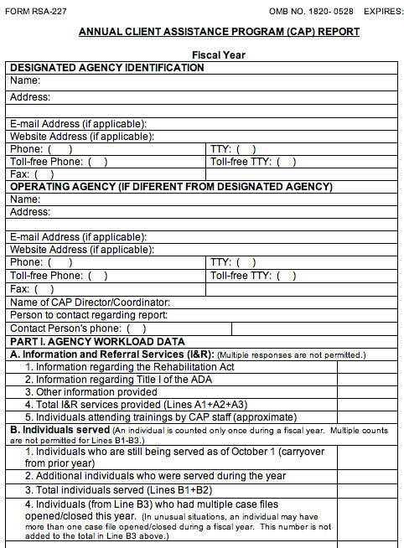
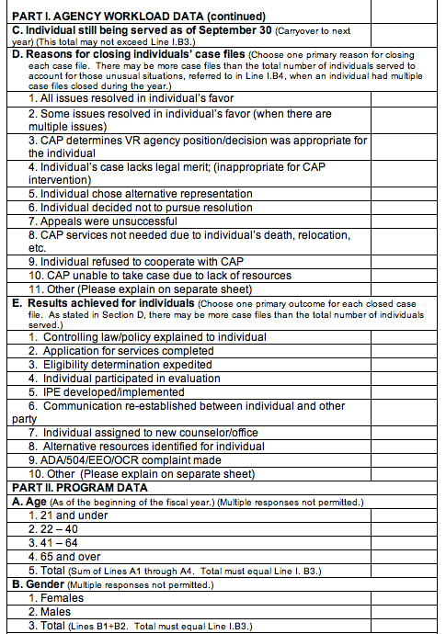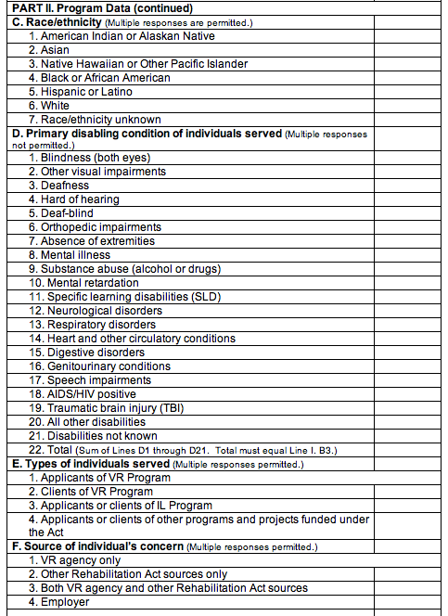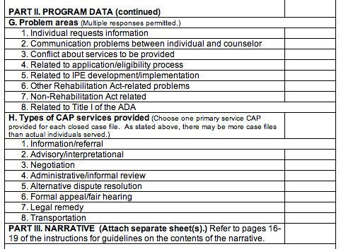

Exhibit D-5: Data items in the RSA-113
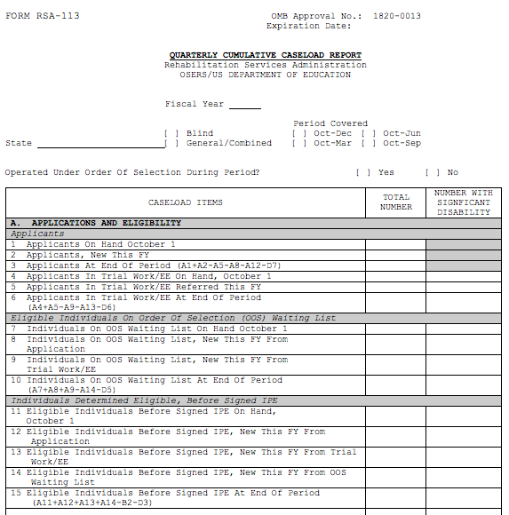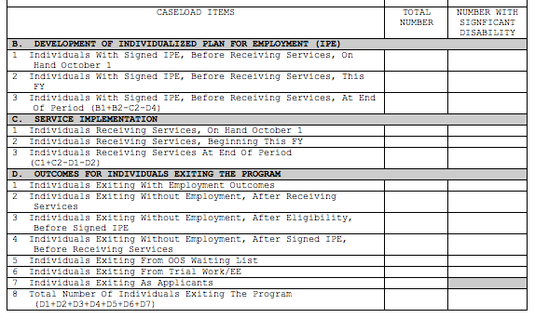

Exhibit D-6: Data items in the RSA-2
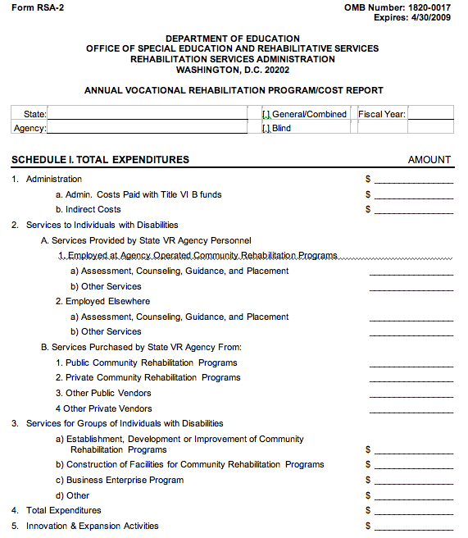

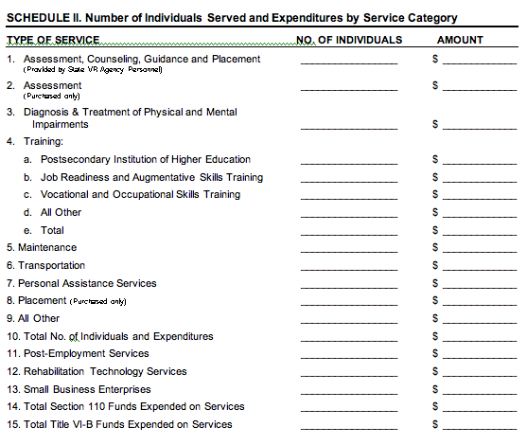

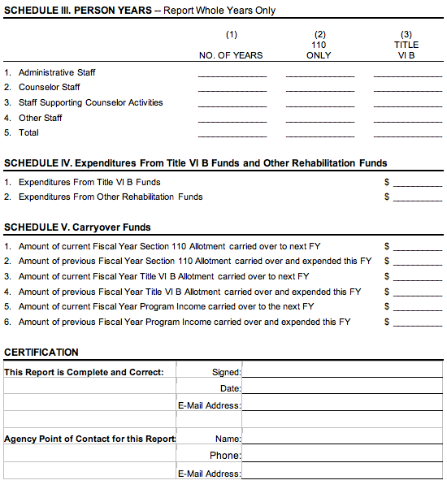

Appendix E: State-level Data from National Programs
A number of federal programs collect and disseminate state-level administrative data about program recipients with disabilities that are relevant to the Comprehensive Statewide Needs Assessment (CSNA). In particular, the Individuals with Disabilities Education Act (IDEA) and Section 504 data on students with disabilities, Social Security data on recipients of disability benefits, and Workforce Investment Act (WIA) data on people receiving services from the WIA system all provide information that helps inform the CSNA.
Data from these programs are collected in all states, using uniform data collection systems that result in cost-effective and reliable information. However, administrative state-level data do not always provide the exact information that is most relevant to the CSNA. For example, data on students served under Section 504 is not available for transition students alone, a particular group of interest to VR, but rather for the entire Section 504 program that serves elementary through secondary students.

Individuals with Disabilities Education Act (IDEA)
The Data Analysis System of the U.S. Department of Education, Office of Special Education, provides program data on special education in the United States. Data are collected from all the states on children and youths, ages 0 to 21 years, who are served under the Individuals with Disabilities Education Act (IDEA).
In order to qualify under IDEA, children and youths must need special education and related services by reason of their disability. IDEA includes children and youths with the following disabilities:
- Specific learning disabilities
- Speech or language impairments
- Mental retardation
- Emotional disturbance
- Multiple disabilities
- Hearing impairments
- Orthopedic impairments
- Other health impairments
- Visual impairments
- Autism
- Deaf-blindness
- Traumatic brain injury
- Developmental delay
IDEA data can provide:
- detailed state-level information on transition-age youths in special education;
- specific disabilities of transition-age students, including disabilities that are significant in the VR system and may be most significant depending on the individual state’s criteria (e.g., mental retardation, deaf-blind, multiple disabilities, traumatic brain injury);
- graduation and dropout patterns by racial and ethnic minority groups; and
- graduation and dropout rates, by disability, for students 14 years and over.
Analyses of IDEA program data are published each year in an annual report to Congress; the 28th Annual Report is the most recent such report (U.S. Department of Education Office of Special Education and Rehabilitative Services (OSERS), 2008a, 2008b). Volumes One and Two of the report are available at:
<http://www.ed.gov/about/reports/annual/osep/2006/parts-b-c/28th-vol-1.pdf>
< http://www.ed.gov/about/reports/annual/osep/2006/parts-b-c/28th-vol-2.pdf>

IDEA Data Examples
Size of the transition age population in special education. The IDEA data can assist in understanding the magnitude of the transition-age population that is potentially eligible for VR services in the state. Exhibit E-1 shows a portion of Table 1-1: Children and students served under IDEA, Part B, by age group and state. The table shows, by state, the total number of students, ages 3 to 21 years, in the program, as well as the numbers in the following age groups that are most relevant to the VR CSNA: 12-17 years, 14-21 years, and 18-21 years.

Exhibit E-1: Table 1-1: Children and Students Served Under IDEA, Part B, by Age Group and State
Table 1-1. Children and students served under IDEA, Part B, by age group and state: Fall 2005
State | 3-5 | 6-11 | 12-17 | 6-17 | 14-21 | 18-21 | 3-21
Alabama | 8,218 | 36,675 | 42,497 | 79,172 | 33,309 | 5,245 | 92,635
Alaska | 2,082 | 7,855 | 7,309 | 15,164 | 5,406 | 751 | 17,997
Arizona | 14,062 | 53,375 | 51,825 | 105,200 | 37,706 | 5,242 | 124,504
Arkansas | 10,286 | 25,125 | 29,060 | 54,185 | 22,428 | 2,843 | 67,314
California | 66,653 | 280,902 | 302,391 | 583,293 | 224,610 | 26,372 | 676,318
Colorado | 10,540 | 34,567 | 34,250 | 68,817 | 26,086 | 4,141 | 83,498
Connecticut | 7,881 | 27,222 | 33,079 | 60,301 | 25,675 | 3,786 | 71,968
Delaware | 2,073 | 7,793 | 8,203 | 15,996 | 6,136 | 788 | 18,857
District of Columbia | 507 | 4,537 | 5,905 | 10,442 | 4,513 | 789 | 11,738
Florida | 34,350 | 164,811 | 180,464 | 345,275 | 136,380 | 19,291 | 398,916
Georgia | 20,728 | 87,681 | 82,627 | 170,308 | 58,733 | 6,560 | 197,596
Hawaii | 2,423 | 7,803 | 11,126 | 18,929 | 8,323 | 611 | 21,963
Idaho | 4,043 | 12,287 | 11,649 | 23,936 | 8,543 | 1,042 | 29,021
Illinois | 35,454 | 131,096 | 142,645 | 273,741 | 107,138 | 14,249 | 323,444
Indiana | 19,228 | 76,487 | 73,460 | 149,947 | 56,458 | 8,651 | 177,826
Iowa | 6,118 | 27,324 | 35,477 | 62,801 | 27,133 | 3,538 | 72,457
Kansas | 9,267 | 26,584 | 26,937 | 53,521 | 20,537 | 2,807 | 65,595
Kentucky | 21,317 | 47,000 | 36,927 | 83,927 | 27,212 | 3,554 | 108,798
Note that Table 1-8 in the same volume shows the number of students by each individual year of age, so that tailored tables may be constructed showing other age groups of interest. For example, if a state VR program had a special program that targeted transition-age youths 15-19 years of age, it is possible to construct a table showing the numbers in that age group within the special education population.
Transition-age students by disability category. The IDEA tables also provide a picture of the representation of different disabilities (as defined under IDEA) in the special education transition-age population. For example, an indication of the number of transition-age students with mental retardation, traumatic brain injury, multiple disabilities, deaf-blind, and other categories may help the VR agency plan for supported employment needs of these groups. Exhibit E-2 shows a portion of Table 1-5, which includes the number of students with disabilities, 12 to 17 years old, by disability category and state. The full table includes all 13 IDEA disability categories, some of which may be “most significant,” depending on the state’s definition. Another table, Table 1-6 (not shown) includes the same disability categories for the population 18-21 years.

Exhibit E-2: Table 1-5: Students Ages 12 through 17 Served Under IDEA, Part B, by Disability Category and State
Table 1-5. Students ages 12 through 17 served under IDEA, Part B, by disability category and state: Fall 2005
State | All  disabilities | Specific  learning  disabilities | Speech or  language  impairments | Mental  retardation | Emotional  disturbance
Alabama | 42,497 | 26,466 | 2,459 | 6,029 | 1,472
Alaska | 7,309 | 4,538 | 773 | 405 | 489
Arizona | 51,825 | 34,806 | 1,679 | 3,984 | 5,016
Arkansas | 29,060 | 14,670 | 1,269 | 6,042 | 532
California | 302,391 | 199,273 | 20,904 | 18,050 | 19,444
Colorado | 34,250 | 16,373 | 3,250 | 1,743 | 5,507
Connecticut | 33,079 | 14,525 | 3,434 | 1,457 | 4,609
Delaware | 8,203 | 4,997 | x | 1,063 | 563
District of Columbia | 5,905 | 3,114 | 302 | 693 | 1,119
Florida | 180,464 | 107,829 | 13,019 | 19,480 | 22,275
Georgia | 82,627 | 33,091 | 3,048 | 14,998 | 14,276
Hawaii | 11,126 | 6,200 | x | 1,048 | 1,686
Idaho | 11,649 | 6,757 | 996 | 997 | 833
Illinois | 142,645 | 85,144 | 5,388 | 14,010 | 19,565
Dropout rates by race and ethnicity. IDEA data also provide information on the graduation rates and drop out rates of students with disabilities from different racial and ethnic groups. Exhibit E-3 shows a portion of Table 4-4d: Hispanic students age 14 through 21 with disabilities served under IDEA, Part B, who exited school, by exit reason and state. Among other data, the table includes the numbers of students with disabilities who either dropped out or “moved, not known to continue.” The dropout rate includes students in both of these two categories.

Exhibit E-3: Table 4-4d Hispanic students age 14 through 21 served under IDEA, Part B, who exited school, by exit reason and state
Table 4-4d. Hispanic students ages 14 through 21 with disabilities served under IDEA, Part B, who exited school, by exit reason and state: 2004-05ª
State | Exiting total | Graduated with diploma | Received a certificate | Reached maximum age ^{b} | Died | Dropped out^{c}
Alabama | 66 | 45 | 13 | x | x | x
Alaska | 33 | 17 | x | x | x | 15
Arizona | 2,423 | 1,218 | x | 53 | x | 1,139
Arkansas | 107 | 67 | x | x | x | 36
California | 14,705 | 8,352 | 678 | 172 | 48 | 5,455
Colorado | 862 | 493 | 23 | 55 | 10 | 281
Connecticut | 834 | 405 | 7 | 18 | 8 | 396
Delaware | 40 | 30 | x | x | x | 6
District of Columbia | 23 | 19 | x | x | x | x
Florida | 3,786 | 1,437 | 997 | x | x | 1,339
Georgia | 323 | 79 | 116 | x | x | 127
Hawaii | 58 | 49 | x | 5 | x | x
Idaho | 196 | 106 | x | x | x | 84
Illinois | 2,151 | 1,458 | 16 | 34 | 6 | 637
Using data from this and the parallel tables on graduation and dropout rates for other minority groups, one can compare dropout rates for specific minority groups with the rates for other racial and ethnic groups in the state and/or with the rates for racial and ethnic groups in the U.S. racial and ethnic groups with particularly high dropout rates in the state will have heightened needs for VR education and training services.
Dropout rates by disability. Another IDEA table provides data that can be used to identify disability groups with especially high dropout rates in the state. Exhibit E-4 shows a portion of Table 4-1d which includes data on exit reasons for students with emotional disturbance. The same information is available for other disabilities in parallel tables.

Exhibit E-4: Table 4-1d: Students age 14 and older with emotional disturbance served under IDEA, Part B, who exited school, by exit reason and state
Table 4-1d. Students age 14 through 21 with emotional disturbance served under IDEA
Part B, who exited school, by exit reason and state: 2004-05ª
State | Exiting total | Graduated with diploma | Received a certificate | Reached maximum age | Died | Dropped out^{b}
New Jersey | 2,145 | 1,105 | x | 21 | x | 1,010
New Mexico | 192 | 53 | x | x | x | 109
New York | 3,871 | 1,216 | 462 | 49 | 20 | 2,124
North Carolina | 795 | 215 | 38 | 9 | 6 | 527
North Dakota | 137 | 69 | x | x | x | 64
Ohio | 1,819 | 496 | 448 | x | x | 660
Oklahoma | 511 | 233 | x | x | x | 277
Oregon | 432 | 138 | 45 | x | x | 238
Pennsylvania | 2,017 | 1,560 | 8 | 30 | 7 | 412
Rhode Island | 341 | 193 | x | x | x | 142
South Carolina | 693 | 129 | 67 | x | x | 494
South Dakota | 70 | 22 | x | x | x | 47
Tennessee | 520 | 118 | 140 | x | x | 256
Texas | 2,879 | 986 | 1,065 | 7 | 11 | 810
Utah | 167 | 81 | x | x | x | 84
Vermont | 248 | 111 | 6 | x | x | 130
Virginia | 1,460 | 414 | 456 | 7 | 7 | 576
Disability groups with especially high dropout rates are at risk for being underserved. For example, in some states the dropout rate for youths with emotional disturbance is greater than 50 percent, indicating a high need for special training, education and other supports for this group in the VR system.

Section 504 Data
The Office for Civil Rights (OCR) of the U.S. Department of Education reports limited data by state on students who are covered under Section 504 but are not receiving services under IDEA. These students have a physical or mental impairment that substantially limits one or more major activities but do not have learning issues that make them eligible for IDEA; they are not included in the IDEA data described above (U.S. Department of Education Office for Civil Rights, 2005; 2007). Unfortunately, data on the total number of "Section 504 only" students are not disaggregated by age or transition status or by specific disability. Nevertheless, these data can help to give a rough indication of the size of the Section 504 population, a group that is potentially eligible for VR services during transition. In addition, state-level departments of education may be able to assist in disaggregating the data by age to give a more accurate estimate of the transition-age group with Section 504 disabilities
Section 504 Data can provide:
- an overall picture of the size of the population with disabilities that was not eligible for IDEA services but did receive Section 504 services because of their disabilities.
The Section 504 data may be accessed from the “The 2006 Civil Rights Data Collection” area at the Office for Civil Rights (OCR) of the Department of Education at the following Web site: <http://www.ed.gov/about/offices/list/ocr/data.html?src=rt>.
Table 3B <http://ocrdata.ed.gov/ocr2006rv30/VistaApp/browsetables.aspx?VistaLanguage=en> provides the number of students receiving Section 504 services only, for the states and the U.S. The table may be downloaded as a comma delimited or Excel file.

Section 504 Data Example
Exhibit E-5, based on an Excel file download (Table 3B) from the Web site listed above, shows the number of students in the state of Indiana who received Section 504 services.

Exhibit E-5: 2006 Civil Rights Data Collection, Projected Values for the State of Indiana
Data Items
ED101 Number of Children Receiving Services Under Section 504 | 6,430

Social Security Data
The Social Security Administration (SSA) collects program data on people who receive disability benefits, including Social Security Disability Insurance (SSDI), which is a part of the Old Age, Survivors and Disability Insurance (OASDI), and Supplemental Security Income (SSI). Individuals may receive benefits from either or both programs, depending on their work history, age, and financial resources. SSA also provides information on participation in the Ticket to Work Program.
Social Security Disability Insurance (SSDI). A federal program in the Social Security Administration providing monthly benefits to disabled workers and their dependents. Disabled workers are people under age 65 who receive benefits as part of the OASDI program. Workers build protection through employment covered under Social Security (compulsory tax on earnings). The disability definition is an inability to engage in substantial gainful activity because of any medically determinable permanent physical or mental impairment. Later amendments made the disability length of time necessary for eligibility to be at least five months.
Supplemental Security Income (SSI). The federally administered Supplemental Security Income program provides income support to people 65 and over, blind or disabled adults, and blind or disabled children who have little or no income or other financial resources. In order to be considered disabled for SSI an adult must be unable to engage in any substantial gainful activity by reason of a medically determinable physical or mental impairment that is expected to result in death or last for a continuous period of at least 12 months. Blindness is defined as 20/200 or less vision in the better eye with the use of correcting lenses or with tunnel vision of 20 degrees or less. Children who have a physical or mental impairment that results in marked or severe functional limitations are eligible for SSI.
Ticket to Work (TTW). The Ticket to Work Program is a federal program designed to help Social Security beneficiaries with disabilities go back to work. The program offers employment support services to beneficiaries between the ages of 18 and 64 who receive SSI or SSDI. These employment support services include vocational rehabilitation, training, referrals, job coaching, and counseling. The Ticket to Work program is designed so that people who are making progress toward employment goals do not lose their benefits because they are working and thus no longer meet the criteria of “unable to engage in substantial gainful employment.” People who are eligible for the program receive a “Ticket to Work” in the mail. The ticket allows beneficiaries to access employment support services provided by VR agencies or ticket service providers called employment networks (EN’s) (World Institute on Disability, 2007).
People who are receiving Social Security disability benefits are considered to have significant disabilities and to be eligible for VR services, provided they intend to achieve an employment outcome (Hager, 2004). States that have adopted order of selection vary in their rules about whether people who receive Social Security disability benefits are considered to have a “most significant disability.” In some states receipt of SSI/SSDI automatically means that a person has a most significant disability.
Social Security data provide:
- the magnitude and age distribution of the SSI/SSDI population in the state, all of whom are considered to have at least a significant disability;
- numbers of Social Security recipients who return to work; and
- the number of Ticket to Work tickets that have been issued to VR agencies and to other entities.
Each year, SSA publishes an Annual Statistical Supplement to the Social Security Bulletin (Annual Supplement) (Social Security Administration, 2009a). The data are available at: <http://www.ssa.gov/policy/docs/statcomps/supplement/2008/>
Data on Ticket to Work are available at: <http://www.socialsecurity.gov/work/tickettracker.html>

Social Security Data Examples
Size of the population that receives Social Security disability benefits. The Social Security data provides the magnitude and age distribution of the SSI/SSDI population in the state. It can also contribute to an understanding of the magnitude and age distribution of the “most significant” population in states where receipt of Social Security disability benefits qualifies as a “most significant” disability under order of selection. Exhibit E-6, shows a portion of Table 27: Disabled Workers in Current-Payment Status, available at: <http://www.ssa.gov/policy/docs/statcomps/di_asr/2007/sect01c.html#table27>

Exhibit E-6: SSA Table 27: Disabled Workers in Current-Payment Status
Disabled Workers in Current-Payment Status
Table 27.
Number, by sex, state or other area, and age, December 2007
State or area |  | Total |  | Under 35 |  | 35–39 |  | 40–44 |  | 45–49 |  | 50–54 |  | 55–59 |  | 60–FRA
 |  |  | All disabled workers
 | All areas |  | 7,098,723 |  | 435,000 |  | 373,621 |  | 603,495 |  | 921,560 |  | 1,228,219 |  | 1,551,082 |  | 1,985,746
 | Alabama |  | 186,067 |  | 9,690 |  | 9,864 |  | 15,865 |  | 24,230 |  | 33,452 |  | 41,983 |  | 50,983
 | Alaska |  | 10,617 |  | 868 |  | 606 |  | 916 |  | 1,474 |  | 1,868 |  | 2,248 |  | 2,637
 | Arizona |  | 130,052 |  | 8,142 |  | 6,984 |  | 10,743 |  | 16,744 |  | 22,476 |  | 28,138 |  | 36,825
 | Arkansas |  | 115,806 |  | 6,655 |  | 5,949 |  | 9,475 |  | 14,874 |  | 19,959 |  | 25,575 |  | 33,319
 | California |  | 593,506 |  | 34,926 |  | 29,576 |  | 48,968 |  | 76,124 |  | 103,942 |  | 132,453 |  | 167,517
 | Colorado |  | 80,207 |  | 5,026 |  | 4,233 |  | 6,612 |  | 10,951 |  | 14,514 |  | 17,668 |  | 21,203
 | Connecticut |  | 70,581 |  | 4,847 |  | 4,050 |  | 7,105 |  | 9,887 |  | 11,906 |  | 13,780 |  | 19,006
 | Delaware |  | 22,855 |  | 1,316 |  | 1,165 |  | 2,080 |  | 3,145 |  | 4,126 |  | 4,909 |  | 6,114
 | District of Columbia |  | 10,732 |  | 789 |  | 618 |  | 1,078 |  | 1,536 |  | 2,161 |  | 2,291 |  | 2,259
 | Florida |  | 418,502 |  | 21,444 |  | 19,281 |  | 33,849 |  | 53,880 |  | 71,908 |  | 91,688 |  | 126,452
Table 27 provides information by age group, including total, under 35, 35-39, 40-44, 45-49, 50-54, 55-59, and 60 years and above.
Disabled workers who returned to work. Social Security data also provides information on disabled workers who received SSDI and/or SSI but had benefits withheld in that year because of substantial work and those whose benefits were terminated because of successful return to work. Exhibit E-7 shows a portion of Table 56: Disabled Workers Who Work, available at: <http://www.ssa.gov/policy/docs/statcomps/di_asr/2007/sect03g.html#table56>

Exhibit E-7: SSA Table 56: Disabled Workers Who Work
Disabled Workers Who Work
Table 56.
Distribution, by state or other area, 2007
State or area | All workers,  December | Workers with benefits withheld  because of substantial work,  December |  | Workers with benefits terminated  because of successful return  to work, calendar year
 |  | Number | Percentage  of all workers | Number | Percentage  of all workers
All areas | 7,098,723 | 37,701 | 0.5 | 33,381 | 0.5
Alabama | 186,067 | 462 | 0.2 | 537 | 0.3
Alaska | 10,617 | 97 | 0.9 | 81 | 0.8
Arizona | 130,052 | 1,069 | 0.8 | 857 | 0.7
Arkansas | 115,806 | 420 | 0.4 | 316 | 0.3
California | 593,506 | 4,783 | 0.8 | 3,234 | 0.5
Colorado | 80,207 | 423 | 0.5 | 419 | 0.5
Connecticut | 70,581 | 540 | 0.8 | 464 | 0.7
Delaware | 22,855 | 148 | 0.6 | 162 | 0.7
District of Columbia | 10,732 | 88 | 0.8 | 148 | 1.4
Florida | 418,502 | 1,645 | 0.4 | 2,075 | 0.5

This table provides information about the relatively small percentage of the overall Social Security disability population that returns to work.
Ticket to Work. Social Security data provides information about the size of the population that is participating in Ticket to Work in the state and the number of tickets issued to VR agencies and other ENs. Exhibits E-8 and E-9 show portions of the tables on tickets assigned to ENs and to VR agencies, respectively. Both of these tables are available at: <http://www.socialsecurity.gov/work/tickettracker.html> (Social Security Administration, 2009b).

Exhibit E-8: Ticket Tracker for Employment Networks (ENs)
EN Ticket Tracker
Updated July 20, 2009
State  (State Abbreviation Table) | Tickets Issued  (Net) | EN Contract  Awards (current) | Tickets Assigned to EN's
AK | 18, 086 | 3 | 17
AL | 284,944 | 13 | 369
AR | 172,078 | 13 | 296
AS | 1,301 | 0 | 1
AZ | 190,682 | 18 | 496
CA | 1,103,981 | 110 | 4,078
CO | 119,806 | 13 | 322
CT | 107,536 | 23 | 208
DC | 25,037 | 14 | 195
DE | 32,548 | 4 | 35
FL | 630,326 | 113 | 2,137

Exhibit E-9: Ticket Tracker for State VR Agencies
State VRA Ticket Tracker
Updated July 20, 2009
State  (State Abbreviation Table) | Tickets Issued  (Net) | Ticket Assigned to State VRAs | Tickets In-Use SVR
AK | 17,953 | 1 | 391
AL | 283,420 | 15 | 2,967
AR | 170,899 | 41 | 2,192
AS | 1,300 | 0 | 1
AZ | 189,731 | 37 | 2,327
CA | 1,099,266 | 25 | 18,569
CO | 119,148 | 13 | 2,135
CT | 107,293 | 773 | 1,734
DC | 24,804 | 12 | 565
DE | 32,362 | 41 | 2,202
FL | 626,152 | 75 | 9,407
FM | 0 | 0 | 0
GA | 335,148 | 304 | 4,614
GU | 1,582 | 0 | 1
HI | 34,207 | 0 | 1,381
IA | 93,994 | 177 | 3,216
ID | 48,982 | 31 | 1,973
IL | 412,759 | 135 | 12,426

These tables include the number of tickets issued in each state, and the (relatively small) number of tickets assigned to the Employment Network providers with ED awards (Exhibit E-8) or to the state VR agency or agencies. (Exhibit E-9).

Workforce Investment Act (WIA) Data
Workforce investment system data represents an important part of the CSNA. In addition to the fact that the Rehabilitation Act’s description of the CSNA identifies the workforce investment system by name (Section 15 A (ii)), the gathering of needs related to this system is helpful in understanding the totality of need being met for individuals with disabilities. While VR concentrates on those with the most significant disabilities, the other components of the workforce investment system also provide employment services to individuals with disabilities who may not be aware of, qualify for, or desire the services of VR. Together, the data from VR and the workforce investment system will provide a more complete picture of need across all programs of public employment for individuals with disabilities and thereby provide a more fundamental answer to the overall question about the rehabilitation needs of individuals with disabilities in the state. The data also may reveal possible differences in the rates or types of services among different groups, for example that minorities, unserved, or underserved individuals with disabilities receive in VR and the workforce system, allowing for potential changes to service structures or opportunities for cooperation across programs.
The Workforce Investment Act (WIA) created a new comprehensive workforce investment system that was designed to alter the way employment and training services are delivered. WIA established three new programs – Adult, Dislocated Worker, and Youth – to replace the Job Training Partnership Act (JTPA). These programs were to allow for a broader range of services to the general population, removing income as a determinant for eligibility for program services. WIA also required that services for these programs and others be provided through a single service delivery system – the one-stop system (the “others” included the Wagner-Peyser funded Employment Service that according to a GAO report “focuses on providing a variety of employment-related labor exchange services including job search assistance, job referral, and placement assistance for job seekers, re-employment services to unemployment insurance claimants, and recruitment services to employers with job openings”) (Government Accountability Office, 2007).
The following list shows the parts of the workforce investment system as noted in the Workforce Investment Act of 1998:
Title I:
- One stop delivery systems (Sec 121)
- Providers of training services (Sec 122)
- Providers of youth activities (Sec 123)
- Adult and Dislocated Worker Employment and Training (Chapter 5)
- Job Corps (Subtitle C)
- Native American Programs (Sec 166)
- Migrant and Seasonal Farmworker programs (Sec 167)
- Veteran’s workforce investment programs (Sec 168)
- Youth Opportunity grants (Sec 169)
- National Emergency grants (Sec 173)
Title II:
- Adult Education and Literacy
Title III:
- Wagner Peyser Act (Subtitle A)
- Trade Act of 1974 (Sec 321)
- Veteran’s Employment programs (Sec 322)
- Older Americans Act of 1985 (Sec 323)
Title IV:
- Rehabilitation Act Amendments of 1998

The WIA mandatory programs and federal agencies include the following:
Federal Agency | Mandatory Program
Department of Labor | WIA Adult  WIA Dislocated Worker  WIA Youth  Employment Service (Wagner-Peyser)  Trade adjustment assistance programs  Veterans’ employment and training programs  Unemployment Insurance  Job Corps  Senior Community Service Employment Program  Employment of training for migrant and seasonal farm workers  Employment and training for Native Americans
Department of Education | Vocational Rehabilitation Program  Adult Education and Literacy  Vocational Education (Perkins Act)
Department of Health and Human Services | Community Services Block Grant
Department of Housing and Urban Development | HUD-administered employment and training

The U.S. Department of Labor’s Employment and Training Administration (DOLETA) maintains a grantee reporting system for WIA grantees called the Workforce Investment Act Service Record Data (WIASRD). It covers the following programs: the Workforce Investment Act Information Management System (OMB No. 1205-0420), the Labor Exchange Reporting System (OMB No. 1205-0240) for programs administered under the Wagner-Peyser Act and the Veterans Employment and Training Service, the Trade Adjustment Assistance Program (OMB No. 1205-0392), the National Farm worker Jobs Program (OMB No.1205-0425) and the Indian and Native American Program (OMB No. 1205-0422) (U.S. Department of Labor 2007b).
The WIASRD is submitted by states to DOLETA on an annual basis. The WIASRD files contain detailed information on program completers (i.e., exiters), including demographics, types of services received, and outcomes attained as a result of participating in the program. The WIA data system also requires customer satisfaction surveys, collected through the state Employment Security Agency.
WIASRD data is collected in a consistent manner, is very accessible, is easily used to look at trends across years and has many characteristics that mirror VR agency data, allowing for easy grouping. WIA data can be cross-tabbed across a variety of variables, is available at the state and local levels, and through coordination with WIA contacts in the state. Agencies already collect a great deal of WIA data that are relevant to assessing vocational rehabilitation needs, making these data highly cost-effective and timely. In many cases these data are standardized in their format, making the data very consistent.
However, agreements with various agencies will have to be arranged to secure the specific data that is needed beyond the publicly available data. WIA data do not differentiate between those with any disability and those with a significant disability. Cell sizes may be too small in any one year for a detailed cross-tabulation.
Data from the WIASRD provides:
- the characteristics of consumers served by the non-VR parts of the workforce investment system; and
- county or regional level data.

The Federal Research and Evaluation Database (FRED) enables analysis of the Workforce Investment Act Standardized Record Data (WIASRD) (U.S. Department of Labor, 2007a). This includes data that is annually submitted by states on WIA exiters' demographic characteristics, the services they received, and the outcomes they achieved after exit.

At the FRED Web page (http://www.fred-info.org/), it is possible to:
- examine performance, caseload and program information from the national, regional, state and local levels;
- display trends in performance by quarter as well as the characteristics of the exiter cohort;
- create comparison groups based on parameters set by the user; and,
- create cross tabulation tables and/or correlations from two user-identified variables.
Data may be examined by program: WIA Adult, WIA Dislocated Workers, WIA Older Youth, WIA Younger Youth, and WIA National Emergency Grants. Each of these WIA program areas has a section on the Web site. Exhibit E-10 shows the diagnosis and planning tools screen for the WIA Adult program.

Exhibit E-10: FRED Screen for WIA Adults Program
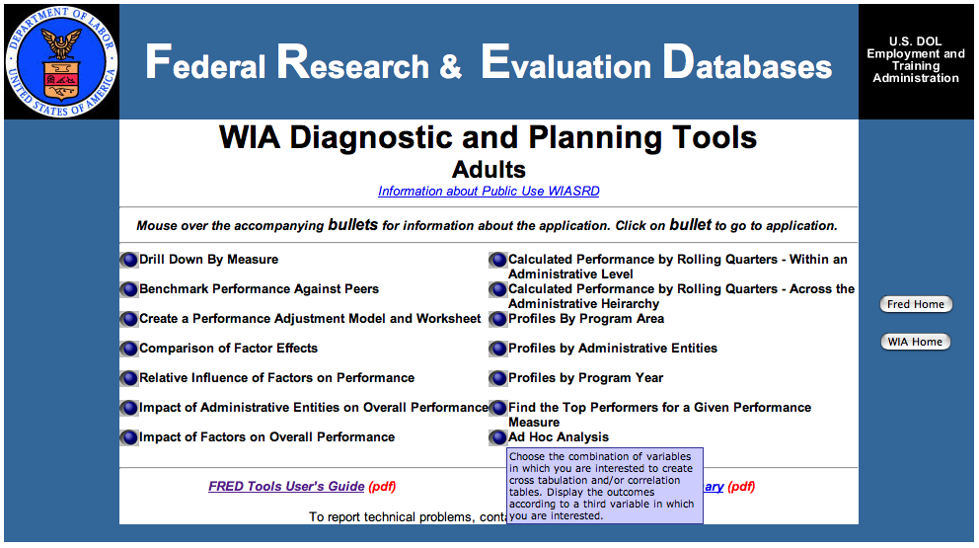
On each program page the Ad Hoc Analysis tool allows one to create frequency or cross-tabulation tables from the WIASRD data. Exhibit E-11 shows a selection of variables for a cross-tabulation in the WIA Adult program.

Exhibit E-11: FRED WIA Variables
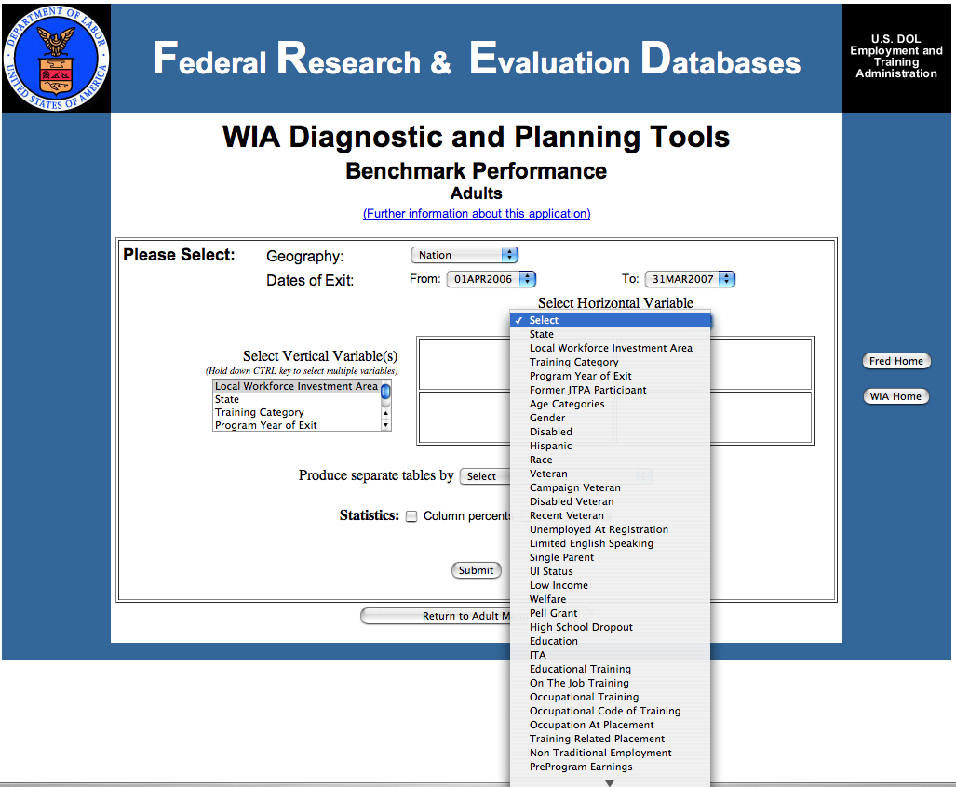
It is also possible to generate these tables "by" other factors in the database. For example, the Web site allows generation of a gender and race cross tabulation by local workforce area. Exhibit E-12 shows selection of geography variables.

Exhibit E-12: FRED WIA Selection of Geography Variables

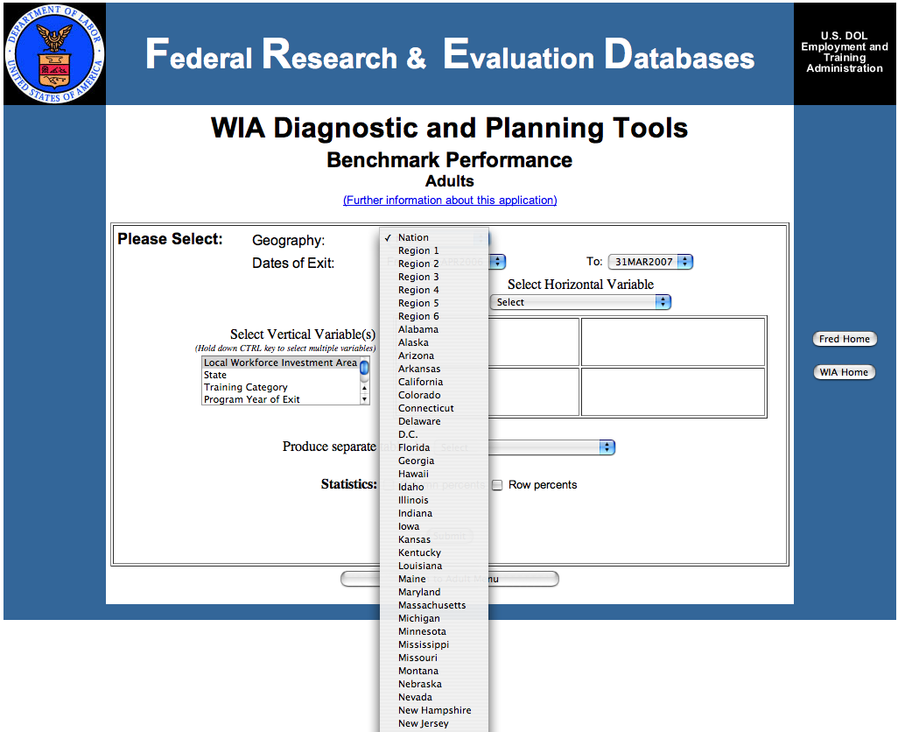

One can also select both a geography and program year of exit –including an option to select all years. See Exhibit E-13 for an example of selecting multiple variables.

Exhibit E-13: FRED WIA Selection of Multiple Variables to Create Cross-Tabulation Tables
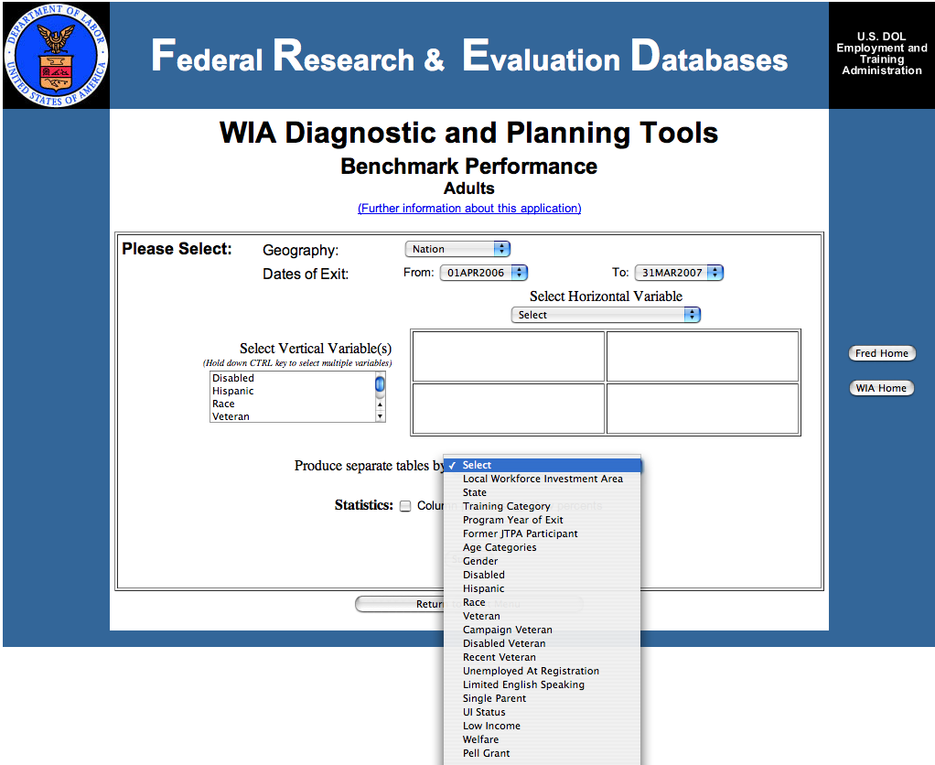
The FRED data systems offer the opportunity to look at the data with “disabled” as a variable for a state.
Using this tool, one can generate the following tables for all programs:
- disabled in state cross tabulation;
- disabled in local workforce investment area for state cross tabulation
- in state – disabled by:
- age
- gender
- Hispanic
- race
- education
- limited English speaking
- low income
- welfare
- high school dropout
- occupation at placement
- average annual earnings
- length of program stay
- For trend analysis (Optional) – program cross tabulations for other years
Information is also available by measure. For example, for Adults, the following measures are available: Adult Entered Employment Rate; Adult Retention Rate; Adult Earnings Change; Adult Average Earnings, and Adult Credential Rate. Similar measures are available for the other programs (Dislocated Workers, Older Youth, and Younger Youth).

Exhibit E-14: FRED Measures in Adult WIA Data
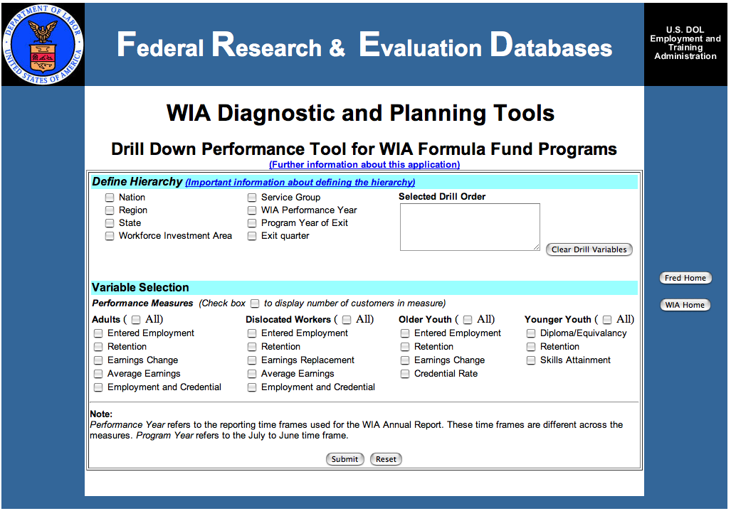
DOLETA performance results Web page. Posted on the U.S. Department of Labor’s Employment and Training Administration’s Web site (http://www.doleta.gov/performance/results/Reports.cfm? #wiastann) are the WIA state annual reports summaries in excel format as well as WIASRD summary reports by state. WIA data tables are standardized and show the same information for every state and for the nation. The tables cover:
- Table A- Workforce Investment Customer Satisfaction Results
- Table B- Adults Program Results
- Table C – Outcomes for Adult Special Populations (including Individuals with Disabilities)
- Table D – Other Outcome Information for the Adult Program
- Table E – Dislocated Worker Program Results
- Table F - Outcomes for Dislocated Worker Special Populations (including Individuals with Disabilities)
- Table G - Other Outcome Information for the Dislocated Worker Program
- Table H.1 – Youth (14-21) Program Results
- Table H.2 – Older Youth (19-21) Program Results
- Table I - Outcomes for Older Youth Special Populations (including Individuals with Disabilities)
- Table J – Younger Youth (14-18) Results
- Table I - Outcomes for Younger Youth Special Populations (including Individuals with Disabilities)

Performance is also reported by local area. Exhibit E-15 shows an example of a disability-relevant table and chart for one state.

Exhibit E-15: Sample State-Level Tables for Adult WIA Data
State Level Tables – Adult WIA Program
Table C - Outcomes for Adult Special Populations
 | Public Assistance Recipients Receiving Intensive or Training Services |  | Veterans |  | Individuals With Disabilities |  | Older Individuals
Entered Employment Rate | 63.7% | 2,442 | 71.2% | 2,890 | 67.2% | 2,114 | 65.3% | 1,485
Entered Employment Rate | 63.7% | 3,841 | 71.2% | 4,060 | 67.2% | 3,145 | 65.3% | 2,274
Employment Retention Rate | 76.3% | 2,131 | 78.0% | 2,457 | 78.6% | 1,815 | 79.3% | 1,341
Employment Retention Rate | 76.3% | 2,793 | 78.0% | 3,149 | 78.6% | 2,308 | 79.3% | 1,691
Earnings Change in Six Months | $4,110 | $10,965,303 | $1,916 | $5,685,481 | $2,768 | $6,129,323 | $664 | $1,055,926
Earnings Change in Six Months | $4,110 | 2,668 | $1,916 | 2,968 | $2,768 | 2,214 | $664 | 1,590
Employment and Credential Rate | 48.4% | 1055 | 47.9% | 863 | 43.5% | 499 | 49.4% | 394
Employment and Credential Rate | 48.4% | 2,182 | 47.9% | 1,801 | 43.5% | 1,147 | 49.4% | 798
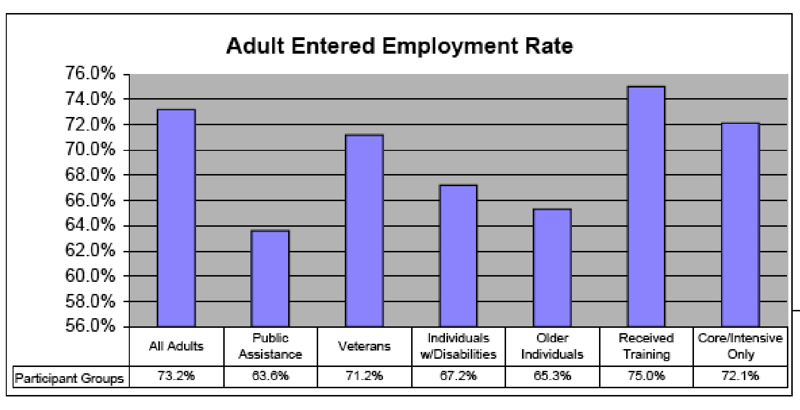
Coordination with state WIA administrator or State Offices of Workforce Security. The data recommended above in the FRED data system is collected and entered by the state’s WIA administrator or the state’s Employment Security Agency. Coordination with this resource can provide data beyond that which is described above. State contacts can be found at http://www.doleta.gov/regions/.
Wagner-Peyser and Veteran’s Employment programs use forms ETA 9002 and VETS 200 to report on activities to the U.S. Department of Labor. On those forms there is reporting on the number of persons with disability, veterans status, demographic information, and services received (career guidance, job search, referred to employment, and referred to WIA services).
Exhibit E-16 is an example of a state’s data produced by this national reporting.

Exhibit E-16: Sample State Wagner-Peyser Data
STATE - WAGNER-PEYSER
Program Year 2007
New Jersey
 | Total Job Seekers |  |  | Total Eligible Claimants |  |  | Total Veterans and Eligible Persons
 | Number |  | Percent | Number | Percent |  | Number | Percent
Total Active Job Seekers
Total Participants |  | 247,653 | 100.0%
Eligible Claimants |  | 150,287 | 60.7% | 150,287 | 100.0% |  | 11,626 | 63.1%
Veterans and Eligible Persons |  | 18,418 | 7.4% | 11,626 | 7.7% |  | 18,418 | 100.0%
Dislocated Workers |  | 7,279 | 2.9% |  |  |  | 380 | 2.1%
Persons with Disabilities |  | 4,903 | 2.0% |  |  |  | 993 | 5.4%
Migrant and Seasonal Farmworkers |  | 150 | 0.1% | 103 |  | 0.1% | 2 | 0.01%
Staff-Assisted Service Distribution
Received Staff-Assisted Services |  | 231,753 | 93.6% | 144,595 |  | 96.2% | 17,956 | 97.5%
Career Guidance |  | 54,827 | 22.1% | 37,868 |  | 25.2% | 2,603 | 14.1%
Job Search Activities |  | 145,785 | 58.9% | 98,027 |  | 65.2% | 12,693 | 68.9%
Referred to Employment |  | 49,519 | 20.0% | 21,306 |  | 14.2% | 4,404 | 23.9%
Referred to WIA Services |  | 7,531 | 3.0% | 5,521 |  | 3.7% | 386 | 2.1%
Received Workforce Info Services |  | 163,265 | 65.9% | 105,327 |  | 70.1% | 9,819 | 53.3%
Outcomes
Entered Employment |  | 118,611 |  | 77,328 |  |  | 10,129
Entered Employment Rate Base |  | 207,361 |  | 132,115 |  |  | 17,505
Entered Employment Rate |  |  | 57% |  |  | 59% |  | 58%
Employment Retention at Six Months |  | 99,725 |  | 64,744 |  |  | 9,755
Employment Retention at Six Months Rate Base |  | 127,937 |  | 79,768 |  |  | 12,034
Employment Retention at Six Months Rate |  |  | 78% |  |  | 81% |  | 81%
From EBSS 11/19/08

Appendix F: State and Substate Reports and Other Materials

State and Substate Reports and Other Materials
Public agencies and private organizations generate a wide variety of resources, including reports, data sets, needs assessments, surveys, hearings and other materials that are often relevant to understanding the rehabilitation needs of people with disabilities in a state. These resources can help to answer the specific questions of the VR comprehensive statewide needs assessment (CSNA), that is: needs of people with most significant disabilities, including their need for supported employment; needs of minorities and other unserved or underserved groups; needs of people served in the statewide workforce investment system; and needs for establishment, development and improvement of community rehabilitation programs. Existing reports and other materials may also provide general information about the rehabilitation needs of people with disabilities in the state.
As these reports and other materials already exist, this is a cost effective method of obtaining information. They provide information that is unique to the state or other substate geographic regions; and in some cases, these sources may be a cost-effective way to obtain information on needs of people with disabilities in a particular city, county or other geographical area. The content and types of information will be unique to a state or locality. The quality of the data, reports, and other materials also vary, making it important to assess the reliability of the methods and the quality of the analysis and reporting.
Examples of state and substate reports and what they can provide include:
- Developmental Disabilities Councils publish a five-year strategic State Plan with estimates of the number of people with developmental disabilities in the state and often reports on people with DD who received supported employment services.
- The National Association of State Directors of Developmental Disabilities Services (NASDDDS) co-sponsors an Adult Consumer Survey in conjunction with the National Core Indicators effort to measure performance of state developmental disabilities systems. Measures of employment are available from this survey.
- Some State Departments of Mental Health have state-specific information about the population with severe mental illness, including prevalence by state and/or county and demographic characteristics that may affect the need for VR services.
- State Traumatic Brain Injury (TBI) offices or registries may have information about the prevalence of TBI in the state.
- The Centers for Disease Control (2007) publishes data for some states on TBI hospitalization and fatalities.
- Agencies and organizations that serve people with significant disabilities may have reports that focus specifically on their needs related to supported employment, such as results of surveys, focus groups or hearings with consumers and their families, businesses, and/or rehabilitation providers. Consumer organizations such as United Cerebral Palsy Association (UCPA), TASH, and the National Alliance on Mental Illness (NAMI), among many others, will be important sources of these types of reports.
- State Plans of the DD Councils may have existing reports or other materials on any population that the VR agency has identified as unserved or underserved in a particular state, such as the needs of American Indians, veterans, people with limited education, or inner city residents.
- Specific state-level reports may be available from the state’s Workforce Investment Board. There are also Web sites with information about state and local resources and reports on disability issues within the workforce investment system, such as the One-Stop State Toolkit <http://www.onestoptoolkit.org/statelocalbytopic.cfm>.
- Some states have membership organizations of community rehabilitation programs (CRPs) that may be a source of information about these programs (e.g., Oregon Rehabilitation Association).
- State Departments of Health and Human Services, Departments of Economic Development or Departments of Labor may have reports or other materials on CRPs.
- Existing reports may also identify trends and emerging unserved or underserved groups. For example, existing reports may identify an increase in the number of students with autism in the schools.
- Population trends among people with specific disabilities may affect rehabilitation services, such as an increase in HIV/AIDS, diabetes, or other conditions that can lead to functional disabilities in the state or in a particular city or region.
- The Centers for Disease Control (CDC) has data on diabetes prevalence and trends for states and counties, which can help in planning for services to groups with diabetes-related disabilities. <http://apps.nccd.cdc.gov/DDTSTRS/default.aspx>
Potential Resources. Each state has a somewhat different configuration of agencies and private organizations, precluding an exhaustive list. In general, it is helpful to scan recent reports and statistics from as many as possible of the major disability-related state departments and state or local organizations to look for information that will specifically help to answer the questions of the VR comprehensive needs assessment. The following list provides a starting point for locating and reviewing sources in the state:
- State, county and local agencies that serve people with disabilities including departments, divisions, boards, councils or authorities:
- Aging and disability services
- Developmental services or developmental disabilities
- Education and/or special education
- Housing
- Mental health
- Mental retardation
- Personal Assistance Services (PAS), Attendant Services, In-home Supportive Services
- Public health
- Regional centers
- Social services
- Transportation
- Welfare
- State or local offices or units of federal programs, including:
- Independent Living Services, Department of Rehabilitation
- Medicaid, including Medicaid waivers and Medicaid Infrastructure Grants (MIGs) (National Association of State Medicaid Directors provides links to state offices: http://www.nasmd.org/links/state_medicaid_links.asp)
- Social Security
- Veterans Affairs
- State and local service providers, including:
- Consumer and advocacy organizations (e.g., UCPA, TASH, NAMI)
- Local independent living centers
- Rehabilitation facilities, hospitals or other providers, especially those attached to teaching and research hospitals and universities
- Supported employment programs
- Research resources in the state or region, including
- Colleges and universities, especially those with departments, grants or contracts related to rehabilitation, special education or other disability subjects
- Rehabilitation Engineering Research Centers (RERCs) (Search on “rerc” at http://www.naric.com/research/pd/advanced.cfm)
- Rehabilitation Research and Training Centers (RRTCs) (Search on “rrtc” at http://www.naric.com/research/pd/advanced.cfm)
- The Regional Continuing Education Programs (RRCEPs) and Community Rehabilitation Programs (CRP-RRCEPs) are another existing source of information on CRPs (http://www.rrcepnationalconsortium.org/resourcesdir.htm).
- University Centers for Excellence in Developmental Disabilities (UCEDDs) and other university affiliated programs (Directory available at http://www.aucd.org/directory/directory.cfm?program=UCEDD
- www.statedata.info Another source of state data, this Web site includes data sets from state mental retardation/developmental disabilities agencies, the Rehabilitation Services Administration, the Social Security Administration, and the U.S. Department of Labor.
- Kaiser State Health Facts at http://www.statehealthfacts.org/index.jsp
- Other State, Regional or Local Resources (which often combine service provision and research)
- ADA Technical Assistance Centers (formerly Disability Business Technical Assistance Centers or DBTACs) (Search on “dbtac” at http://www.naric.com/research/pd/advanced.cfm)
- Spinal Cord Centers (Go to SCI-Info at http://www.sci-info-pages.com/rehabs.html or Spinal Cord Injury Information Network at: http://www.spinalcord.uab.edu/
- Traumatic Brain Injury Centers and Registries (Go to the Brain Injury Association of America at http://www.biausa.org/stateoffices.htm; or the Traumatic Brain Injury Collaboration Space at http://nashia.org/issues/tbi.html)

Appendix G: Input from Stakeholders
Gathering input from stakeholders is an important part of the CSNA. Surveys, key informant interviews, focus groups and hearings are the tools for gathering the perspectives of the stakeholders.
In this appendix we review the methods and their advantages and limitations for those stakeholders, describe what information should be retrieved, and give examples, as available.
These methods are frequently used in needs assessment as well as in other social science research. While these methods are common, experience and knowledge of how best to use them is needed in order to achieve meaningful results. Experience with the methods is assumed here. Methods textbooks can provide additional depth if needed, as can several needs assessment texts, including Reviere, Berkowitz, Carter & Ferguson (1996a), Soriano (1995), and Altschuld and Witkin (2000).

Surveys
Surveys are often the method of choice in need assessments (Berkowitz, 1996b). Surveys generally use close-ended instruments with a predefined set of topics. They may also include open-ended questions, but one advantage is the speed with which a survey using close-ended questions can be analyzed. Surveys can be conducted with the entire population of interest or with a sample of the population.
There are four main options for a survey data collection: mail, telephone, electronic, and in-person. The choices are best made on budget, type of information to be gathered, detail of information, and target audience of collection.
Mail surveys are best for straightforward, factual information, counts or numbers (e.g., of clients served), and budgetary information. Mail surveys work best when they are short and to the point. They are relatively inexpensive to conduct, but to achieve an adequate sample, follow-up mailings to nonrespondents can raise the cost. Mail surveys also need accessible alternatives, such as large print and Braille versions.
Electronic mailings or Web-based data collections are even more inexpensive than direct mail while offering the same advantages. However, the respondent group needs to be electronically aware and capable, although it can be made available at local libraries, Centers for Independent Living, and other consumer groups. Accessibility is a key issue here as well. One advantage of the Web method is the opportunity to cut costs on data entry by more easily loading data from respondents directly into a database. This does require some sophistication with Web-based database programming.
Telephone surveys are useful if the information to be gathered is more detailed or needs professional judgments. These are more expensive due to training of interviewers, phone, and personnel costs.
Face-to-face interviews also are an option, although this method is more cost intensive due to staff time and may be most relevant here in internal interviews with VR agency administrators and staff.
The CSNA includes two surveys to solicit input from stakeholders: a VR counselor survey and a VR consumer survey.
VR counselor survey. This method is recommended for this stakeholder group. Adding questions to an established feedback or quality assurance survey of counselors will be a cost-effective way to gather the data needed, if these surveys are already in place. Topics to ask about in a VR counselor survey include:
- Counselor impressions of needs of individuals with significant and most significant disabilities;
- Counselor impressions of needs of minority individuals with disabilities;
- Counselor impressions of needs of underserved individuals with disabilities;
- Counselor feedback of needs for establishment of CRPs
- Service gaps, needs for new CRPs;
- Counselor feedback of needs for development of CRPs
- Service gaps, needs for expanded services or new locations; and
- Counselor feedback of needs for improvement of CRPs
- Needs for improved services or outcomes
VR consumer survey. Since consumer satisfaction surveys or feedback forms are a very commonly used data-gathering tool, the addition of questions to this type of instrument to gather needs assessment information is very cost-effective. This method also gives a method for consistent input from customers who have had recent experience with the VR program and whose point of view will be very current. Besides lending input to the topic of needs of all individuals with disabilities, the customer’s own background and experience with VR can inform several other requirement areas, including the needs of those with significant disability, minorities, and those who are underserved.
Topics to ask about in a VR customer survey include:
- Consumer impressions of VR experiences, including
- Were service needs met?
  - Other services needed
- Was desired employment outcome achieved?
- Services, processes that worked well
- Recommendations for improvement
An example of a customer survey can be seen at the end of this appendix (Exhibit G-1).

Focus Groups
Focus groups provide depth on a relatively small number of topics. They rely on either unstructured or open-ended instruments that concentrate on a clearly defined set of topics. This method aims to establish communication for the facilitator to gain a broad understanding of the participant’s point of view. Focus group facilitators need to be trained in how to effectively manage the groups, especially how to encourage the respondents in conversation.
Focus groups usually bring together eight to 12 individuals based on characteristics on which the research seeks input. While the number of participants may vary, it should be large enough to gather a diversity of opinion but small enough so that everyone can participate.
The model contains at least five focus groups to solicit input from stakeholders: focus groups of people with disabilities, an Employer focus group, a joint Disability Navigator/One-Stop staff/VR staff focus group, a VR Administrative staff focus group, and a service provider/CRP focus group.
Focus groups of people with disabilities. Example focus groups include:
- individuals with significant disabilities (e.g., blind group, deaf group, mobility impairment group);
- minority individuals with disabilities (e.g., African American, Asian American, Hispanic, American Indian, etc.);
- most significant disabilities and underserved individuals with disabilities (e.g., mental retardation group, mental illness group, traumatic brain injury group, other groups identified as most significant and/or underserved in the state); and
- unserved individuals with disabilities: Use CILs, advocacy groups, One-Stops, and other local community resources to recruit individuals who have not used VR services but are eligible.
Topics to discuss in the focus groups include:
- VR services needed
- Barriers to service
Employer focus group. One of the most important ways to understand market demand is to hear from the people that the product is intended to reach. In this case, employers can express requirements or preferences such as entry level worker skills or behaviors they need in their organizations, which may be interpreted as needs for individuals coming through the VR or WIA system. A focus group is the preferred method for gathering input from these stakeholders for several reasons: 1) a detailed understanding of the perspectives of employers is required to implement a responsive plan (close-ended questions in a survey might provide some answers, but not at the level of depth and understanding that can really help an agency take the steps necessary to be responsive); 2) employers have shown a recent disinclination for responding to surveys; and 3) a focus group can also promote or reinforce a connection with the employer community that will serve both the employers and the VR agency to mutually beneficial ends.
Topics to discuss in an employer focus group:
- Employer needs for entry-level worker skills
- Employer needs for entry-level worker behaviors
- Employer needs for accommodations for workers with disabilities
- Other employer needs for which VR or WIA programs can prepare applicants and workers.
Disability Navigator/One Stop staff/VR staff focus group. Disability Program Navigators (DPNs) are located in One-Stop Career Centers. The DPN program is to provide facilitation of integrated, seamless and comprehensive services to persons with disabilities in One-Stop Career Centers; improve access to programs and services; facilitate linkages to the employer community and develop demand responsive strategies to meet recruitment and retention needs; increase employment and self-sufficiency for Social Security disability beneficiaries and other people with disabilities; develop new and ongoing partnerships to leverage resources; and create systemic change.
The approximately 500 Navigators throughout local workforce investment areas in 45 states plus the District of Columbia and Puerto Rico train One-Stop staff to help individuals with disabilities access and navigate the programs and supports needed to maintain and gain employment. Navigators facilitate the transition of in- and out-of-school youth with disabilities to assist in obtaining employment and economic self-sufficiency. Navigators conduct outreach to organizations that serve people with disabilities. Navigators are not case managers, rather the position focuses on expanding the capacity of the One-Stop Career Center to serve customers with disabilities. Many Navigators are developing cross agency “integrated resource teams” to blend and braid resources around an individual job seeker’s employment needs.
A focus group that includes one or more Disability Navigators or equivalent along with One-Stop staff members and VR staff from the corresponding statewide or local area will provide a depth of understanding of the gaps and approaches as seen by the entire workforce system for individuals with disabilities. The joint focus group also offers the opportunity for increased understanding and potential for coordination and cooperation between the systems. Topics to ask about in this joint Disability Navigator/One Stop staff/VR staff focus group:
- Service needs and gaps
- For individuals with a disability, including unserved and underserved
- For individuals with significant disability
- Need for supported employment
- For individuals served under the workforce investment system
- For establishment, development, and improvement of CRPs
- Opportunities for coordination and cooperation of VR and One-Stops
Service provider/CRP focus group. Focus groups of service providers and/or CRPs will provide input from the field on needs of individuals as well as on CRPs. Using a focus group is the most appropriate method due to the need for in-depth understanding of the issues.
Topics to discuss in this Service Provider/CRP focus group:
- Service needs and gaps
- For individuals with a disability, including unserved and underserved
- For individuals with significant disability
- Need for supported employment
- For individuals served under the workforce investment system
- For establishment, development, and improvement of CRPs

Key Informant Interviews
Key informant interviews are done with experts who are particularly knowledgeable about VR needs of people with disabilities, including people who have in-depth knowledge of the rehabilitation needs of individuals with disabilities and of the rehabilitation service system. As with focus groups, this method provides depth on a relatively small number of topics. These interviews use interview guides or open-ended instruments on a clearly defined set of topics. The aim is to establish a conversation and for the interviewer to gain a broad understanding of the respondent’s point of view. Interviewers should be trained in managing the key informant interview, especially how to draw out the respondent in conversation. Interviews can be done in-person or on the phone.
The model includes key informant interviews with 15-20 people knowledgeable on one or more of the following, including members of statewide and local boards and disability organizations:
- VR system
- State Developmental Disabilities system
- State Mental Health system
- Employment of people with disabilities, including WIA
- Community rehabilitation programs (CRPs)
- Community services for people with disabilities
- Needs of minorities with disabilities
- Unserved or underserved groups
Topics to discuss:
- Service needs and gaps
- For individuals with a disability, including unserved and underserved
- For individuals with significant disability
- Need for supported employment
- For individuals served under the workforce investment system
- For establishment, development, and improvement of CRPs

Community hearings
Commonly conducted in a public location where the audience size can be up to 100 people or more, community hearings offer the opportunity for members of an area to voice views and opinions for the agency to consider.
Community hearings will be particularly useful in gathering input on needs for individuals with disabilities, those with significant disabilities, and minority, unserved, and underserved populations.
Use of existing hearings that review the State Plan will be a cost-effective method for input. Transcripts of these hearings can be reviewed for comments of needs as related to the populations identified in the Rehabilitation Act.
Other public hearings and testimony also will contain relevant information. Examples include hearings conducted by developmental disability, mental health, and Veteran’s Administration agencies. Public comment from state government legislative actions (such as testimony given at public meetings as bills pass through committees) also may contain input.
In addition to existing hearings, hearings on other specific CSNA questions such as CRP establishment, development, and improvement are appropriate.

Exhibit G-1 Example Customer Survey
The Oregon Department of Vocational Rehabilitation (DVR) uses the following survey instrument for collecting data from consumers for a customer satisfaction survey. The instrument below is the long form. There is also a short form and corresponding forms in Spanish.
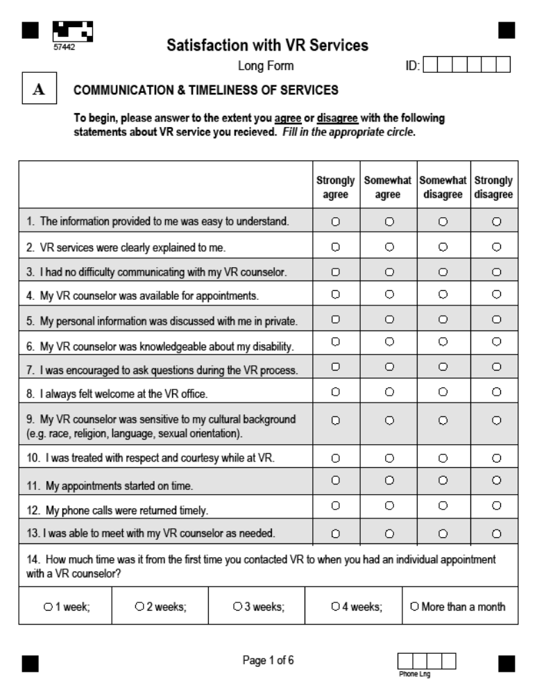
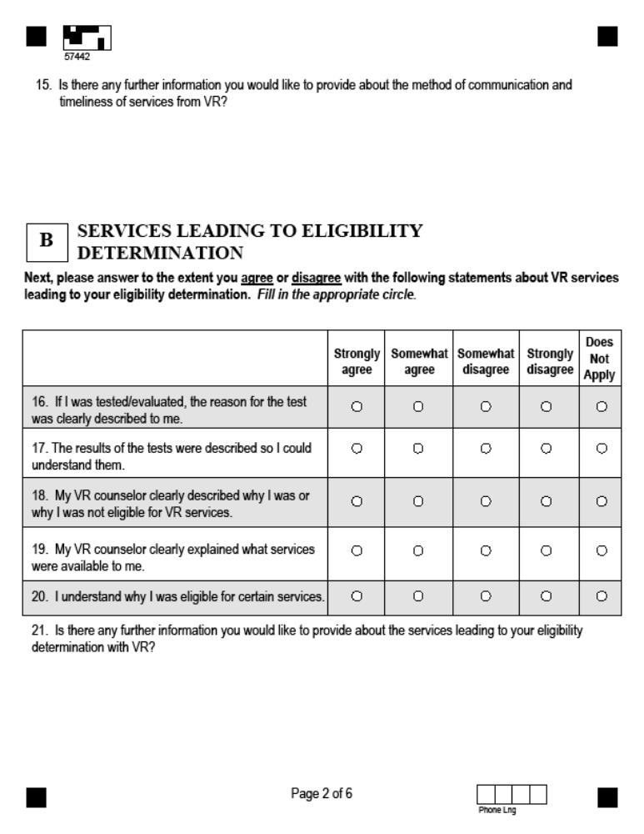
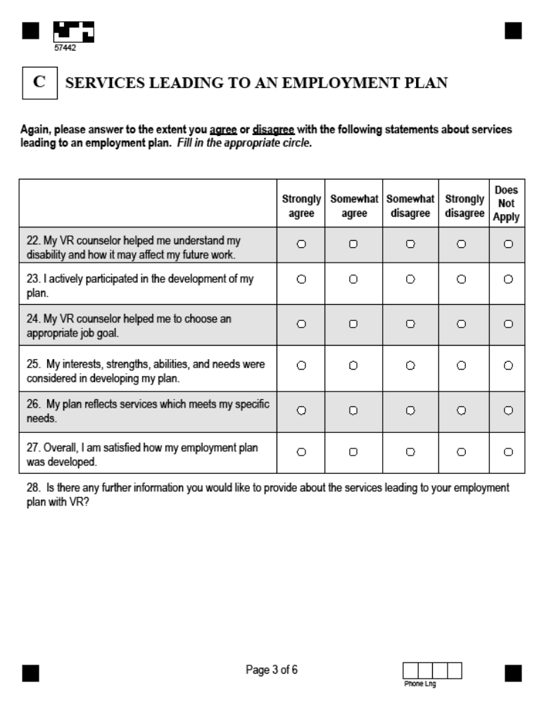

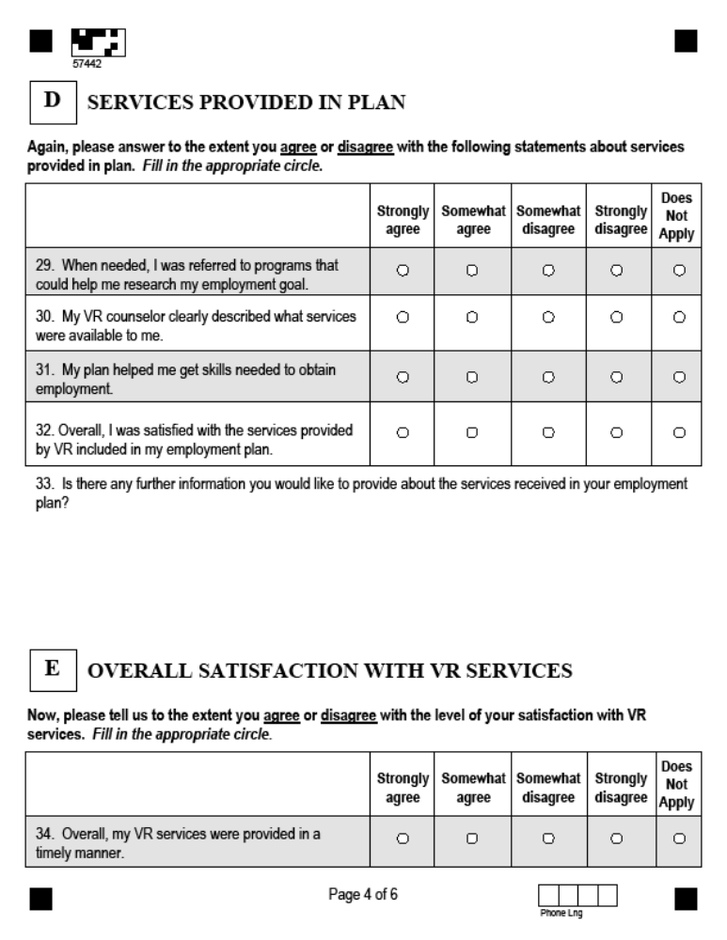
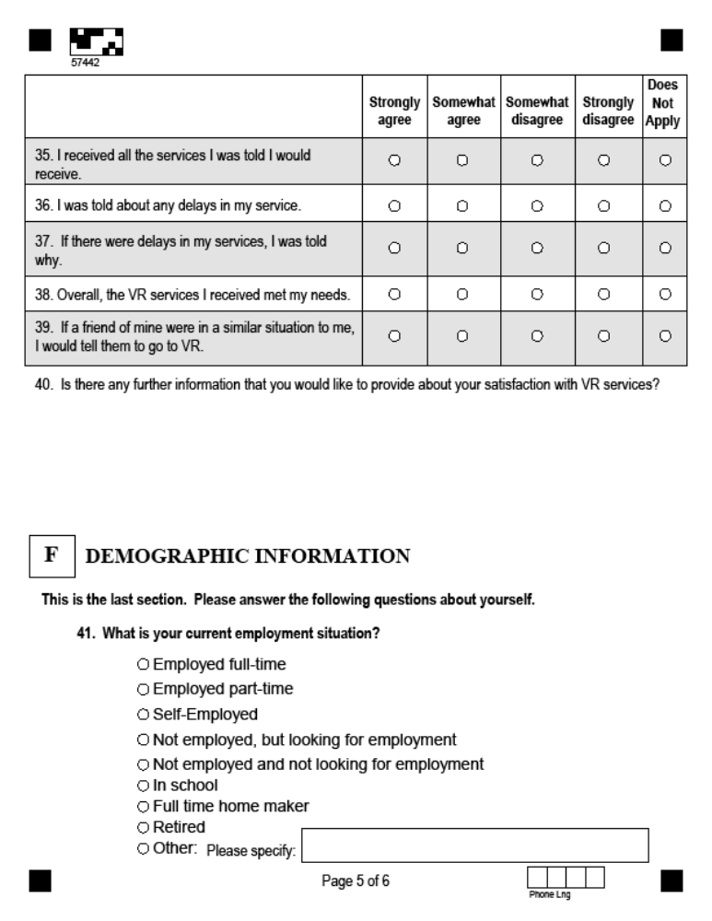

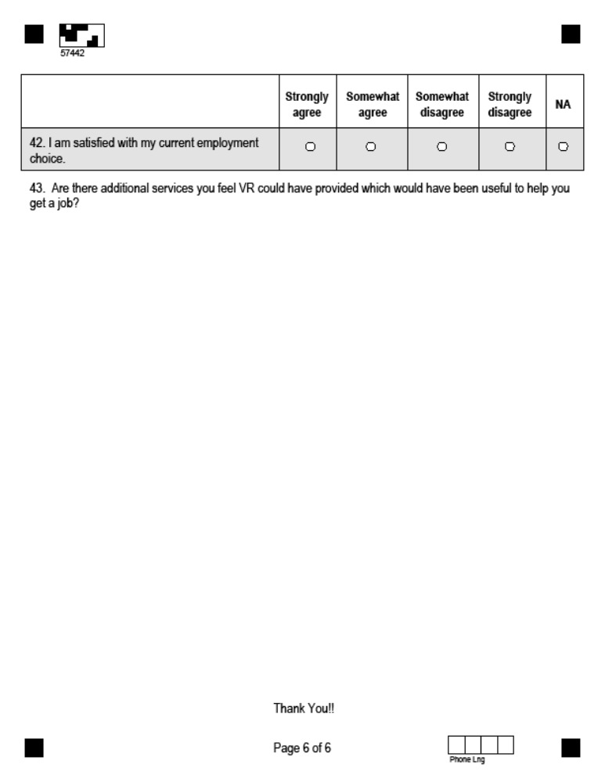

Appendix H: Minorities and Unserved or Underserved Groups
The term “individuals with disabilities who are minorities and individuals with disabilities who have been unserved or underserved by the vocational rehabilitation program” may refer to a wide range of different groups.
In documents on the RSA Web site, “traditionally underserved” is often used to mean racial and ethnic minority populations. For example, a priority on “capacity building for traditionally underserved populations” cited services to individuals from minority backgrounds as the target population (Rehabilitation Services Administration, 2001) and a number of rehabilitation research and training centers on underserved populations have focused on racial and ethnic minority groups. Racial and ethnic minorities that have been traditionally unserved or underserved by the vocational rehabilitation program include African Americans, Hispanic or Latinos, Americans Indians, and Asian-Americans, but may also include people from two or more racial or ethnic groups, people with limited English proficiency and people from other racial, ethnic or cultural groups that may be minority groups in a state or substate area. A number of different methods for assessing the needs of minority groups within the state are offered, including data from the ACS, IDEA and WIASRD; census projections; economic projections; VR agency data, including the R-911; state and substate reports and other materials; customer satisfaction surveys; interviews with key informants; community hearings; and business focus groups.
However, unserved and underserved groups are not limited to racial and ethnic minorities. For example, a section of the RSA Web site on “traditionally underserved populations” also refers the reader to keywords for other populations, including “high risk students,” “at risk persons,” “developmental delays,” and other disabilities, which suggests that a number of other groups may be underserved, depending on the circumstances. A Web review of definitions of “unserved or underserved” revealed a long and varied list of populations that have been considered unserved or unserved within the vocational rehabilitation program. A list of populations that are potentially unserved or underserved is summarized below.
Examining an individual state context will determine whether any of the following listed groups or other groups that may be identified are unserved or underserved.
Unserved people are those who would be eligible for VR services but have not received any VR services.
Underserved groups are those that have not traditionally received equal access to and benefits of rehabilitation services (e.g., racial and ethnic minorities).
The CSNA includes an examination of the size and needs of disability subpopulations and their representation within VR, which can help determine whether certain disability groups are unserved or underserved. Review of state and substate reports and other materials, as well as data collection from stakeholders, can help identify the other kinds of groups that are unserved or underserved in the community. In particular, interviews with key informants and hearings can help to reveal needs of individuals who are unserved in the VR program. VR agency data, including the R-911, VR counselor surveys, customer satisfaction surveys, interviews with key informants, and community hearings can provide an understanding of the needs of people who are underserved by the VR program.

Examples of Potentially Unserved or Underserved Groups
Racial, ethnic and cultural minorities. The Rehabilitation Act identifies people from racial and ethnic minorities as traditionally underserved, and other cultural groups may also be unserved or underserved:
- racial/ethnic minorities in general
- African American
- Asian/Pacific Islander
- American Indian/Alaska Native
- Hispanic/Latino
- two or more racial/ethnic groups
- limited English proficiency
- other linguistic or cultural minorities in the state
Disability groups that may be unserved or underserved. Depending on the particular state, there may be groups identified as unserved or underserved in that state. People with the following conditions have been mentioned in the literature as potentially unserved or underserved:
- mental illness, chronic or serious
- traumatic or acquired brain injury
- developmental disabilities, including mental retardation
- autism spectrum disorders
- deaf-blind
- deaf/hard of hearing
- spinal cord injury
- blind/visually impaired
- degenerative conditions
- HIV/AIDS
- dual diagnosis
- other “low incidence” disabilities
Other potentially unserved or underserved groups. In addition, other groups have been identified in the literature as possibly unserved or underserved, and each state may have groups that are of particular interest because their needs are known to be unmet or only partially met. Depending on the particular state context, a review of existing reports or other materials, conducting interviews with key informants, and other primary data collection methods can assist in understanding the rehabilitation needs of one or more of these groups. Groups identified in the literature include, but are not limited to:
- students in transition
- veterans
- people living in rural areas
- older people, including the aging workforce
- people with limited education
- poor/low income people
- inner city residents
- victims of crime or domestic violence
- former prisoners
- other disadvantaged social groups

Appendix I – Literature Review
In the literature, needs assessments have been defined in many ways. Given the purpose of the VR CSNA and its focus on informing the State Plan, the most relevant definitions include not only the conduct of the needs assessment but also a focus on how it is used. Reviere and her colleagues describe needs assessments as “a systematic and ongoing process of providing usable and useful information about the needs of the target population – to those who can and will utilize it to make judgments about policy and programs” (Reviere, Berkowitz, Carter & Ferguson, 1996b). They state that the process is “population –specific, but systemically focused, empirically based, and outcome-oriented. Needs assessment then is a form of applied research that extends beyond data collection and analysis to cover the utilization of the findings.” Witkin and Altschuld (1995) concur, describing a needs assessment as “a systematic set of procedures undertaken for the purpose of setting priorities and making decisions about program or organizational improvement and allocation of resources. The priorities are based on identified needs.” Furthermore, they state that “data gathering methods by themselves are not a needs assessment. Data collection is but one component in the process, which also includes analysis, presentation, and integration of the information” (Witkin & Altschuld, 1995).
What are the “needs” that the assessment is measuring? Witkin and Altschuld (1995) describe need as the discrepancy or gap between a present state, “what is,” and a desired end state, “what should be.” Kaufman (1992) describes need as the difference between the actual and the ideal. Grayson (2002) further notes that need is neither the present nor the future state but rather the gap between them. A need is not a thing in itself but, rather, an inference drawn from examining a present state and comparing it with a vision of a future (better) state or condition. In a sense, a need is the problem or issue of concern (Grayson, 2002). Reviere et al. (1996b) suggest a definition that synthesizes these ideas and define need as a gap between the real and ideal conditions that is both acknowledged by community values and potentially amenable to change.

Stakeholder involvement
Needs assessment is a participatory process (Witkin & Altschuld, 1995), with stakeholders ranging from clients who receive services to service providers, management, community members, funders, businesses or associations, and researchers invested in the outcome (Reviere et al., 1996b). Reviere et al. further emphasize the importance of inclusion of stakeholders, especially service and program users in “defining, targeting, and carrying out the research…” They note three rationales for the use of stakeholders in needs assessments. First, active participation will generate a sense of ownership, and that will increase the likelihood that the results will be used. Second, gathering input from diverse stakeholders will more strongly guide decision-making during conduct of the needs assessment and implementation of the findings. Finally, participation in this research can empower groups that have been previously marginalized.

Connection to plans and actions
Many authors note that successful needs assessments depend on quality planning (Altschuld & Witkin, 2000; Soriano, 1995; Reviere et al., 1996b; Reviere & Carter, 1996). They point to the connection between the needs assessment’s goals and its direct relationship to an organization’s planning, while also noting the political nature of conducting needs assessments. In the case of a vocational rehabilitation needs assessment, the Rehabilitation Act connects the goals to the generation of a state plan that uses the needs assessment’s findings (Region V Study Group, 1991a).

Methodology
Needs assessments are a “type of applied social research” and therefore must have a methodological design to collect and analyze data according to social science research guidelines (Reviere et al., 1996b). Several types of methods recur in the conduct of needs assessments: surveys of service users; use of existing data including area demographics as well as program data; use of key informants with knowledge of problems, needs and desires of the population; use of group processes such as focus groups; use of public hearings for testimony or assembling interested persons for consensus on service and needs priorities; and service user statistics (Lareau, 1983; Warheit, Bell & Schwab, 1979; and Harlow & Turner, 1993 in Reviere et al., 1996b).
Berkowitz (1996a) stresses that needs assessment methods should be driven by research questions, the needs the study is attempting to address, and recommends a matrix to link research questions to information goals and sources.

Information sources
One major approach is the use of existing information sources such as national or state survey data, program data, or administrative data. Use of this ”secondary data” may include use of existing tables, or may require new analysis. These data have a number of strengths: They provide estimates of prevalence and incidence (Region V Study Group, 1991a); they can include a wealth of demographic information; and they can provide easy access to program data on who is using services (Soriano, 1995). Other advantages include: the data are often free or low cost; they often include large respondent pools and good sampling methods – leading to valid data; and the data are usually fairly current or are available in a timely manner. Drawbacks include: the sources seldom contain the exact data one is seeking; program data do not describe anything about those not using services; data can require technical expertise to analyze (Soriano, 1995). Existing data will not necessarily reveal needs in a low-incidence population (e.g., Hmong) nor reveal how critical a unique need is among populations (e.g., need for native language interpreters). Another issue is that definitions of disability, severity, age ranges, nature (e.g., noninstitutionalized vs. all), and scope (i.e., national, regional, or state) of the populations usually do not correspond to definitions and classifications used in VR (Region V Study Group, 1991a).
Because of these shortcomings in relying on secondary data alone, needs assessments typically involve the collection of new information as well. “Primary data collection” can be both open- or close-ended, and quantitative or qualitative in nature. Needs assessments often use surveys, key informants, focus groups, and public hearings, to provide new information that is not available in existing data. Each of these methods also has advantages and disadvantages.
Surveys done with service participants, providers, or others involved in the service provision process can be cost-effective for gathering data from a large number of people with little assistance needed. Surveys also can address attitudes, perceptions, and needs for services (Soriano, 1995), and can allow for flexibility in assessing the expectations and needs of subgroups and other audiences concerned with the needs assessment (Region V Study Group, 1991a). Surveys, however, may need technical expertise in sampling, questionnaire design, and/or analysis to be technically valid (Berkowitz, 1996b; Region V Study Group, 1991a).
Key informants are those who are particularly knowledgeable about the community or the service process. Advantages of this method include the fact that participants can competently address topics, that only a limited number of participants are needed (Soriano, 1995), and that it is relatively inexpensive to conduct (Region V Study Group, 1991a). However, reliance on a small number of respondents may emphasize biased or skewed points of view, or the effort may miss some key informants view (Soriano, 1995; Region V Study Group, 1991a). Also, input may uncover potentially sensitive issues that an agency would prefer not to confront (Region V Study Group, 1991a).
Focus groups can give an understanding of the target market through meetings of small numbers of individuals. Focus groups allow for more participation by group members, concentration on quality (not quantity) of information and can be used to design more quantitative instruments, although they rely on facilitator expertise, and may lack broad representation (Soriano, 1995), and cannot be generalized statistically (Berkowitz, 1996a). This method can use open-ended questions that allow responses in the words of the respondent – and thus a greater range of complete responses – but time is needed to code responses – and responses are not easy to quantify (Soriano, 1995).
Public hearings are conducted with members of the community at large. Hearings offer the community an opportunity to be heard, but they are likely not statistically representative and may be prone to the “squeaky wheel” effect: the most persistent advocates making the most comments. Advantages and disadvantages are similar to focus groups because of the use of an open response format.
One logical question is whether one method provides sufficient information. Generally, needs assessments include a mixture of quantitative and qualitative methods to increase the quality and validity of the findings. For instance, Altschuld and Witkin (2000) note that it is not possible to understand the current situation or the desired outcome from just one method.

Conclusions
Needs assessments should be useable and useful to program management and identify the gaps in existing services that can be reduced through policies and programs. Needs assessments combine the use of existing information and the collection of new information to address defined study questions or information goals. Any one method will have strengths and weaknesses, and there is no one “best” combination of methods. Stakeholder involvement is important to inform the needs assessment and planning process, to provide opportunity for input and buy-in, to assure the relevance of the data collection and the results, and to satisfy programmatic requirements.

Appendix J – Reviews of State Needs Assessments
To date, state VR agencies have addressed the needs assessment requirements in the Rehabilitation Act through different methods and designs. A review of current practice is useful in understanding the need for a model and for technical assistance. State agencies were invited to submit needs assessment materials as part of this project. Several agencies have shared documents; in addition, a few states include the needs assessment reports on their Web sites.
The following is based on a review of nine studies available for the project and shows a wide range of approaches to the satisfaction of the needs assessment requirements. Table 1 shows the extent to which these nine studies used different types of methodologies in identifying needs and summarizes the extent to which the specific information requirements defined in the Rehabilitation Act are addressed directly in the reports. The table also shows whether SRC involvement was described and whether the report included recommendations for the State Plan.
Of the nine studies, five used U.S. Census or American Community Survey information to estimate the prevalence of disability in the state. Other national survey sources were used in two of the studies to estimate specific conditions: in one case, blindness, and in another, mental illness.
Population and economic projections and forecasts can be valuable in identifying future directions, especially when considering service capacity. Two of the studies used population projections to look ahead to expected changes in state population.

Table 1: Need Study Methods and Coverage of Rehab Act Requirements
 | 1 | 2 | 3 | 4 | 5 | 6 | 7 | 8 | 9 | Total
State Population: Census, ACS | • | • | • |  |  |  | • | • |  | 5
Projections of population, economy | • |  |  |  |  |  |  | • |  | 2
VR caseload data, 911, other data | • | • | • |  |  | • |  | • |  | 5
VR Agency reports, internal studies |  | • | • |  |  |  | • | • |  | 4
Reports, surveys from other agencies | • | • |  |  |  | • | • | • |  | 5
Special written or internet surveys | • | • | • | • |  | • | • | • | • | 8
Focus groups | • |  | • | • | • |  |  |  |  | 4
Public hearings or discussions |  | • |  |  |  | • |  | • |  | 3
Identifies need for services for most significant disabilities | • | • |  | • | • |  | • |  |  | 5
Identifies need for supported employment |  | • |  |  | • |  | • |  |  | 3
Identifies needs for services for unserved or underserved: minorities |  | • | • |  |  | • | • | • |  | 5
Identifies need for services for specific other unserved or underserved groups | • | • |  |  |  | • | • | • |  | 5
Identifies need to establish, develop, improve CRPs | • | • |  |  |  |  |  | • |  | 3
Identifies need for services for individuals served through state workforce investment system |  | • | • |  |  | • |  |  |  | 3
Involvement of SRC | • | • |  | • |  | • | • | • | • | 7
Shows relationship to State Plan | • | • | • |  |  | • |  | • |  | 5
Types of methods used (8) | 6 | 6 | 5 | 2 | 1 | 4 | 4 | 7 | 1
Addresses required topics (8) | 5 | 8 | 3 | 2 | 2 | 5 | 4 | 5 | 1

Information from the VR agency itself is a valuable resource for describing the current services and caseload and identifying VRs own trends and changes over time. Five of the studies used VR data from the case management system or existing data reports to describe characteristics of individuals served, services and expenditure.
Other agencies and organizations may have very relevant information, and five of these studies used such materials such as brain injury statistics from the Department of Health, a Department of Education study of Students in Transition, and an annual survey of state community rehabilitation programs.
Surveys are a popular needs assessment tool, valuable for collecting new information. Surveys were conducted in eight of the nine studies. Survey subjects varied by state and included community rehabilitation providers, VR counselors, supervisors, support staff, VR consumers, VR exiters, representatives of state businesses, students in transition, and education coordinators.
Focus groups were conducted in four of the nine studies, in most cases involving current VR consumers. Comments from public hearings and meetings were used as resources in three of the studies.
No specified topic from the Rehabilitation Act was addressed explicitly or systematically by all of these nine studies. Five of the studies identified the need for service for most significant disabilities. Usually this was with a focus on one or more conditions: blindness, developmental disability, mental illness, deaf/hard of hearing, brain injury, or transition. Three of these studies addressed the need for supported employment. Five reports discussed unserved or underserved populations, including racial or ethnic minorities. Need for establishment, development or improvement of community rehabilitation programs, or needs of people with disabilities served by other parts of WIA, were each addressed by three of the studies. Most studies (7 of 9) mentioned involvement of the state rehabilitation council in the design of the studies or in the review of findings and recommendations. Five mentioned recommendations for the State Plan and other actions of the agencies.
The studies show a wide range of choices in the methods and combinations of methods used. Some concentrated much of the information collection within VR and among VR consumers, limiting the input regarding individuals who do not currently receive VR services. Four of the nine studies used a number of methods in carrying out the study, while the others focused mostly on a few methods such as focus groups and surveys.
One of the nine studies explicitly addressed all Rehabilitation Act required topics and conditions, and several others were somewhat consistent with the content requirements, addressing at least four of the identified topics. In four cases, though, the studies focused more on the findings of a particular survey or other information collection, and, while providing useful information, these studies do not organize the findings to describe the needs as specified. Some addressed disability subpopulations but not specifically whether they were either most significant or unserved or underserved.
The nine studies reviewed spanned a period from 2004 to 2008 and represent a range of approaches to conducting needs assessments. From the differences in approach, it is clear that the agencies for the most part selected the topics to pursue and the methods to use. Furthermore, by focusing primarily on people already being served some state agencies are missing the sources that would help to identify needs that are not being met or individuals who are unserved or underserved by the system.

